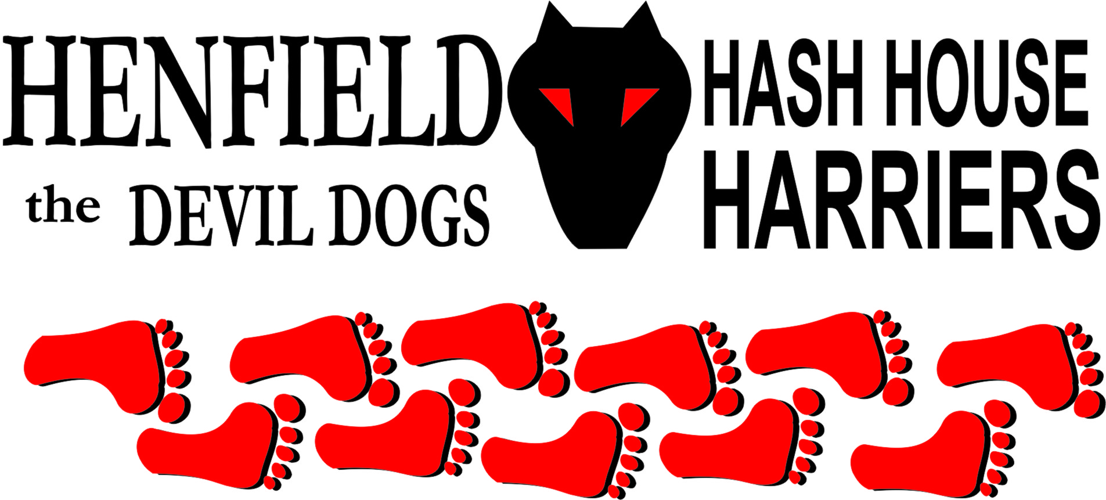

Henfield Hash House Harriers Run #99

Sunday 22nd May 2011 11:30 am
Cat & Canary Henfield

Scribe: Sir Snot

The weather was perfect for a Sunday run, not to Sunny to deter would be barbie cooks and a threat of rain keeping miseries like Moneypenny and Auld Banger away – or in Auld Bangers case a skid in wet weather may just put a dent in her last dent-free panel or mark the duck tape holding the bumper up.

Alas a good turnout with runners eager to move and Malibog coming over just one month too early for the 100th run. Homer sitting and Roadrunner eager to get away to burn all that pent up energy.

The walkers set off on trail down to lower station road whilst running trail took runners down upper station road with Slash having to be called back from heading to the river for a Sunday morning skinny dip. The assumed clever ones in the pack headed off towards the walkers, but true trail was in the opposite direction, off into shiggy lane, through the horses’ field to where the hair was waiting at the sty!

Malibog and Bouncer were almost joined at the hip for most of the run talking all the way like a couple of old housewives! Roadrunner followed by Daddy Homer, to be heard saying “go on check it out” then running in the opposite direction. Splitpin was not taking any crap and kept a nice steady pace just behind the frontrunners.

Radiosoap had just been to an Adam Ant party night and all the way round she could be heard singing “Stand and deliver……….” But that was the only words she knew!!

With the downs in view the pack went along the path into some real muddy shaggy – quite a feat in this dry time! Complaints all the way “my trainers will get muddy” was heard from……….Female fraternity!

Through to parkland south of the village then across the Henfield/Small Dole road up through a small vineyard onto the beer stop.

The last 2-3 miles the leading pair of Homer and Roadrunner could not be heard shouting On-On, although they did admit to whispering On On – No shout it you dopey’s!

The walkers had already reached the beer Check and Oome and clan were playing spot the turd and covering it so some other soul could not see it and step into it! Cystpit had severely given his little lad brain shake on his back.

Finally Malibog, Bouncer, Slash, Bollocks and Splitpin made the stop and beer was had by all.

The runners went off and Cystpit wanted to follow them around with the walkers and hare in tow – which we did in rain wind and sun and arrived back to the pub some time after the runners who had avoided the rain.

Oome had brought a brolly but fat use it was in the car as did the hare!

Finally a circle was formed and marks for the run ended up at a surprising 6.9, with Radiosoap still singing her three Adam Ant words – which she was made to take a down down to!

Bouncer and Malibog finally separated to have Down Downs and Bollocks receiving another Down Down for interrupting… Again and holding up the circle for playing Jenga which he lost to Bouncer!

Food and drinks enjoyed by all onto the 100th !!!!!!!!!!!!!!!!!!!!!!!!!!!!!!!!!!

On On
The Henfield Hash House Harriers cast in no particular order, nor importance to anyone other than the hare:
Hares | Sir Snot
Runners | Bollocks, Split Pin, Snotty, Slash Gordon, Radiosoap, Homer, Roadrunner, Malibog and Bouncer
Walkers | Oome, Oome clan, Cystpit and Cystpit clan.
Drinkers | The above + Angel
Apologies | Moneypenny
Grand Master | Snotty
Religious Adviser | Bollocks ( self-appointed)
Large Wildlife | Henfield Residents
Twin Town | Who would have us!
Hashshit | Homer

NEXT HENFIELD HASH --
The 100th Weekend 17-19 June only a few places left!

