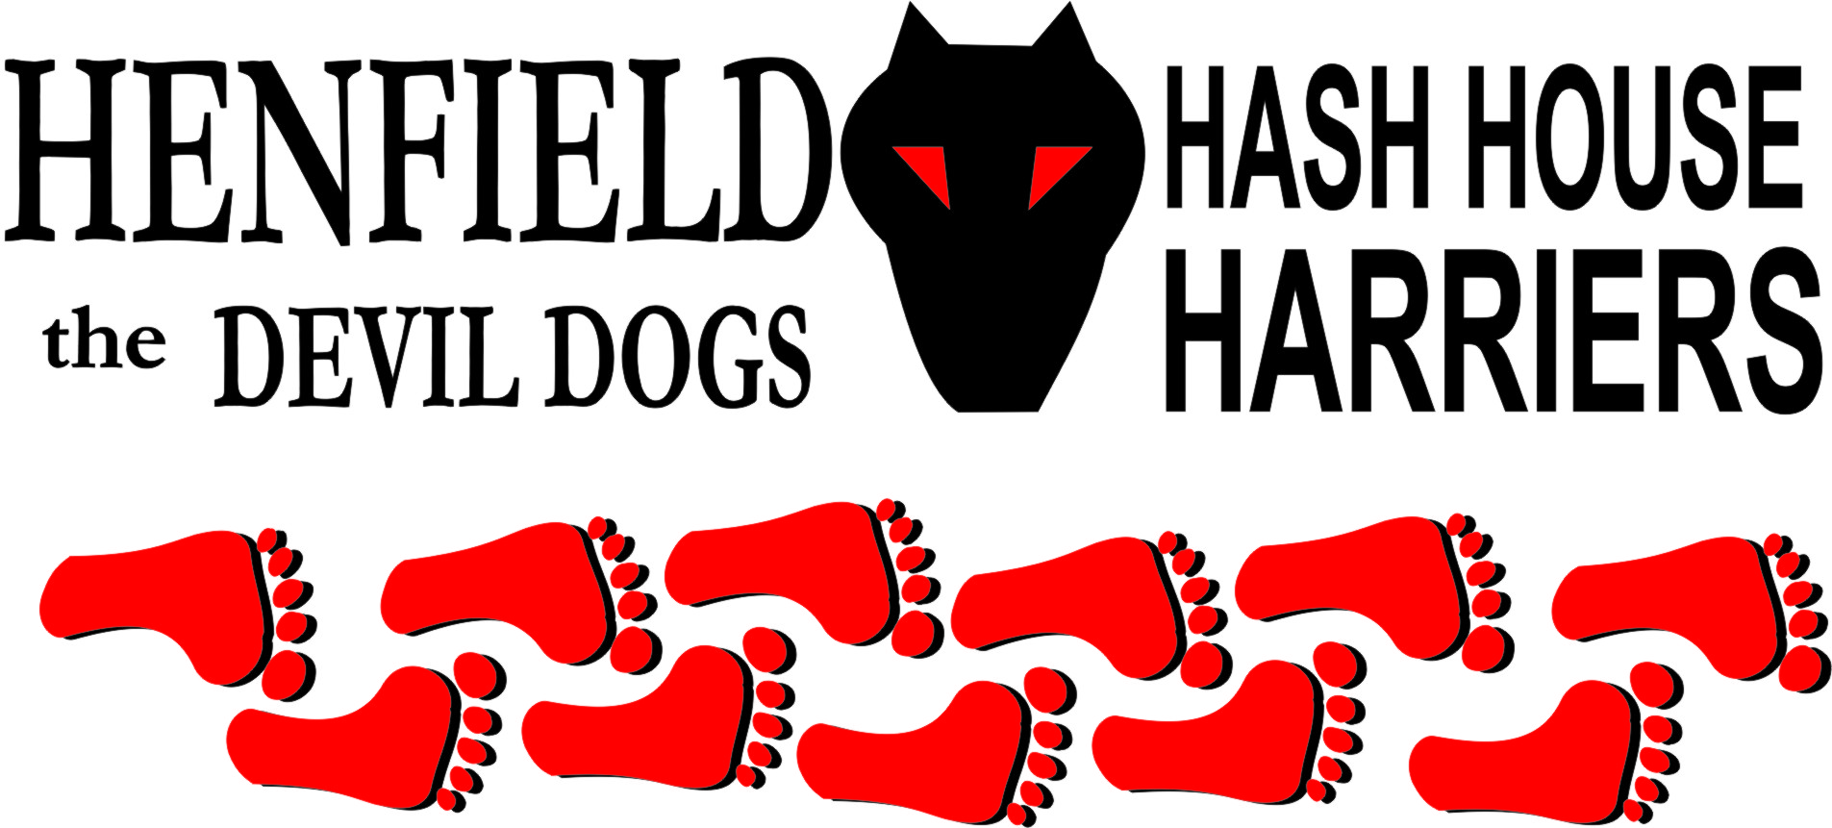

Henfield Hash House Harriers Run #98

Sunday 24th April 2011 11:30 am
Frankland Arms Washington

Scribe: Bouncer

This should’ve been Burgess Hill but Homer blew us out, so Bouncer stepped in with a last-minute trail from the pub that a bunch of Brighton hashers were having a little romp in the woods from. Well, I say Bouncer, but as Moneypenny pointed out, only Dave appeared, so should get a down down as Bollocks referred to previous r*n reports.

So last-minute in fact, that as the thrilling mongs gathered, hare was still out setting. Word that Snotty was on the opposite square of the cube had got out ensuring a large pack mustered to greet hare, with Bollocks, Split Pin, Tosser, new boot Helen, Moneypenny, Radio Soap, Dave, Dave dog and Chris on the long trail, plus Cyst Pit, Auld Banger, the flying Mafiosa brothers – Vincent and Louis, and Nightmare on the walk.

Hare had ensured plenty of confusion at the start with a check teasing pack with countryside, but the call was up the road where an even more dastardly false trail drew them on. Chris thought “Sod this for a game of soldiers” and went in hot pursuit of the walkers up towards the Church. Wrong called the pack who were now back on trail. Also wrong Moneypenny who had decided it would be road all the way, as a hard climb up the hill beckoned. Radio Soap found a lovely trail off the next speculative check (that’s, like, a check what the hare put down without bothering to look or set falsies. There were a lot of these) and we nearly lost her. Given the options at the next check of an even steeper climb or checking down the pack took the sensible option of waiting for hare to crack and spill dust. Well, except Chris who chose up incorrectly. As Bollocks revealed he’d knocked off a 27-miler the day before in the heat, hare took the kindly option of marking the next cxhek through – straight across the A24. “Down down” cried Moneypenny!

At last there was a small amount of enthusiasm and pack started to jog up to the next check where Chris again flew solo. Moneypenny (who suggested that hare should get a down down), Radio Soap, and yup, Chris again, this time caught up in mobile chat, missed the false trail to head for the summit of Mount Sullington. Hare had a change of heart and called them back before they got too far as the balance of the pack, which had been having intercourse of the social type with some cyclists, disappeared into the distance. After wandering down 1000 steps, cross a luvverly meadow and up a narrow path the two packs failed to unite so a quick mark through was choze. At the farm, hare marked an SCB, which the unseasonable warmth attractivacised, then went looking for the front half. A fond reunion took place on the SCB as hare caught up to find Soapie on her knees, trying to retrieve a wild garlic bulb.

As hare took off to mark the new trail to the sip, usual comments were made “interactive hash”, “normally dust is laid before”, “I once got a down down for doing that” etc, but all was forgotten at the lovely sip where the walkers were well in their cups along with Angel and rugrats. Good job it was only Tesco Value bitter at 2% and therefore a) ideal for drivers, b) in keeping with the non-existent St. George’s theme which only hare knew of and c) a down down offence per Moneypenny. Nightmare was especially impressed with Warren Hill though Split Pin had guessed trail.

After restorative beer and mini eggs, trail went off into the pine wood where Dave, Tosser and Helen fell for hares antics, “has anyone checked thataway?” A bemused hare then called tjekk where there clearly wasn’t one, and again a few seconds later, with no marks between. To the excuse that they’d clearly been rubbed out, Moneypenny said “yeh yeh, that old chestnut!” and some other shit about hare getting a beer later. Served him right that he then went troppo as trail was again picked up, out of the woods, through the underpass, and along the stream past the campsite for an altogether too lovely finish. Should mention that Radio Soap also went troppo after admiring the fields full of narcissi and bluebells, but used her loaf better to get back in touch!

Back at the pub, Belcher and Spud Edwards were spotted briefly in the garden, Gotlost, Aunty and Spreadsheet having already taken off. Wiggy was over excited about seeing the offspring of an old mate making his way up to London for the royal wedding dressed in a full suit of armour. Google it.

Meanwhile, there was some concern about the absence of walkers. Hare insisted they should have gone straight but it turned out that Angel had assigned Gooey and Crackerjack the job of leading them home and they’d taken them on a Cook’s tour. Eventually they appeared, quite happy as it had continued nice.

Bollocks then took charge of down downs dishing just the one to hare, a half-century beer to Nightmare, newbie drinks to Helen and water to Dave, which meant that Dave also had to have a water in accordance with hash ordnance that “one Dave drinks, all Dave’s drink”. A bit of bluster went on about a hash name for Chris but despite a popular call for Gaddafi, it was never really going to be anything but Pirate, especially with the one-man band of Radio Soap pushing up the clapometer. That left just the one beer which was awarded to Snotty as hash shit for his absence, part time hasher! Homer was on this occasion a justifiable entry but has been awarded unjustifiably nearly as many times as Cums Never-at-all who always deserves it.
The Bouncer song (to the tune of Solsbury Hill):

Hashing up near Warren Hill,
I could see the hash in sight
Sun was burning, time stood still
Pirate didn’t take trail to the right
He was something to observe
Went off trail, Didn’t hear my voice
Lost hashers, I didn’t deserve
Had to call back had no choice
He did not believe the information
He just had to trust imagination
His phone going brrm brrm brrm
"ON ON," I said "Get back here,
I've come to take you home."
To cut the trail I was resigned
The hounds would think I was a nut
Turning beer into urine
Open doors would soon be shut
So I cut trail back to the pub
Tho' the flour had all been rubbed
In the woods we had to play
Which connection should I cut
Missing out on part of the scenery
We hashed right on through the greenery
The pack yelling “On on on”
"Hey" I said "Follow me
I've come to take you home."

On On
The Henfield Hash House Harriers cast in no particular order, nor importance to anyone other than the hare:
Hares | Bouncer and Dave
Runners | Bollocks, Split Pin, Tosser, Helen, Radiosoap, Pirate, Dave the Dog, Moneypenny
Walkers | Auld Banger, Nightmare, Cystpit, Vinnie, Louis, Crackerjack, Gooey, ET & Angel
Drinkers | The above + Wiggy, Belcher, Spud, Aunty, Gotlost, Spreadsheet
Apologies | Homer
Grand Master | Snotty
Religious Adviser | Bollocks ( self-appointed)
Large Wildlife | Sheep, various goats, alpacas, more alpacas
Twin Town | Who would have us!
Hashshit | Sir Snot

NEXT HENFIELD HASH --
- 22nd May in Henfield Area – watch the website.

