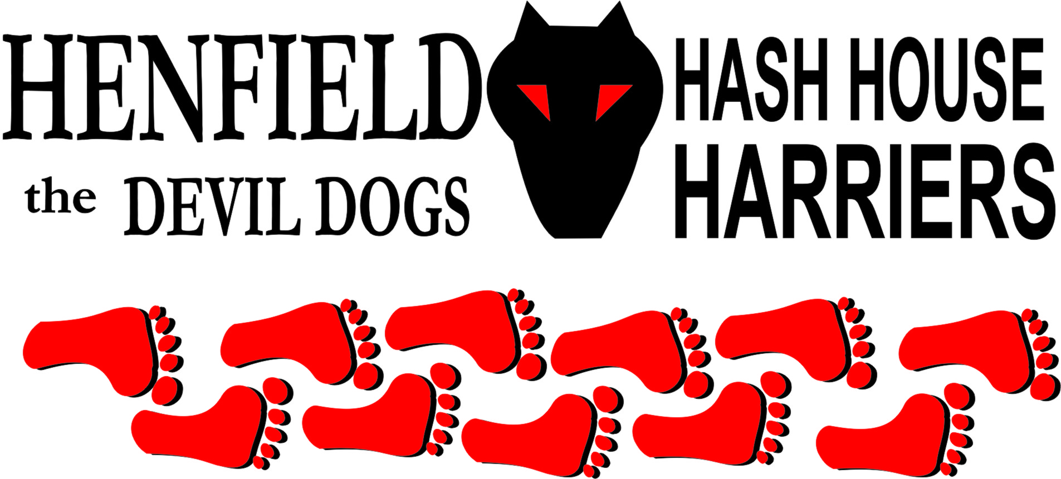

Henfield Hash House Harriers Run #97

Sunday 27th March 2011 11:30 am
Poacher Pub Findon

Scribe: Bollocks

No words can express my disappointment when after having spent two hours on Saturday evening and a further two hours on Sunday morning setting magnificent running and walking trails over stunning downland, and spending a ransom on fine beers and cider, softies and snacks, Splitpin and myself were rewarded with a pack of two runners and a walker. So really there should be no words…

New man Julian was no doubt confused as to why somebody would go to such lengths to prepare a run and then be rewarded with only two others to run it.

Where were you Henfield Hash, bunch of idle ner-do-wells.
Homer forgot to put his clock forward and so had a sort of excuse and did at least turn up for the après beer, but what page in the Cum Lately book of excuses did Auld banger find ‘I was coming but the indicator bulb on my car failed’?

Full marks to Snot and Moneypenny, Bollocks and Splitpin and new runner Julian.
F**k all marks to the rest of you.
It was a great run but I’m not going to waste my time telling you about it.
Bollocks to you all from Bollocks.

On On

The Henfield Hash House Harriers cast in no particular order, nor importance to anyone other than the hare:
Hares | Bollocks and Splitpin
Runners | Moneypenny, Julian & Bollocks
Walkers | Splitpin & injured Snotty who at least turned up!
Drinkers | The above + Homer
Apologies | Auld Banger
Grand Master | Snotty
Religious Adviser | Bollocks ( self-appointed)
Large Wildlife | Sheep, various goats, alpacas, more alpacas
Twin Town | Who would have us!
Hashshit | Homer

NEXT HENFIELD HASH --
- 24th April in Burgess Hill Area – watch the website.

