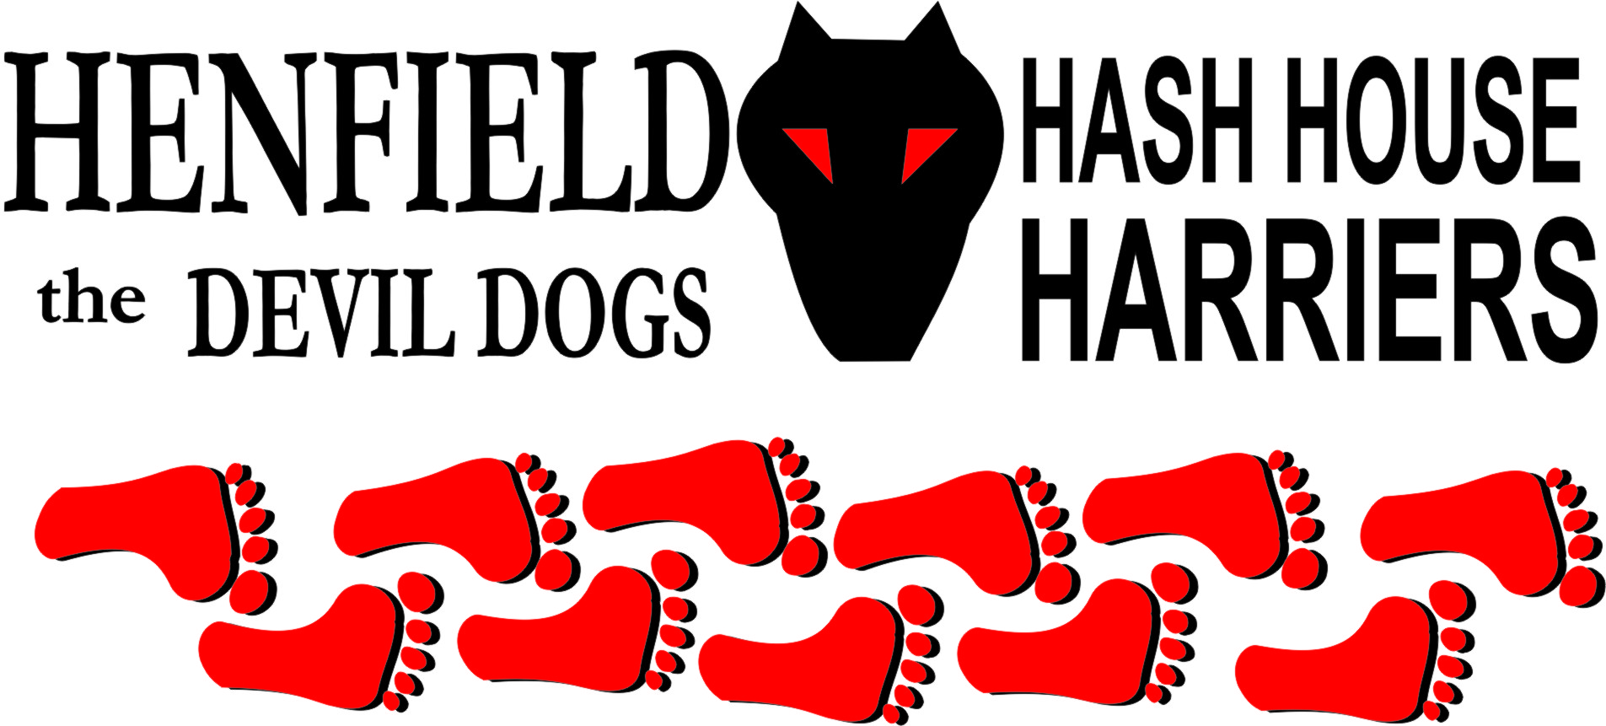

Henfield Hash House Harriers Run #96

Sunday 20th February 2011 11:30 am
Poacher Pub Hurstpierpoint

Scribe: Moneypenny & Tosser

The 96th Hash went off smoothly, despite efforts by Snotty to sabotage it, by repeatedly sending out messages saying the run would be in Haywards Heath, when it was actually in Hurstpierpoint.

After setting up the Beer Stop, with glorious beer for the drinkers, from famous local craft brewery, Tesco’s, and a choice of soft drinks for the kiddies (well, bottled water or rainwater),
The Hares went off to set the trails. Moneypenny set the run, and Tosser set the walking trail.
They returned at 11.30 to find 10 2-legged hashers, plus 2 hash-hounds, Dave and Scaredy-Cat, waiting eagerly to run/walk/ drink.
The hashers had all managed to follow the instructions published on the website - except Snotty, who was last seen heading for Gatwick airport, with a ticket to Malaysia clutched in his sweaty paws.
(He must have been even more confused than usual, as Malaysia is not in Sussex, and doesn’t even begin with H).

Anyway, 5 Runners set off, followed by 5 walkers, each pack equipped with a Hash-hound, so 14 legs each. Just to be a little bit daring, the Hares swapped places: Money penny had set the run, but went with the walkers, and Tosser went with the runners, showing complete faith in Moneypenny’s ability to lay a trail of flour.
(Tosser had not been around for Moneypenny’s previous attempt at setting a trail from Hurstpierpoint, when he failed to find the Beer Stop, despite having set it up himself an hour earlier!).
The routes took the runners on a loop to the north, before heading south onto the Danny estate, while the walkers took a shorter route across the fields. There were loads of mud and as a special treat; most of the gates were in the middle of small lakes, so no dry feet on this event.
The walkers got to the Beer Stop 5 minutes after the runners, who had jogged round, following Roadrunner who sneakily managed to find the right route at every check. Nobody moaned about the Tesco beer, for once, although the pack was probably too busy scoffing cakes (a big box of muffins, which Mrs. M had accidentally (how?) Bought in Sainsbury’s.
Everyone then moved on, braving huge herds of alpacas and several sheep, to return past Danny House to the On-Inn. (Genuine historical note: Lloyd George rented the house in 1918, and the armistice Treaty was drafted there)

The walkers had a surprise Photo Opportunity on the way back – OohMe took a flyer coming over a style, and went arse over tit (or maybe, arse over arse) in the mud, and lay there for several minutes, refusing to get up until we’d all taken her picture.

The pack went up to The Poacher for the Circle (great little pub, excellent beer, good cheap food). Bollocks elected himself as Religious Adviser, and the RA called the Circle to order.
Marks for the Run were surprisingly high, ranging from 3 up to 11 out of 10, so an average of 110% (6.9!), with bonus marks for mud and alpacas.

Negative comments were: oh, sorry, the scribe wasn’t listening at that point.
The RA ordered up some down-downs and awarded them to:
- the Hares – well deserved refreshment
- Slash Gordon, for wearing new shoes – what a silly boy! Slash compounded his mistake by keeping the (formerly) white trainers on in the Circle. The RA poured the down-down into a shoe and Slash had to drink it. Still, Harveys out of a sweaty shoe with mud and cowshit in it is probably better than any beer he’s had in Scotland!
- Ooh Me, for not running, despite having managed to mislay her children that morning, and thus having no excuse to walk
- Roadrunner for not driving (can’t explain that one – your scribe scribbled some notes down, and not all of them make sense!)
- Split Pin was given 2 down-downs.
- Bollocks had turned up for the hash in shorts so brief; you could almost see his nameplate. He explained that when he asked Spit Pin why she wasn’t going to run in shorts, her answer was – “I can’t, I haven’t had a shave”.
- Split Pin got another one for wearing a yellow shirt, which according to the RA is against the international laws of hashing. This was news to everyone else, and extensive research (well, Google, and talking to a bloke the scribe met in Surrey) has found nothing to say yellow is banned.
But we all know that the only rules of hashing are Rule 1: THERE ARE NO RULES. Still, it serves Split Pin right for hitching up with a guy with no social graces, and a face like a turkey’s todger. The only reason he stopped giving her down-downs was when he realized he needed her to drive him home and feed him his tea. (Hope he didn’t dribble too much).

A rare event then occurred - a Re-Naming. The RA had ordered one too many beers, and announced that he’d noticed how Dave the Dog had been enthusiastically jumping in every puddle or patch of mud he could find, which was a very good impression of Bouncer.
Therefore (according to the mind of Bollocks), it was essential that either Dave the Dog should be renamed Bouncer, OR, Bouncer should be renamed Dave. This was put to the vote, and it was decided that the hasher formerly known as Bouncer, will forever more be known as Dave (on the Henfield Hash). The last down-down was passed round the circle, everyone present took a drink, and the name change became law (Rule 17b, see above). This also means that Dave (NOT the Dog) will need to have a down-down as a visitor next time he shows his face at Henfield.

Snotty should have been Hashshit, for pretending to go to Malaysia on urgent business. And for trying to get the Pack to meet at Haywards Heath, which is 5 miles away from the pub.
But the title goes to Bollocks, for making up a completely new rule, and giving his own spouse a down-down for wearing yellow on the Hash. Did they get dressed in the dark that morning?

On On

The Henfield Hash House Harriers cast in no particular order, nor importance to anyone other than the hare:
Hares | Moneypenny (for Run); Tosser and Dave the Dog ( for Walk)
Runners | Bollocks, Split Pin, Tosser, Dave Dog, Slash Gordon & Roadrunner
Walkers | Moneypenny, Mrs. Moneypenny, Ooh Me, Auld Banger, Homer & Scaredy-Cat
Drinkers | The above
Apologies | Snotty (skiving), Dave, Angel and brood (skiing); Forrest ( for being a garlic-muncher )
Grand Master | Snotty (absent)
Religious Adviser | Bollocks ( self-appointed)
Large Wildlife | Sheep, various goats, alpacas, more alpacas
Twin Town | Haywards Heath
Hashshit | Bollocks.

NEXT HENFIELD HASH --
- 27th March at Findon– watch the website.

