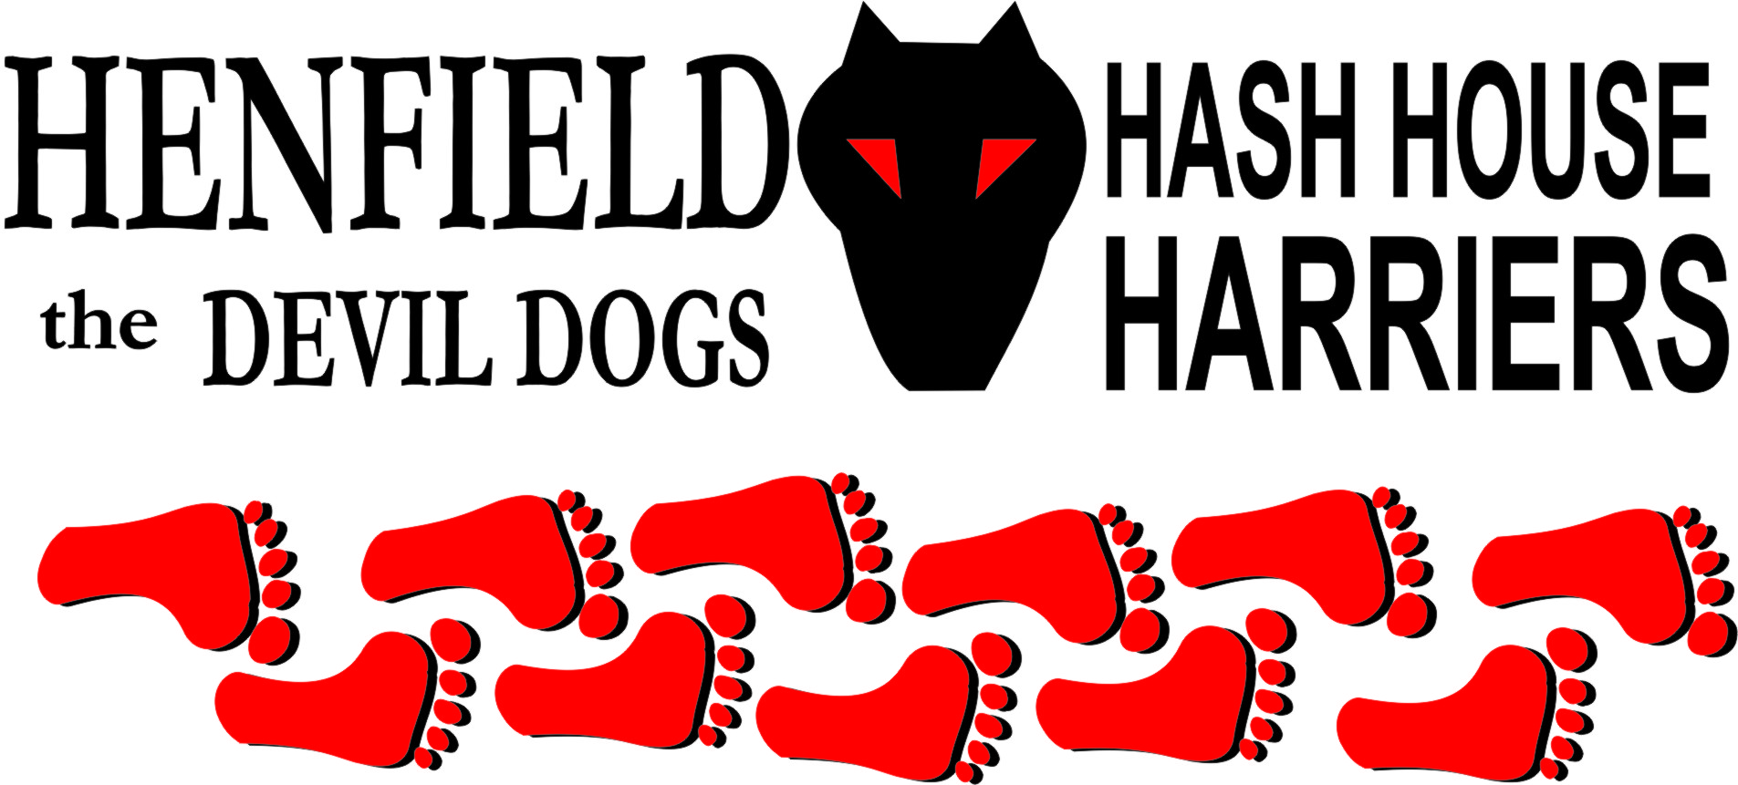

Henfield Hash House Harriers Run #95

Sunday 30th January 2010 11:30 am
Cat & Canary Henfield

Scribe: Mrs Slash Gordon

We were lucky to have a sunny, albeit it cold day for our second haggis hash. The turnout was good; we even had a runner all the way from Sweden (had he heard about the ‘neeps’?) . The best dressed was Bouncer, sporting a lycra tartan number. Slash Gordon, the hare, was looking a bit ‘see you Jimmy’. King of the hash Snotty was carrying an ankle injury gained during some night frolicking in Hawaii so could only make the half way stop by thumbing a lift from Mrs Slash.

As usual Roadrunner was out in front chasing the wild haggis in all directions while the two new runners Ellie and Heather (daughter of Slash) were slowly bringing up the rear under the kindly chaperoning of Splitpin. Ross (yet to be named) was struggling with the cold and spent the run with his hands in his pockets, which called for a down, down later on.

The half way point proved to be popular, there was everything from Hot Whisky Toddies to oatcakes and shortbreads. One keen drinker (rumoured to be Homer) even had a go at the 9% Tennants! The stop was not without tension though, as the walkers were very late in arriving and Moneypenny was getting very worried about the safety of Mrs Moneypenny (ahh love is!). However, our intrepid walkers had not got lost but just delayed by a jungle of brambles, electric fences and knee deep mud! Oohmee, Banger, Mrs M and the kids were not a pretty sight when they appeared! However, Oohmee Mud was heard asking her mum if she could go back along the muddy path for a second time – at least someone enjoyed the walk.

The Cat and Canary did us proud with a fantastic Haggis, Neeps and Tatties lunch. The huge Haggis was piped in by Bouncer with his up-turned stool, Slash slashed the Haggis while giving his rendition of the Ode and the girls played two classic highland tunes which ended with ‘auld lang syne’, with all the hashers joining in for two rowdy verses . The service of the meal went smoothly which is amazing after all the fuss Bouncer made about cooking his vegetarian haggis, this sort of behaviour is definitely worth a down, down. The haggis was so big that there was lots available for seconds, Oohme’s eldest son was lapping up the fodder and the three musketeers on the little table ate so much that their stomachs were definitely ‘bent like drums” (quote from the ode).
Well, the kilts are packed away for another year, cheers to everyone for making the event such fun.

On –On

The Henfield Hash House Harriers cast in no particular order, nor importance to anyone other than the hare:
Hares | Mr & Mrs Slash Gordon
Runners | Slash Gordon Bollocks, Splitpin, Bouncer, Roadrunner, Homer, Moneypenny,Hamish, Ross, Malibog,Chris, Cyspit
Walkers | Mrs, Slash Gordon,Sir Snot, Auld Banger, Ooh me, Mrs Moneypenny,Heather, Elanor, Devlin, Greg,Olly,Rosy
Drinkers | All the above
Apologies | None
Large Wildlife | Vegetarian Bouncer
Twin Town | Who would want to!
Hashshit | Homer

NEXT HENFIELD HASH # 96 to be arranged by – Moneypenny and Tosses on Sunday 20th February – Watch Website for latest details.

