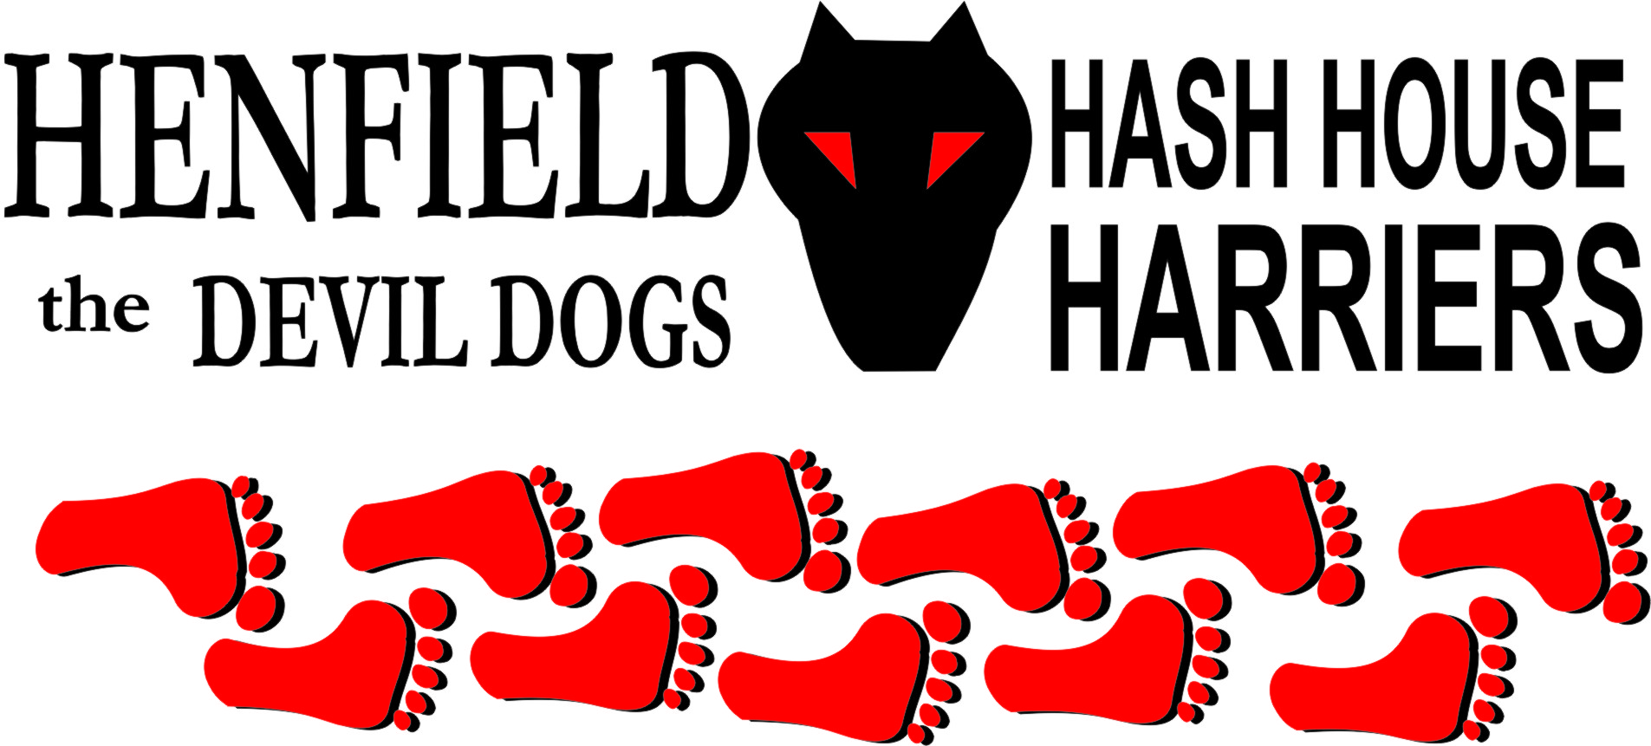

Henfield Hash House Harriers Run #94

Sunday 19th December 2010 11:30 am
Cat & Canary Henfield

Scribe: Snotty

On one of the coldest days of the year with the morning temperature at -3 Deg Celsius with many excuses coming from heavy colds, stuck in London, or computer broken down a small turnout was expected. As 11:30 approached a couple of new boots showed up as Malcolm, Susan and Hash Hound Murphy. Apparently Splitpin had met them at a swimming pool and asked them to come to the run! Malcolm had been on a hash in the Middle East.
Then Roadrunner showed without old chap Homer who was supposedly stuck in London. Then Nightmare appeared, with Bollocks and Splitpin and Alice close behind, and then just as we had thought the pack was complete, Bouncer, Angel, ET, Gooie and Crackerjack appeared to swell the pack.

Markings were in blue and green children’s poster paint as flour could have been difficult.

Before we all froze to death the pack set off to the first check then down Staples Lane then after a few cunning checks the pack set off past the guide hut and onto the disused railway line before cutting back through Parsonage Farm on some new trail before Bollocks and Roadrunner le the group around the field back in a big circle jerk back to the railway lines.

A check allowed Splitpin Susan, Malcolm and Murphy to catch up whilst the walkers including Nightmare, Angel, ET, Gooie and Crackerjack all took a shortcut, whilst the runners all followed Roadrunner on true trail, past the farm and Bollocks found true trail up to Stonepit Lane and onto the beer stop, including mince pies, malt whiskey and some Southern Comfort for those with a sweeter tooth.

A hat award for Bollocks who is getting cold shivers in his old age, with his name suitably stitched in the back, one of only four H4 hats in the whole world – presently. After the On On it was all back to the Cat & Canary where a good warm Harvey’s was the order of the day with down downs for the new boots Susan and Malcolm.

Alice was nominated as best dressed without even getting her shoes dirty – Posh Spice look out!

As the next run falls close to Burn’s night Slash Gordon was nominated to be hare as well as master of ceremonies.

On –On

The Henfield Hash House Harriers cast in no particular order, nor importance to anyone other than the hare:
Hares | Snotty
Runners | Sir Snot, Bollocks, Splitpin, Bouncer, Roadrunner, Susan, Malcolm + Murphy (Hash Hound)
Walkers | Nightmare, Angel, Alice, ET Gooie and Crackerjack
Drinkers | All the above
Apologies | Slash Gordon, Homer & Auld Banger
Large Wildlife | Frozen horses
Twin Town | Who would want to!
Hashshit | Homer

NEXT HENFIELD HASH # 95 to be arranged by – Slash Gordon on Sunday 30th January – Watch Website for latest details.

