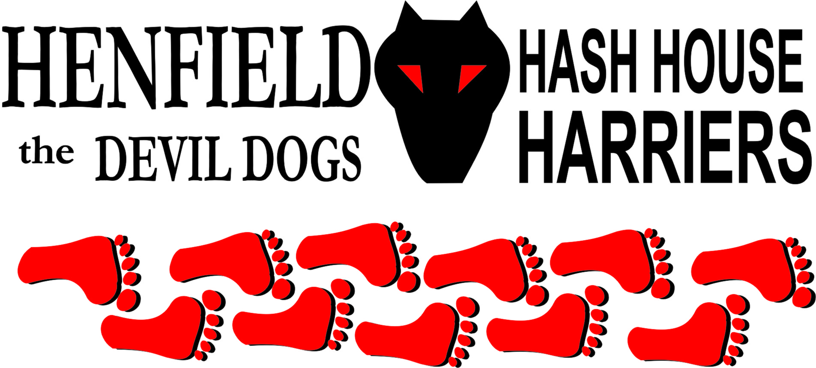

Henfield Hash House Harriers Run #93

Sunday 14th November 2010 11:30 am
Red Lion Ashington Village

Scribe: Bollocks

In the tradition of the Henfield Hash, hares are requested to write some words after the run for posting on the web site. Now, I am not convinced that the lazy gits that frequent the Henfield Hash ever bother to read the run write ups. So confident am I that only Sir Snot bothers himself to read run write ups that I am offering to buy a drink at the Henfield Xmas piss up trail to any-one who approaches me and utters the phrase ‘fishcakes taste better with marmite’.

However, a run was ably set by Splitpin and Bollocks 10 days ago from the Red Lion at Ashington. Virgin territory for Henfield Hash, and a bit of a risk from the proprietors of the pub letting the hash into such a prestigious boozer for the après.

In the car park at 11.20 first to arrive was Ratstail with Eleanor, swiftly followed by Moneypenny, Tosser and Dave. This would have normally been a full quota but for some reason others followed. Slash Gordon and John the Kilt, Sir Snot and Nightmare, Homer and Roadrunner, Wiggy & Bouncer soon followed and then with a fart and a whine from his (t)rusty Transit, Forrest the French squealed his way onto the gravel.

A brief excuse of an explanation of the run from the hare and they were off. Walkers Splitpin, Nightmare and John the Kilt wandered off towards the east whilst the energetic stumbling group set off apace into the backstreets keen to show off their athletic prowess. Ratstail in particular was finding all the falsies, and with an enthusiasm seldom seen on the hash ran them all down. The checking chickens stayed together as a group and soon after the church were to be found following Bouncer on the true trail into the shiggy whilst a delusional Ratstail went off on another lonesome and pointless pursuit of glory on a falsie.

Up past the ponies, onto the tarmac and down to the A24. Passed some citizens who were suitably confused by our behaviour. Local knowledge once possibly held by Forrest was wasted as he led Snot and Slash up a falsie towards Kates Cakes whilst the rest of the pack braved the Sunday traffic and sped along the footpath towards the safety of the Ashington underpass.
Bouncer, free of sprogs and Angel bravely led the way up the road to Broadbridge farm and even more bravely took the first falsie off along the river bank and through some particularly wet and nasty shiggy. Wiggy and Slash headed off along the road completely ignoring the check back and were soon out of sight. Moneypenny and Tosser coerced a reluctant Dave (a dog!) to follow the errant Wiggy and they too were soon out of sight. The Hare was yelling them back but they were having none of it. At this point a concerned Eleanor pointed out that her dad the Ratstail had not been seen for some time. Her concern was short-lived as along came the puffing Ratstail suffering his extra efforts earlier in the run following every falsie to the end.

The remains of the pack were encouraged to take the correct trail past the sewerage farm and it was at the end of a narrow trail that Ratstail encouraged Sir Snot to perform a graceless slide into a water filled ditch. Snot insists he was pushed. A bit of ‘hand of God’ stuff, he got a good soaking! We then followed a recently repaired Roadrunner around the new lakes and up through a spinney, across a field, under an electric fence and eventually arrived at the beer stop.

Walkers Splitpin, Nightmare and John the Kilt were already enjoying the choice of fine ales, and we joined them. After a good sip we were ready to leave on the second half when Moneypenny, Tosser and Dave turned up having by some miracle managed to follow the trail back from their adventure chasing a bewildered Wiggy earlier. They were allowed a quick beer then encouraged to run on into a wood, along a trail and there appeared the itinerant Wiggy and Slash. Abuse was quite rightly directed at these two and we were unsympathetic when they complained of thirst.

On on through some more woody trails, a bit more mud, Forrest stopped to harass some citizens he claimed to Know but they told him to go away, and eventually the entire pack arrived back at the Red Lion.
Good beer, fine snacks and some deserved down downs the run got a justifiably high mark of 6.9.

On –On

The Henfield Hash House Harriers cast in no particular order, nor importance to anyone other than the hare:
Hares | Bollocks & Splitpin
Runners | Sir Snot, Bollocks, Slash Gordon, Homer, Ratstail, Eleanor, Wiggy, Bouncer, Forrest, Moneypenny, Roadrunner, Tosser, Dave the dog,
Walkers | Splitpin, Nightmare and John
Drinkers | All the above
Apologies | Oohme & Auld Banger
Large Wildlife | Bulls, Sheep & Wiggy
Twin Town | Who would want to!
Hashshit | Auld Banger

NEXT HENFIELD HASH # 94 to be arranged by – Snotty – Watch Website for latest details.

