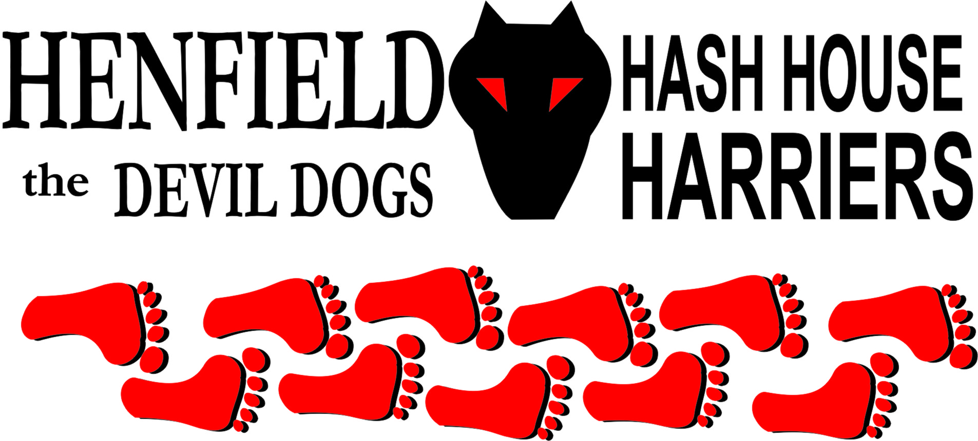

Henfield Hash House Harriers Run #92

Sunday 17th October 2010 11:30 am
Cat & Canary Henfield

Scribe: Snotty

A very sunny October Sunday, was interrupted with a phone call from Auld Banger – definitely not a homing pigeon in her last life! Who found herself at the library – Most people would have just looked in a map. No she blamed a road name change – poor excuse; just sniff for beer!

With Bouncer and Splitpin together with Slash Gordon plus Homer and Mrs. Homer with Hash hound SC – The first on a Hash to be given a name before his first run, SC stands for Scaredy Cat name given after this German Shepherd coward behind Homer after being snarled at by our unassuming feline Gizmo, less than 20% SC’s size but definitely a louder bark!

Cystpit present without Radiosoap but with sprogs Vincent & Louis Bouncer eventually showed with Sprogs ET & Gooie

Mrs. Snot led the walkers with Nightmare carrying the beers and Oome complaining about a bad neck crooked back and one boob heavier than the other could have been excused for shouting ‘The Bells…’

Chris our latest runner was very keen to follow trails false or otherwise – Chris certainly is heading towards a possible Gump name for he just loves to run – Just like Forrest!

Whilst the walkers set off over the tatty fields the runners took off down to Station road and after chasing around some false trails Bollocks led them up the old railway line and a cunning check right where they scoured the field for marks with homer wandering all over the place and the Hare bringing pack back on trail by the bull field, Slash Gordon grunting away disturbed the bulls as they have never heard a human make pig noises, Splitpin was keeping up with the pack and the group went diagonally across the horse field towards Lawyers lane, Chris went down to a cottage – for a cup of tea perhaps? With Slash and Homer going in the wrong direction; until Bollocks called the on on.

A scenic downs view then right towards upper station road, where Splitpin and Hare took a long cut! But found some new virgin trail. However Homer came back from a falsie to join Hare and Splitpin for the trail down to the river, where the walkers had already arrived. Beer was opened and drunk the sun was beating down and the view was sanguine. SC looking at the water wondering if the fish would snarl! ET & Gooie were balancing water bottles on their heads – Bouncer obviously training them for a career in the Circus

The walkers set off in one direction led by Mrs. Snot and the runners in the other, along the river bank past a couple of Swans, cows and the odd fisherman. Homer was leading the pack with Bollocks and Splitpin not far behind and Chris and the snorter – Slash trailing at the rear.

Homer’s lead was soon cut short when he hit an X and returned to the core group to catch up with the walkers just prior to the Tatty field catching Mrs. Homer and Nightmare, following the march of Cystpit, sprog on chest. Bollocks made Mrs. Snot run up the Tatty field much to the surprise of most!

To the On On where the bar was crowded with thirsty Hashers the down downs were relatively easy for yours truly for changing road signs – so says Auld Banger – our resident homing pigeon – NOT! So Auld Banger for finding the library and Oome for impressions of the hump man! SC for his first virgin drink which he took like a true Hash Hound!

Slash Gordon for scaring the bulls with his pig impression, Bouncer just for being there and late, Mrs. Homer and Mrs. Snot had down downs for the first appearance this year, with Mrs. Homer unable to finish her drink due to some foam on the top. Cystpit got a down down for not letting his Sprog see the great views, but his Sprog was able to get a beer shampoo from his unfinished down down. Finally Nightmare for allowing the ladies to carry the heavy beer bags!

Next run volunteered by Bollocks and Splitpin – watch the website.

HashShit goes to Auld Banger – At last Homer is rid of it!

On –On

The Henfield Hash House Harriers cast in no particular order, nor importance to anyone other than the hare:
Hares | Snotty
Runners | Sir Snot, Bollocks, Splitpin, Slash Gordon, Chris & Homer
Walkers | Nightmare, Mrs. Snot, Mrs. Homer, SC (hash hound) Oohme, Auld Banger, Cystpit, Vincent, Louis , Bouncer, Et & Gooie.
Drinkers | All the above
Apologies | Moneypenny – needed to add more poison to the outlaws’ tea!
Large Wildlife | Bulls, Sheep & Bouncer
Twin Town | Who would want to!
Hashshit | Homer

NEXT HENFIELD HASH # 93 to be arranged by – Bollocks and Splitpin – Watch Website for latest details.

