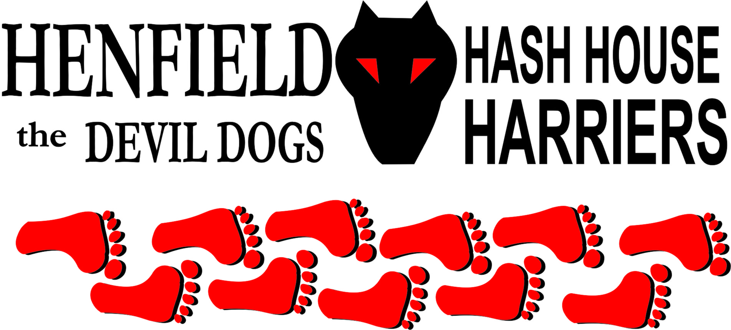

Henfield Hash House Harriers Run #90
Sunday 22nd August 2010 11:30 am
Jack & Jill Pub Hassocks

Scribe: Moneypenny & Tosser with a few barks from Dave

What goes up must come down. We ran up and then ran down….can I go now? No? Start again?? Er hell …

A precision trail amidst ancient walkways, laid by experts after comprehensive research….what do you mean equine excrement? Begin again?? Glory!! Will we never get to the pub!!

The morning, wet and overcast, mist and drizzle, humid, hot, had not put off the usual suspects, with bugger all else to do, who “on-on’d” from the Jack & Jill at Clayton, towards the South Downs, after a debate on car park resources with the manager. (Another instance of the Moneypenny Curse, whereby Moneypenny goes to great lengths to check that the pub know we’re coming, only to find on the day that they’ve been closed down, double-booked or taken over by aliens. Still, at least this time, he didn’t manage to lose the Beer-Stop).,
Snotty sported (sic) a colour not seen in recent seasons, creating style mythology again, in what the jargon would call “visible”. We were off, checking up a muddy Wolstonebury Hill, climbing the pain-inducing punchbowl with the less fit taking the ridge to the Bronze Age Hash earthworks at the top. Stunning views marred only by the dark clouds breaking the horizon. Snotty set off with the runners, but after running to the end of the car park, he claimed to have injured himself in a rabbit’s hole, and spoilt the walkers’ day by joining them. Bollocks was his normal self (pale, wrinkled and hairy). Homer was also on form, getting lost at the second check and having to be rescued by Roadrunner. The runners were shepherded by Dave, assisted by Tosser, and Moneypenny led the walkers (Ooh Me and Auld Banger, who talk the walk, as they say). Split Pin and Angel played a canny game, running gently between checks, while the keen athletes (well, Bollocks and Roadrunner) checked out the wide range of falsies. Bouncer took his brood of bouncelings via a shorter route, to ensure he got to the beer-stop first (although he had his chips later !)

On down! The trail checked out the steepest descent. Roadrunner road tested the seat of his tracksuit with an off-path arse-led trajectory but set the pace as the front-runners circled the hill and checked through a very nice wood where the fast and the slow all met up. Ooh Me tried sliding down the hill on her cag, but found her bum was better. No picnicking teddy bears were spotted. On-on through posh Sussex countryside to the much anticipated Beer Stop, with a choice of 2 beers, softies and crisps ! Well done Tosser for the catering. Pissed down during refreshments but a belch and a fart and the finely honed athletes were on again checking meadows and copse on the last quarter. The final sector taken with untypical focus as concentration on the proximity of the pub overcame all and we were on-in. A splendid outing; well, the hares thought so.

Before being rewarded in the customary manner, proceedings were distracted by Auld Banger’s extra security measure of locking her car keys in the boot. Snotty demonstrated a professional knowledge of lock picking, and Cystpit offered to just put his hand in through the rust, but the Proton remained closed to all before the RAC came to the rescue. A rather crowded and stretched hostelry with the accompaniment of the Count Basie tribute orchestra did not do wonders for the down downs but needs must…… and the circle was held round a table under a dripping tree in the kiddies garden. Chips were priced for the Ritz but half the quantity and a consequent run in with an unrepentant management soured the final stages. A pity as the hash had been good. HHHH is unlikely to grace that establishment again for a while.
(In defence of the pub, they were very busy, and they did keep a room in the restaurant, for up to 20 of us to have lunch, till we got back at 1.15. But it soon became clear that we were a disorganised, ill-dressed (did you see Snotty?) rabble, who were more interested in borrowing things for car-breaking than having lunch. Between the lot of us, we had 2 ploughman’s lunches, which were excellent value, and 2 bowls of chips, which were presumably hand-cut by the manager, as they cost about 50p each! Still, Ryanair would have charged extra for the plates….. The beer was good, but not cheap. Bouncer was invited to finish his chip and leave, which will cost the pub in the long run, as Brighton Hash and Women’s Institute won’t be coming here on a Monday night for quite a while).
Marks were awarded for the run, ranging from less than 10 to 10, so well done the Hares, average score 6.9 as usual.

ON-ON!

Moneypenny, Tosser and a dog called Dave (If only Dave could talk we could get the true happenings!)

The Henfield Hash House Harriers cast in no particular order, nor importance to anyone other than the hare:
Hares | Moneypenny, Tosser and a dog called Dave
Runners | Bollocks, Splitpin, Roadrunner, Bouncer, Cyspit, Tosser, Homer, a dog named Dave
Walkers | Moneypenny,Sir Snot, Oohme, Auld Banger, Angel, Crackerjack, ET & Gooie, Vincent, Louis & Radiosoap.
Drinkers | All the above
Apologies | Nightmare, Slash Gordon
Large Wildlife | Alpacas, Teddy bears on a picnic
Twin Town | Who would want to!
Hashshit | Homer closely followed by the Landlord!

NEXT HENFIELD HASH # 91 to be arranged by – Bouncer in Shoreham– Watch Website for latest details.

