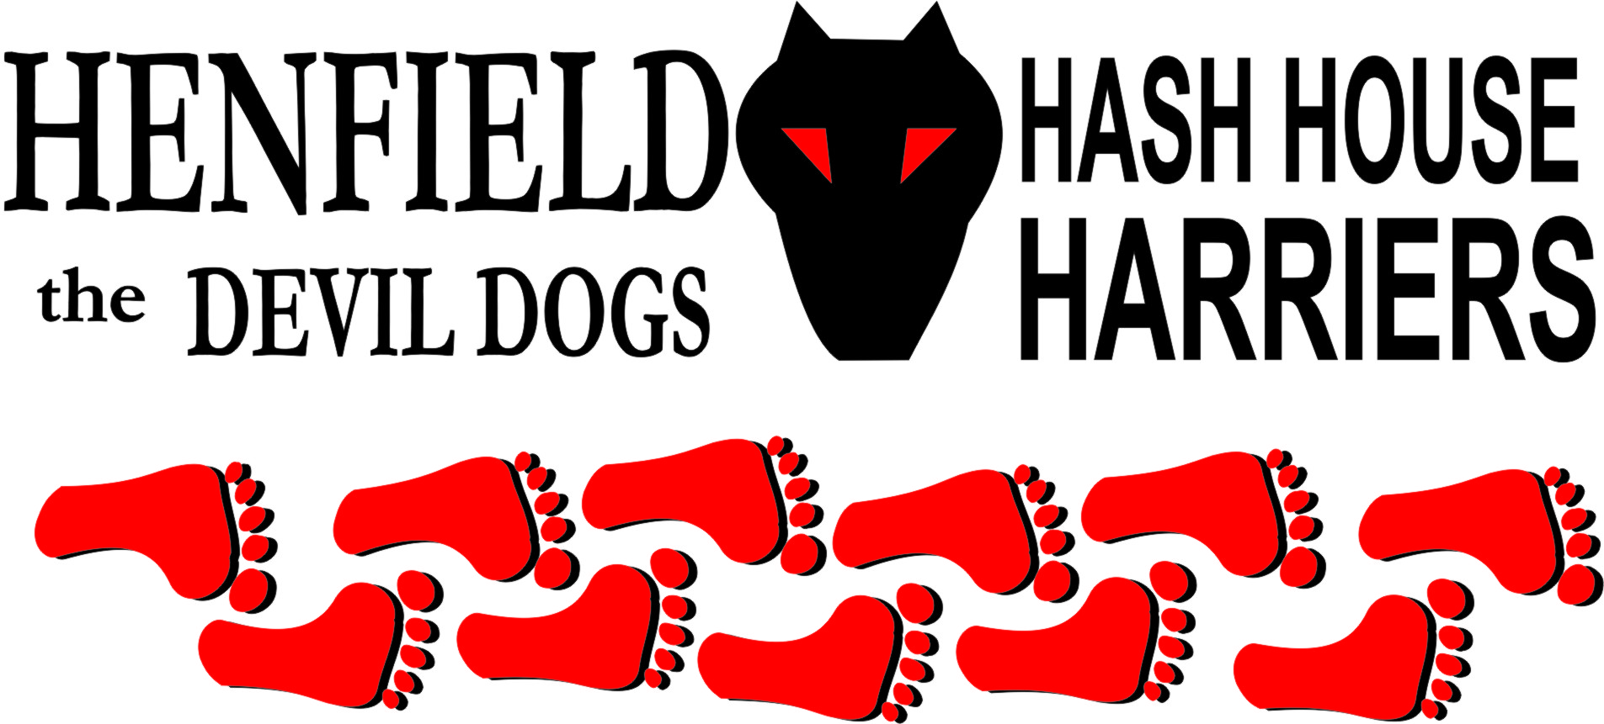

Henfield Hash House Harriers Run #89

Sunday 18th July 2010 11:30 am
Hare & Hounds Cowfold

Scribe: Bollocks

A lovely sunny morning and what better way to waste it than with a H4 run! 11.20 am at the Hare & Hounds car-park and the usual suspects of Sir Snot, Nightmare, Homer and Roadrunner were already waiting for the off. Soon after, Oomee and Auld Banger plus kids arrived, swiftly follower by the elusive Ratstail returning from his new posting as backup Large Hadron Collider in Geneva to take Rat-trap and Monty out for the day. Already the pack was in double figures but the numbers were swelled with the arrival of Tosser, Slash Gordon, Sally, Cystpit, Radiosoap, Bouncer and Angel with a few more kids between them.
Splitpin announced a cunning plan to keep the FRB’s (and basically everyone that was faster than her, which is pretty much everyone) speed down by making all male hounds drink a beer before the run. This was much appreciated and may well become a feature at future runs. Fortified the pack set off with much enthusiasm to seek out the trail. Hounds went south, east and north but failed to spot any marks so were reeled in and shown the true trail North towards the village. Cystpit and Slash Gordon were first onto the second check, Slash trotted off on the true trail whilst Cystpit and Roadrunner sniffed out the falsie. Even though Slash arrived at the Churchyard ahead off the following pack, he was moaning about his lack of pace due to him having already been out on an 11 mile ‘Sunday Penance” run with Henfield Joggers that morning. No sympathy was afforded him and it was rewarding to see him take the next falsie!
The good folk of Cowfold had been out strimming down the trash in the footpaths so the going was good and fast. When a footpath takes a definite route between a fence and a hedge there is little or no chance of going ‘off piste’, so why was Snot to be heard mumbling to himself and anyone else listening that he was looking for rocking- horse shit? Before long he was to be rewarded with plenty of sheep and cow shit so was not too disappointed!
Apparently the early beer had not had the effect of slowing down the FRB’s who stormed off across the fields following true, false and made up trails. Cystpit was spotted miles off trail trying to sneak his way into a herd of Simmental cattle but was spotted by the hare and shamed into returning to the trail. Homer, Tosser, Slash, Ratstail and Snot wisely kept their speed down and allowed the younger hounds to sniff out the trails and then just about managed to keep up. Are there two Cystpits? Starting at the back of the pack after the incident with the cows he was very quickly way out ahead with, Roadrunner trying to keep up. Unable to follow designated marks he shot off south towards a large industrial farm unit whilst Roadrunner wisely sniffed out the true trail down the rural Pond Lane and out onto the main road. One by one the rest of the pack stumbled through the next check, Angel looking a bit red faced and Splitpin acting as sweeper, not out of choice, but lack of pace. The beer in the car park clearly failed to achieve the desired result! The objective was to make it to the beer stop around the same time as the walkers, and it was rewarding to see them appear at said designated stop at the same time as the runners, even though they had completely misread the map and were approaching from the wrong direction. Sir Snot put on his beer-sniffing nose and soon found the stash of fine ales and softies hidden in a hedgerow. A long and leisurely beer stop was enjoyed in the summer sunshine,
eventually an on-on was called and the runners once more hit the trails with the wind in their hair and in Snot’s case in his guts as well. (He chose the Carlsberg, so no wonder!) Bouncer, who had dutifully been in charge of his youngest during the first half and had arrived at the beer stop with the knitting circle, now abandoned his responsibilities and joined the runners for their return route to the pub.
The walkers were sent home in a straight Northerly direction on a trail that even Nightmare could find. Radiosoap managed to get a puncture in the pushchair so Nightmare was denied a comfy ride home and had to walk!
Meanwhile the runners continued apace over field and trail, across polo pitch and stream to eventually arrive back at the pub at the same time as the walkers.
Straight into the bar to order drinks and chips which were consumed on the patio in the sunshine.
Marks for the run were probably 6.9 average.
On –On to Bolney!

Down Downs, awarded for bad behaviour by the GM;

Hashshit – Homer say no more!

On On!

Bollocks

The Henfield Hash House Harriers cast in no particular order, nor importance to anyone other than the hare:
Hares | Bollocks and Splitpin
Runners | Sir Snot, Bollocks, Splitpin, Roadrunner, Bouncer, Cyspit, Radiosoap, Ratstail, Tosser, Slash Gordon, Homer,
Walkers | Sally, Nightmare, Ratrap, Monty, Oohme, Auld Banger, Angel, Shaun, Chelsey, Devlin, Greg, Rosy, Vincent, Louis & Gooie
Drinkers | All the above
Apologies | Moneypenny – needed to add more poison to the outlaws tea!
Large Wildlife | Cattle
Twin Town | Who would want to!
Hashshit | Homer

NEXT HENFIELD HASH # 90 to be arranged by – Moneypenny & Tosser at Bolney– Watch Website for latest details.

