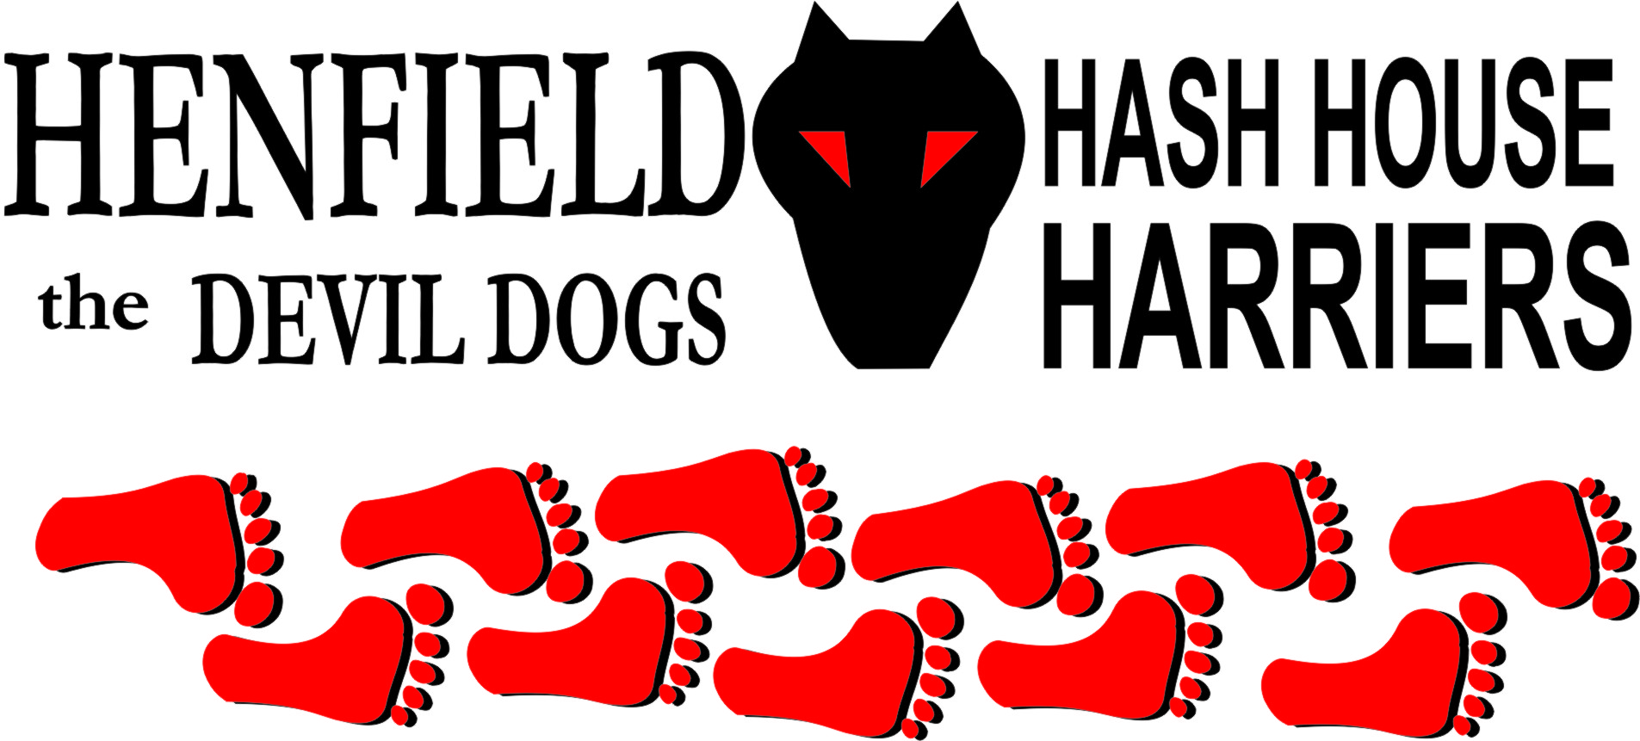

Henfield Hash House Harriers Run #88

Sunday 27th June 2010 11:30 am
Partridge Arms Partridge Green

Scribe: Snotty

A really hot summer’s day greeted the early arrivals with the temperature hitting 30 Deg C, Slash Gordon and Sally always pick the best days even in winter! With new and old runners alike gathered and Moneypenny and Tosser sporting straw hats as if they were attending the Regatta, however water was nearby! We all assume Auld Banger must have finally hit something in her car as no phone call received, or it could have been crushed!

Slash gave final instructions to the young and uninitiated then off we went with yours truly striking up as early trailblazer only to be thwarted by a check. Early on two new circle magnets appeared in the form of David and Harry Bremner it seemed they worked out by standing on the circle until true trail was called or walking with the hare was the way to do things. Younger Bremner can be forgiven as it was his first time, but the old Bremner had no excuse and was heading for an early down down.

The run was a little short of flour but as Slash explained in his woeful Scottish accent the price of flour has soooored recently in Budgens and Sally had to make some cakes later. So the pack had to follow the hares lead on many occasions. No shade and the run took us down to the river then across on a huge circle jerk to take us around back to the same bridge we crossed, Roadrunner who took the initiative on many occasions as his old man Homer was on walking trail, found trail back along the river to the beer stop. Tosser and Keeps it up bravely took the wrong trail on many occasions but as no flour was seen (even on true trail) the two brave explorers were called back on more than one occasion.

Some shade was eventually found and most took time out and walked through the intense Partridge Green heat, the views were serene with cattle scattering as Bollocks, Roadrunner and yours truly ambled through them, the last check saw the Bremner family stuck on the check whilst Splitpin, Tosser, Keeps it up and Moneypenny tried to see any sign of flour, Roadrunner kept going followed by yours truly hoping this was true trail, but not a sign of flour – which could mean we were on trail, guess what, we were! In the distance was the bridge we had crossed once already with the walkers accumulating in the shade.

Eventually we all made our way to the walkers where Sally was ready with Beer, water or Pimms! Plus crisps! Wildbush and Mrs Moneypenny basking in the heat sipping Pimms in the heat of the sun. Well that certainly raised the bar and was a very welcome refreshment, Homer already beer in hand, with Tosser and Keeps it up closing in fast, last was Bremner senior panting like an old mule complaining he was about to pass out – Plus he had run less than anyone else as he had not checked out one single check. Never mind he soon started to recover after a beer. Bouncer showed up some 5 minutes later on his bike – luckily he had a map as he may still be out there looking for any sign of flour!

Homer had hurt his foot some days earlier and when Sally offered to take a small ruck sack to help his foot he agreed – yet two nights before he had struggled around a nine hole golf course with a bag of clubs on his back, without a murmur about his foot – What can we say!

With Pimms and beer just about fully consumed the walkers and runners set off together back to the On On, the day was blazing and the excitement of Wimbledon and England was calling – Well so far Andy Murray got through and England are as the good film title ‘Out of Africa’ as were the USA!

The circle up gave high comments for the run but poor marks for the marking but the mark of 6.9 was salvaged by the superb beer stop refreshment of Pimms, Beer and Crisps – The bar has been raised Champagne next! (Cold of course).

Circle stalkers were awarded down downs and Roadrunner was 15 on this day! Plus his old man; Homer did not give him any money to buy a round for us all – shame on him!

Moneypenny got a down down for not checking the BP oil rig, and chanting ‘You have got nowhere to swim now!’ - A bit harsh!

Two of our crew Keeps it up & Wildbush were off to Interhash next day! Bouncer made the announcement for next weekend’s alternative Interhash in Eastbourne, sporting some wigs for the red dress run, they actually suited him. A cross dresser in the making – hang on to your clothes Angel!

Bollocks and Splitpin volunteered to do the next run on 18th July venue to be decided, expectation is now high after the Gordonflourless Highlanders provided such wonderful delights.

Hashshit – Homer for not being a gentleman and carrying the beer, and we await the return of Cum Lately so he can return the number plate and vessel, which he denies having but we know otherwise!

On On!

Sir Snot

The Henfield Hash House Harriers cast in no particular order, nor importance to anyone other than the hare:
Hares | Slash Gordon, Mrs Slash Gordon (Sally)
Runners | Sir Snot, Bollocks, Splitpin, Moneypenny, Roadrunner, Bouncer (on bicycle) David Bremner, Harry Bremner, Tosser, Keeps it up, Wildbush
Walkers | Homer, Sally, Mrs Moneypenny
Drinkers | The above plus Angel, ET, Gooie & Crackerjack
Apologies | Oome – Too much work not enough play
Large Wildlife
Twin Town | Who would want to!
Hashshit | Homer (Ungentlemanly conduct) – Red Card!

NEXT HENFIELD HASH # 89 to be arranged by – Bollocks & Splitpin – Watch Website for latest details.

