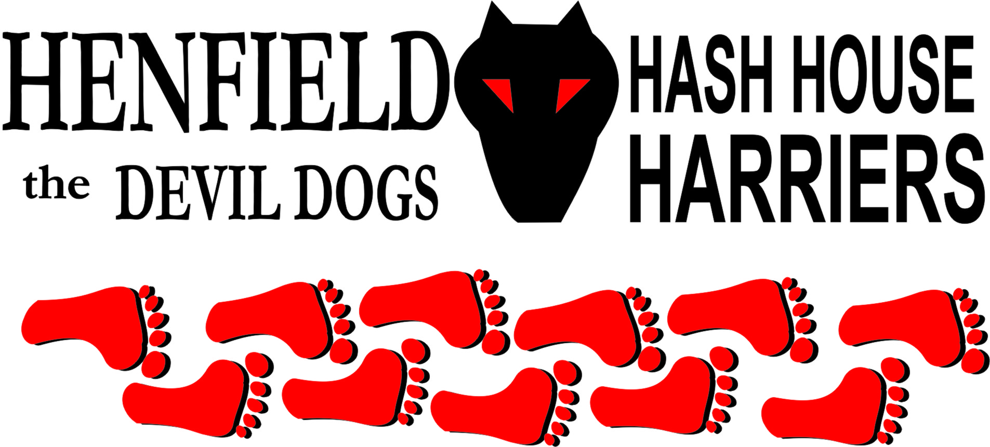

Henfield Hash House Harriers Run #85

Sunday 21st February 2010 11.30 pm
Castle Hotel Bramber

Scribe: Bollocks (Co Scribed in areas by Snotty)

Mad dogs and Englishmen go out in the mid-day sun…. but only Henfield Hashers go out in the cold February rain, we call this raining for you USA readers cats and dogs or for any UK hash cats and hounds!

Sunday morning was wet, very wet! (Just short of a Sunami to set the scene). This would not have been a disappointment if Splitpin and myself had not spent four hours the day before setting a long and challenging trail for the Sunday hounds to chase. A flurry of texts and calls to and from Hash Central (Snotty’s bedroom) finally confirmed that the run would take place, although it would be shortened to avoid un-necessary suffering to the hounds.

So we drove out and stashed the beer at the new beer stop and went to wait in the car park for the hashers to arrive. - First up was Old Banger, proudly displaying a trailing fender, the result of some reckless behavior the previous evening. She was quickly followed by Moneypenny with Mrs M and ‘new boy’ Tosser. Then the rest of the rabble soon arrived and one by one we all assembled in the bus shelter attired with brolley’s (Umbrellas!) for briefing and to offer up a futile prayer for a break in the weather.

The hounds (walking and running types) were told of location of the new, unmarked beer stop. ‘ It is on the railway bridge, next to the sewerage works, the beer is stashed underneath for the first arrivals to retrieve’. Shimple, as meerkats say. So on-on to the run ….

Heading off on a falsie the entire pack failed to spot the cross and sped off towards the castle. Slowly it dawned on the slower runners that the hare was calling them back for a reason and one by one they turned and headed back to the check. Apart from Bouncer who was chasing an imaginary trail and disappeared up the track to the castle and was soon out of sight. Never mind.
The second check found Homer out on his own heading for Upper Beeding, Road Runner heading for the coast and Cispit heading off on the correct trail into the shiggy of the river levels.

Homer was called back, but failed to make the connection that the stragglers heading out to the fields were on the right trail, made a left turn back at the check and was off on another falsie. The hare went back to rescue him and found him wandering around aimlessly, with a by now re-appeared Bouncer, in a puddle at the end of the lane.

Roadrunner cleared the first two huge water crossings with a leap only to find out the third was futile and he followed Snotty through the quagmire and once wet al was comfortable and squiggy and f*&*%^$ freezing.

Suitably verbally chastised Homer and Bouncer followed the hare back onto the trail and off through the mud and water towards the river.

Arriving at the bridge which was the site of check 3 it was obvious that Cispit had failed to find the true falsie but had picked up the on-in from the now abandoned long trail and had set off at pace along the river bank. Slower, wiser, hounds were encouraged by Splitpin to investigate a trail to the left… Off went Tosser to check 4, got it wrong and this allowed most of the pack to catch up. Cispit, half a mile away finally turned to see no hounds were following him and hastily retraced his track to the bridge and eventually caught up as the pack entered the mean streets of Bramber.

Snotty had stopped at each bridge claiming this must be the beer stop, but alas his weary legs had to take him further.

Homer after his initial wrong guesses decided to stand in the middle of the check until true trail had been called – This was a little lazy even by Sir Snot’s standards which are pretty low!

This was virgin territory, several hashers looked nervous and out of their comfort zone, but bravely tested each check point whilst keeping the rest of the pack in sight – Even Snotty! Whilst the youthful Roadrunner checked everything at 100 MPH. – Too keen - a few beers and old age should cure that!

Over the 283 and into Steyning where there was little sign of life, the masses were either at church or in the pub. On around the twittens and then back over the 283 into familiar shiggy, and on to the next check at the electricity distribution station. Moneypenny, our very own professional industrial safety engineer was heard to enquire if this was the sewerage works. This obvious lack of understanding does go some way to explain how he is often in demand to offer his expertise to the Middle East. – Use your nose - the sewerage you can smell – get it!

Slash Gordon bravely ran the falsie and despite calls to return was soon out of sight. The time it took him to re-appear suggests he was living up to his name and relieving himself of excess weight in the bushes.

On over the stream, up the slippy slope to the railway bridge (minus railway!), and the long awaited beer stop. It was expected that the earlier arrivals would have located the beer as per the instruction proffered with unambiguous clarity at the bus shelter. But no, Cispit had run straight through and was going like a train towards the Downs Link tracks. Road runner as the only hound with any speed to match Cispit was sent off to reel him in. Bouncer had also missed the scent of beer and had gone through the stop, as had all three of the knitting circle, Mrs M, Ooomee and Old Banger!.

Our ex Royal Naval First mate Oohme maybe able to guide a destroyer to it’s target on the ocean but flapping the map in the wind and using the damsel in distress bit with Bouncer was an incredible feat of navigation where the alternative map must have been on the Bouncers tongue which he used as a USB! A case of getting Starboard and Beer Port confused! Incredibly both Oohme and Auld Banger had more mud on their boots than some of the runners! Apparently Auld Bangers driving is of a similar vein!

So a small thirsty group set into the beverages while they waited for the errant hounds to return. Thankfully Snot did not try and sing, but Bouncer did get a couple of verses of something lewd out before he stuck his snout into the beer.

Snotty kept uttering the fact that he had stopped at every iron bridge looking for beer, plus the point was made that someone had nicked the railway line!

Dark clouds loomed over the pack and suitably refreshed they turned for the final run back to the pub. As we passed a lone hiker Sir Snot suggested we relieve him of his beer and waterproofs. In the true spirit of the hash we left him alone which may have irked Snot, but was a good decision as he did not look to be carrying anything worth harassing for.

Back at the car park sodden hashers discreetly removed layers of wet clothing and put on dry and clean apparel suitable for the pub. All that is except Snot who put on a shocking display in front of several frightened and bewildered citizens by stripping down to his underpants and showing off his substantial rear end. However as he turned round one of the female occupants of a nearby car was seem to break into a laugh as he showed off the effects of extreme exposure to the cold on a male appendage.

On on to the pub where a jovial landlady offered us the use of her restaurant before eyeing up Bouncer and suggesting we use the back room where any mess was easier to clean. A quick circle up. Very high marks for the run, probably 6.9 again. Extra marks obtained for a rain break at the beer stop! Down downs for the hares Bollocks and Splitpin, Homer for checking chicken, Moneypenny for scaring us with his inability to identify electricity, map flapping by Oohme and yet another dent on Auld Bangers car! Road runner for trying to keep dry, Tosser for having a crap name and Cispit for just being there, Bouncer for constantly interrupting the GM. Mrs MoneyPenny for having to double as MoneyPenny’s nose, Slash Gordon for continual grunting on the run!.

Finally Hashshit award stays with Homer for acting as checking statue!

Bollocks.
On On!

Snotty

The Henfield Hash House Harriers cast in no particular order, nor importance to anyone other than the hare:
Hares | Bollocks and Splitpin
Runners | Snotty, Homer, Bouncer, Tosser, Slash Gordon, Moneypenny, Roadrunner and Cesspit.
Walkers | Ooh Me Bladder, Auld Bange and Mrs Moneypenny
Drinkers & Hounds | The above + Angel + Crew
Apologies | Cum Lately (another excuse – Don’t ask!)  Forrest (for living in France).
Large Wildlife | Customers at ON ON
Twin Town | Who would want to!
Hashshit | Homer

NEXT HENFIELD HASH #86 watch the site this will be in Burgess Hill

