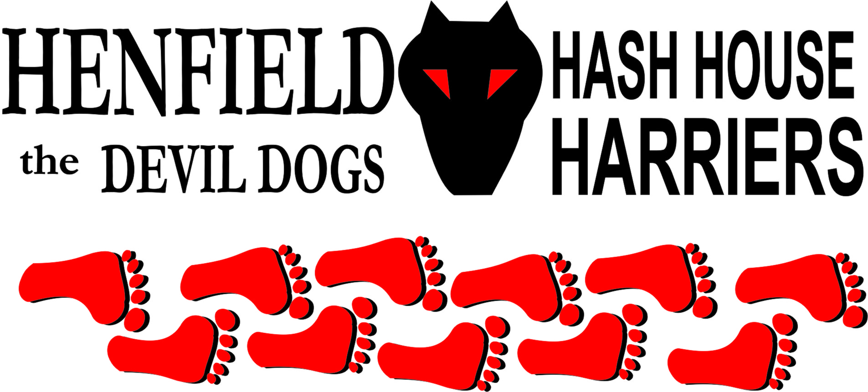

Henfield Hash House Harriers Run #83

Friday 11th December 2009 7.00 pm
The Plough Henfield

Scribe: Sir Snot

It was the Henfield late night shopping, or maybe a crowd had collected as they had heard about the infamous H3 where people wear shorts in – Deg weather and for this night only were sporting some exciting headwear. Well it appeared Bouncer enjoyed himself bring several hats one for each pub. Or maybe he just did not want to be recognized or picked out the line up at the police station.

In actual fact 3 policeman were seen on the high street earlier that evening, yes proper ones not community (part time) police. I offered to take a photograph and they were a little bemused as to why a man wearing a tribal hat and shorts wanted a photo of 3 policeman, until I explained they were a rarity and just like buses, never one around when you want one and all of a sudden they all turn up together, when I asked if this was the entire West Sussex contingent on a Beano they started to walk away. Somehow the humour chip had been removed from these three plods as well as the facial muscle that causes a smile!

In the Plough at 7pm I was all on my own sporting my tribal hat, much to the amusement of the punters. No one else around – Not even Cum Lately (What a surprise), so off I went to NK hair to grab a glass of Champers to pass some 10 minutes or so and amuse the incumbants. Back to the Plough and a punter told me two women had been looking for me, after I clarified if they had weapons to which fortunately they replied a negative they described ladies were also wearing hats! Which I concluded must have been The Old Banger and Tamsin (Soon to be renamed Ooh me Bladdah).

After retrieving the girls, I rang Homer only to find he had forgotten to read his e-mails and not realized the date had changed, he said he would get out of bed and come to the Hash!- A true Hasher! Eventually Bouncer showed up with Cispit a bag of hats, modeling them all, from cows udders to everything disgusting that at least thrilled the drinkers in the Plough. Bouncer even offered to sing but we all passed on that one. Bollocks and Split pin showed up with Christmas hats with Bollocks moaning about the change of date! Then Ratstail came in dressed as an Arab and the pub evacuated to have a cigarette outside just in case he was a suicide bomber, but after a quick breaking of wind and no Monty to blame it on he took off his sun glasses to reveal who he was! Then Mr & Mrs Moneypenny came in followed in the rear by Angel from Brighton.

So from 0 to 9 the trial of the six pubs was about to begin, now everyone had ordered a meal, which would be ready when got back, we all made our way to the George where a singer was trying his best to dampen the village spirits, but things took a turn for the better when Sir Snot gave a rendition of the only song I know, then one verse of a hymn followed by over the hill and faraway, well I guess that is what everyone wanted. But the pack was held back when Tamsin – Soon to be Ooh me Bladdah did some fancy footwork on the dance floor and yours truly dancing with Ratstail – Good time to leave. The pack followed the trail around the back while the wiley hare Old Banger and Ooh me Bladdah took a short cut to the Gardeners, where Homer appeared next to Irish who has been glued to the same seat for at least 5 years! I was going to give Irish a mark for attendance if only he could get off the stool – But no, not this month!

Next with a few checks in between we made it to the Cat and Canary where an old East London boy with a nose to match wore his old cobbers hat and took a down down for the hell of it. Bouncer was now well on song carrying his mug around, and Ratstail was hoovering down well. The pack left onto the 5th pub in the circuit where piggy backs were the order of the night, somehow I got left out of this one but Tamsin was feeling the pressure when part way down she shouted ‘Ooh Me Bladdah’ well the rest is history. The Bell was the roughest pub on the run, this was easy to tell as the cats had dustbin lids on their heads and the barmaid had a bullet proof vest on her head, leaving her brains exposed. The pool table was on bricks and all the glasses were chained to the bar! This was probably the shortest stay as someone gave Ooh Me Bladdah a dirty look and she nearly decked him!

Onto number 6 – The White Hart where the owner of NK was hoisted up to the bar and Homer and I were given a quick snog but her chest saved us as it was only a brief lip encounter before we were bounced away! Jokes and songs exchanged we eventually made it back to the Plough where beer was ordered and food was brought out as promised! Plus one more attendee from Brighton.

Circle up (seated) was arranged and marks for the run/walk ranged from 6-9 giving the good average of 6.9. A naming was imminent and so it was that Tamsin will be known from this point forward as ‘Ooh Me Bladdah’ or Oohme for short, (who said she is short!!) –That’s me decked next time! A new Hashshit has been supplied to the H3 – courtesy of Ratstail – a Life Jacket – Just in case Oozing comes over again! The proud person who wears this for the first time is Homer for forgetting to turn up, albeit late after a phone call! Where was Cum Lately – interviewing a maid – The excuses he comes up with, is just constant Hashshit material and if he is reading this we want our number plate back – we know you have it!

Well all had a good time and managed to get home safely as far as we know.

On On!

Snotty

The Henfield Hash House Harriers cast in no particular order, nor importance to anyone other than the hare:
Hares | Sir Snot
Runners | Old Banger, Ooh Me Bladder, Bollocks, Splitpin, Homer, Ratstail, Bouncer, Angel and Cispit
Walkers | All the above + Mr & Mrs Moneypenny for part of the way!
Drinkers & Hounds | The above + Cispit
Apologies | Cum Lately (another excuse – Don’t ask!)  Forrest (for living in France).
Large Wildlife | Henfield Late Night Shoppers
Twin Town | Who would want to!
Hashshit | Homer for coming almost undressed!

NEXT HENFIELD HASH #84 watch the site. Walking Hash jointly with no-one but ourselves at the Jack and Jill car park Ditchling January 1st at 1:45 – Hare Ratstail and Rattrap, if it rains its off! (Ratstail instructions)

