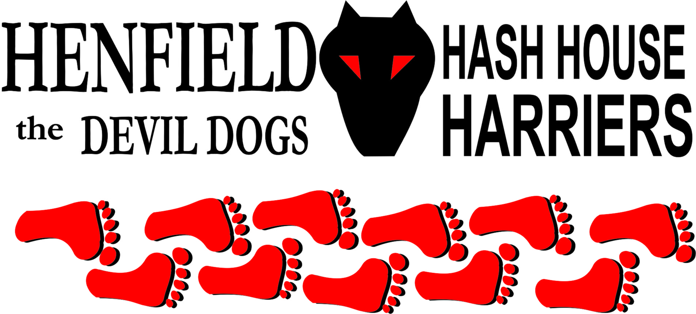

Henfield Hash House Harriers Run #82

The time: Nov 15th, Sunday, 11.30 pm.
The place: The Fox pub, Small Dole, briefly!

Hash sponsor: Grumpy, the landlord of The Fox

Scribe: Moneypenny & Snotty

Well, The Fox seemed like a good place to have a run from, with some good paths and lovely views, to the south of Henfield. Snotty went to see the landlady, explained what we were doing, and booked a table for lunch. The Hare also phoned the day before, to check that the pub had not been washed away by the storms and gale force winds on Saturday, and arranged with the landlady to park at the far end of the car park from 9.30am.

Sunday came, and the sun was shining, so your Hare set off to the pub with a song in his heart, a spring in his step, and 3 bags of flour in his flour-sack. After setting up the Beer Stop (with a choice of soft drinks for the softies!), Hare parked as agreed, grabbed his sack, and was then faced by the landlord, wearing a butcher’s apron, waving and shouting that “You can’t park there!” After some discussion, Mrs. Landlady came out and told the silly sod that we had arranged it with her.

Hare then went off to set the trails for Runners and Walkers, and returned at 11.30 to find 13 2-legged hashers, plus Monty the hash-hound, waiting eagerly to run/drink/walk. Malibog was welcomed, as our first visitor from the Stockholm Hash (sadly, he did not look like the blonde one from ABBA). But there was more excitement over parking, and Snotty went into the pub to smooth over the problem, using his diplomatic skills. As a result, we all had to rapidly move our cars out of the car park, and the On-Inn was moved to the Plough in Henfield.

We carried on with the Hash, and 7 Runners set off, followed by 6 walkers, led by Mrs. Moneypenny as the Walking Hare (Rabbit?). The route took the pack across the fields, with the runners having a lovely long stretch of river bank, some of which was not under water, and the walkers cutting across by a shorter route to the Beer stop. A bit further on, the runners had to get across a water jump, as the river was overflowing – a stream 4 feet wide had appeared since Hare set the trail 80 minutes earlier!

Ratstail was complaining about the lack of crosses on the falsies, which was a nerve after the last hash he set! Moneypenny got his revenge by letting Ratstail and Bollocks run the wrong way up the walking trail, not long before the beer stop. The Hare admits that there was a trail of flour marks, but they should have noticed that the flour was pointing in the other direction! Split Pin thought this was really funny, until she realised that it was Bollocks and not Bouncer who was heading off into the distance. Luckily, they met the walkers coming the other way, who rescued the poor dears.

The walkers got to the Beer Stop 5 minutes after the runners - good work by Mrs. M, who had never seen the route before, and just had a sketchy map to follow. The younger walkers enjoyed Coke; while the runners moaned about the cheap Tesco beer (didn’t stop them guzzling it down). Snotty adds; This came awfully close to the Cum Lately sample bottles of the past, but a few attempts at vocals from Snotty and Bouncer were soon brought to a halt.

Showing unusual keenness, the runners set off again in a group, heading towards the road, despite a complete lack of flour. But Split Pin sussed out that the route was backwards from the beer stop, following the walkers trail back to minimize road running, and she stayed in the lead for the next half-mile. Snotty adds; Yours truly led the pack for most of the way home only to be caught by Bollocks – our new Mr. Gadget, with a milometer on his wrist, which at one time was the portable TV from his bedroom! But with heart rate monitor, blood pressure check, cholesterol option, built in urine/alcohol checker and self resuscitation kit, the optional extra of blow job simulator was apparently too big to manage and doubled up as an oxygen aid! His arm was dragging along the floor for most of the run but the muscles were starting to develop. It did not give the time but accurately recorded the run distance at 69.69 yards. – Incredible 1980’s technology! (Downside car battery was a bit of a burden on the other shoulder)

The trail then led back to the Fox, but we all shot off to the Plough in Henfield instead, where the landlady was very welcoming (despite knowing Snotty). Snotty called the Circle to order, and awarded down-downs to the Hares, and the visitors, including Malibog and 2 junior walkers
Marks for the Run were surprisingly high, ranging from 2 out of 2 up to 12 out of 10, so an average of 6.9 (again). Negative comments were: too dry, not enough water, not enough mud, and why was there a big puddle just before the Beer Stop? The answer - to wash your feet!
A rare event then occurred - a Naming. Cheryl now rejoices in the name - ‘Old Banger’. (Does this mean that if she comes 10 times, we can trade her in and get £2000 off the price of a new model?) – Apparently she likes mash – which she might make Moneypenny into!

Snotty adds; Cum who? Not seen as well as Rumpole – not sure what the excuse was? Our drinking does need working on with the exception of Malibog, Old Banger and Tam (soon to be named), but more to it Devlin and Shannan, made Mrs. Moneypenny crying in her coke! These youngsters have been well trained by our experienced drinkers – Very impressive. The Moneypenny’s although setting a good run need more practice on the down downs, we know you don’t like to swallow but this was only beer and coke!

The GM forgot to award the Hashshit to anyone, again. Therefore he can have it back from Moneypenny. Snotty adds; However the award is handed to Homer who went to Southampton to watch a football match against Brighton and told Road Runner to stay at home and do his homework! – Child action line has been notified!

Next run changed from 18th December to 11th December in Henfield village – more details to follow on transport. It is late night shopping in Henfield that night so best hats will win prize! Plus this will be the Henfield 6 pub hash with trail and twittens in between.

Plus Ratstail offered to set up an unofficial Hash on New Years’ Day, probably at Jack and Jill . (Check Hash website for exact details, and dress code)

On On

The Henfield Hash House Harriers cast in no particular order, nor importance to anyone other than the hare:
Hares | Moneypenny and Mrs Moneypenny
Runners | Bollocks, Split Pin, Moneypenny, Bouncer, Malibog, Ratstail & Sir Snot
Walkers | Mrs Moneypenny, Tamsin, Old Banger (née Cheryl), Shannon, Devlin & Rattrap Plus Monty (Hash Hound)
Drinkers | The above
Apologies | Homer, Nightmare,  Angel and brood. Forrest (for living in France).
Large Wildlife | Cows, a horse’s backside
Twin Town | Stockholm
Hashshit | Homer for Child abuse!

NEXT HENFIELD HASH --
- 11th December at Henfield– watch the website.

