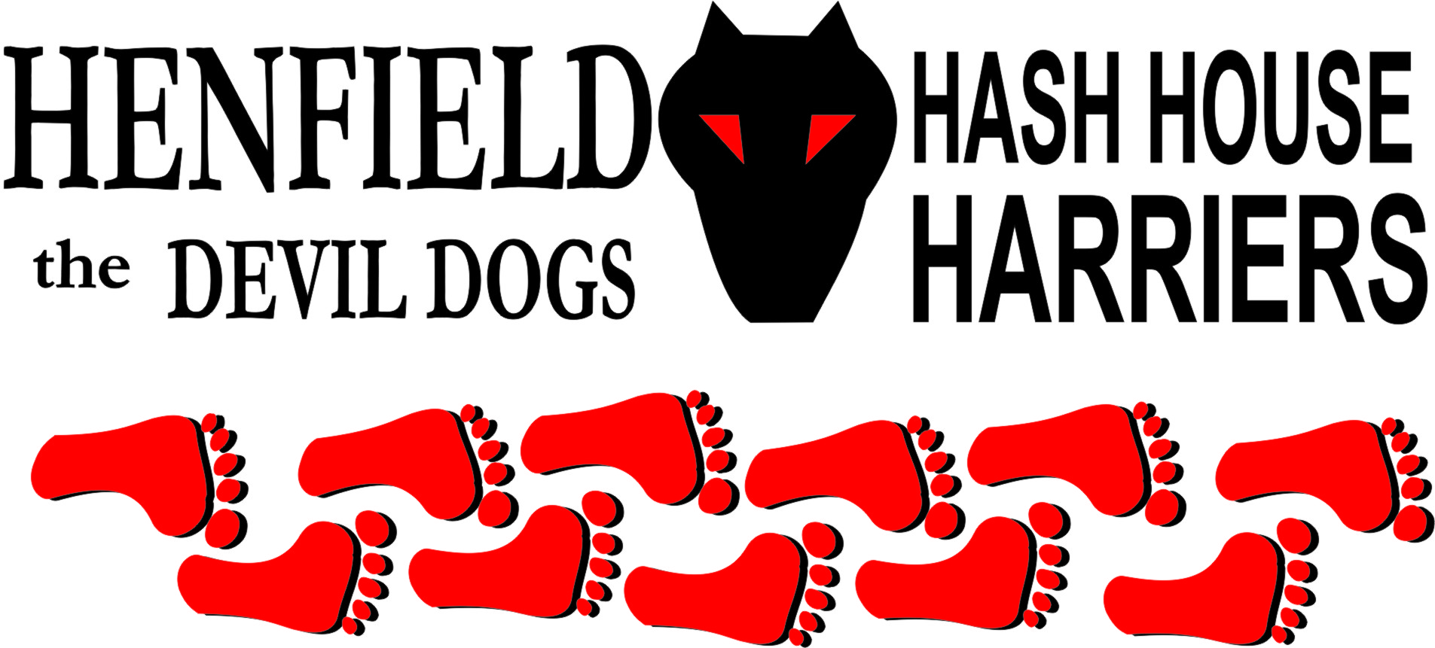

Henfield Hash House Harriers Run #81

Sunday 18th October 2009 11:00 am
Duke of York Sayers Common

Scribe: Ratstail (Aided by Snotty)

After a lengthy briefing by hares Ratstail and Rattrap, c/w warning about possible back-checks, no falsies marked and how all the flour was used up on the first three marks, a suggestion of a handout was muted for Ratstail’s next run, the walkers had easier instructions – just follow the walking hare – Rattrap, finally the pack set off on what was promised to be a short run. Before the start we had been treated to a blow-by-blow account of Homer’s Great North Run just to get us ‘in the mood’.

As ever, the sun was shining on the Hash – so we all posed for a photo to prove it! The runners headed towards the A23 through the Berrylands housing estate. After a quick check it was On On, over a style towards the dual carriageway. Fortunately it was a back-check to the old A23, as the footpath actually crossed the full dual carriageway! Bollocks at this point was questioning the Hares credentials with all these non Henfield markings and suggested a trip to Nightmares proctologist (Bum Doctor) to see if he could cut the crap!

Back on trail, we then turned west, passing an old priory and heading out into flat, picturesque countryside. We were treated to a 200 metre race between Roadrunner and Slash Gordon – which Slash lost – but only just! Then on through New House Farm (home of the local Greyhound Rescue). Unfortunately no room for any more old dogs...... so Snotty was allowed to continue on the run (which remarkably he was leading at the time!) Singing I am Leader of the Pack and call me Gary! – see photo album.

Roadrunner after starting well used the ‘I have got to retie my laces’ routine at all the checks as his Dad had only ever bought shoes with vacrel straps. Briefly on to Twineham Lane, at which point we realized that 2 of the 9 runners were missing – Moneypenny and his Brother-in-Law. No surprise there I hear you say after Moneypenny’s performance on the last Hash. Slash Gordon ran back and found that Moneypenny’s Brother-in-Law had refused at a jump and pulled up lame – and that they were heading back to the pub - A likely story (about him being lame not that they were heading for the pub). Note to GM: What’s the punishment if Moneypenny fails to complete the next one – which he’s setting? (Response – Lifetime Hashit award!)

After a quick re-group at Great Wapses Farm (waiting for the Hare!) and a few check points, the pack headed back East to the Beer Stop where we met up with the walkers and Monty, we were treated to beer, snacks and another blow-by-blow account of Homer’s Great North Run.

Having been treated to nice beer the Hare was enthusiastically running off, whilst Splitpin, Bollocks, Homer and Snotty were all breaking wind and belching trying to de-gas before the final part of the run.

On On, heading South East, past Stuckles Farm, though some woods and back to the edge of Sayers Common. But there was one last treat in store for the runners (apart from SCB Snotty who prematurely headed for the pub) who were artfully led to a bridge over the A23, where there was another back-check, but this time to the pub. The run was approx. 5.75 miles and walk 3.5 miles, so quite a respectable distances.

Snotty addition;
Down downs followed at the pub, where we were joined by Bouncer who found Snotty on his way back and commented well you are either the first back or last! – Bloody Cheek – Initiative is what we have in the H3! In case anyone had missed it we were treated to a blow-by-blow account of Homer’s Great North Run – this time in glorious Technicolour as he was wearing his medal and souvenir T-shirt – while he lifted ££££ of us of sponsorship money. The run came out with a mark of 6.9 mainly due to lack of false marks and lack of flour. Notable absentees were Cum Lately and Rumpole.

Moneypenny and Brother took off before the circle up, hence Moneypenny was awarded Hashshit for this act. The Hares had down downs and were quickly followed by Bollocks paying more attention to his other half Splitpin than the circle and Slash Gordon for making funny animal noises and scaring Snotty in the rear (ask no questions). Roadrunner for using the ‘Got to tie my laces up’ at each check even though he had vacrel straps!

Then Tam and Cheryl, for ordering and consuming a complete Sunday Roast before the circle up had concluded and if you think they can eat, well they made the Down Downs vanish in 3 seconds flat, and commented perhaps they should down pints whilst the ‘boys’ used halves!
Now – naming time is approaching and one or two names are warming up, perhaps as they always come together perhaps Suck and Swallow comes to mind or some derivation there of – But these two will outdo any hash drinker I am familiar with – even Bondo from RI Hash! OK well keep rattling those brains to see what names you can be creative with!

An unusual ceremony took place of naming as yet a virgin runner, it is Homer’s German Shepherd Saxon, after being chased down the road by Snotty’s cat - Gizmo snarling and giving him the paw! We have re-named this Hash Hound ‘Scaredy Cat’. We all look forward to meeting SC on one of our future runs! – It’s OK because Gizmo is lazier than his master Rumpole so no chance he will ever be seen at a run. – Just keep clear of the sheep!

Bonus ball: – Cheryl and Tam ended up with free lunches after they were served cold roast potatoes, now they must have been cold as they had no time to lose heat from the time they hit the table to actual consumption – who says ‘there’s no such thing as a free lunch’?
And finally, in case you haven’t heard, Homer successfully completed the Great North Run. Well done Homer! 15 bodies in all including Bouncer and Hash Hound Monty!

On On!

Sir Snot

PS Photos even ones of Cum Lately back in 2004 can be seen at; http://www.henfieldh3.co.uk/Photoalbum1.htm or just go back to the website and go to Photalbum link

The Henfield Hash House Harriers cast in no particular order, nor importance to anyone other than the hare:
Hares | Ratstail, Rattrap and Monty
Runners | Sir Snot, Bollocks, Splitpin, Homer, Moneypenny, Moneypenny’s brother (Dave), Slash Gordon, Roadrunner,
Walkers | Nightmare, Rattrap, Monty, Cheryl, Tam.
Drinkers | The above plus Bouncer
Apologies | Cum Lately (another excuse – Don’t ask!)  Rumpole
Large Wildlife | Horses and Ratstail
Twin Town | Who would want to!
Hashshit | Moneypenny

NEXT HENFIELD HASH # 82 to be arranged by -- Moneypenny - 15th October starting from the Fox in Small Dole (South of Henfield)

Hash # 83 on Friday 18th December 7pm start – 6 Point pub run/walk/crawl – whatever. Hare Sir Snot

