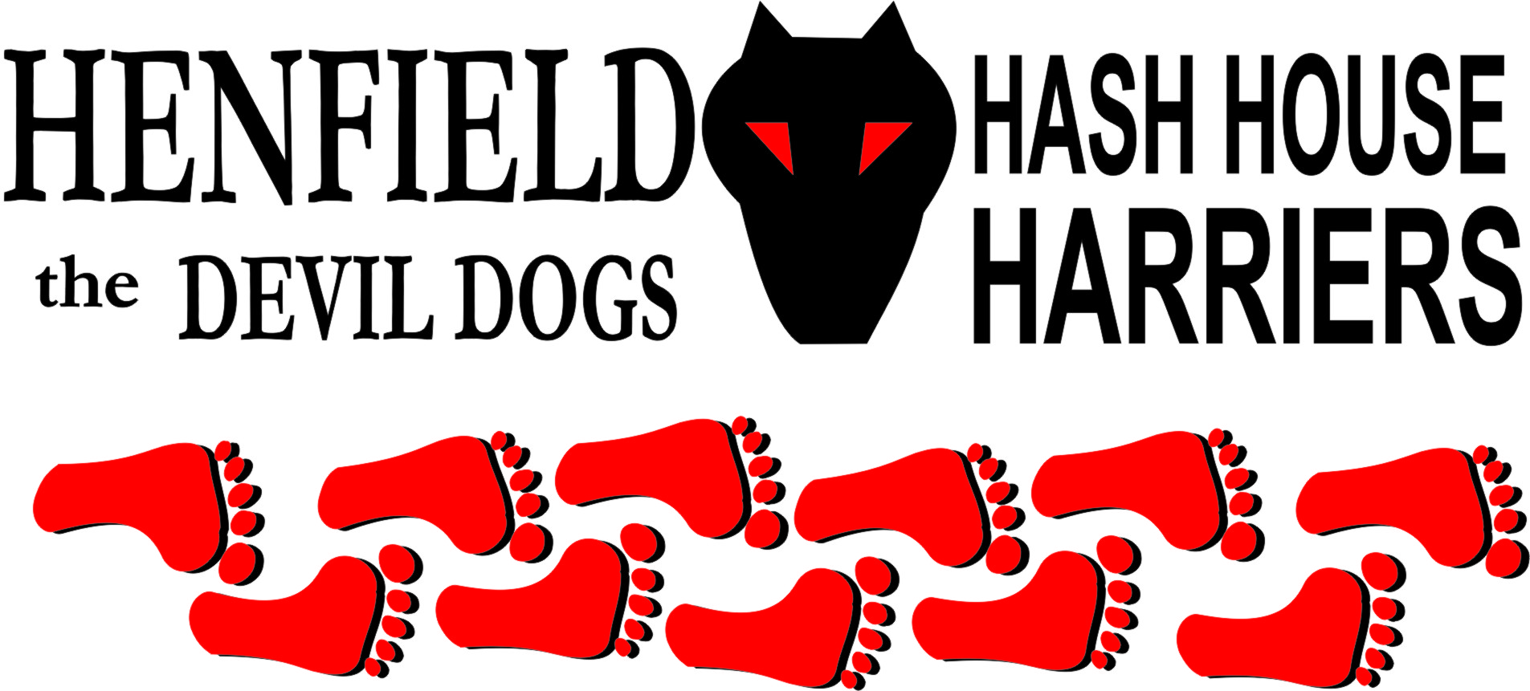

Henfield Hash House Harriers Run #79

Sunday 9th August 2009 12.30 pm
Washington – Franklynds Arms

Scribe: Bollocks

The recent interest in the Henfield Hash, with turnouts in the high teens (not including dogs) meant that the Hare felt it his duty to ensure sufficient amber fluid at the beer stop. So on a hot Saturday afternoon he stuffed a rucksack with large cans of ale, trudged to the top of Chanctonbury Ring and stashed the grog in the trees ready for the salivating hounds arrival on Sunday.

So it was a tad disappointing when on Sunday at 12.30 only 9 bods and one dog turned up at the Frankland arms in Washington. But hey, a Hash run with Henfield H4 is an unpredictable event and those that made the feeble excuses missed a great run.

Whilst on the subject of excuses special mention must go to Rumpole, the strapping athletic offspring of the HM who wimped out yet again due to an overdose of Smirnoff (allegedly) and therefore unable to rise from his pit in Brighton.

Cum Lately ( Bsc Hons) advised from his Blackberry device that he was on a family holiday in Vladivostock with Olga and the young Putin.

Moneypenny was doing as he was told and visiting family, again. Nightmare just didn’t turn up.
But we don’t care about them! Those hounds that did turn up were fairly champing at the bit and keen to get away, so the pack was split into 6 runners and 3 walkers.

The walkers, Splitpin, Rattrap and Lucinda strode away in the direction of Chanctonbury whilst the runners, Hare Bollocks, Sir Snot, Ratstail, Homer, Ollie (soon to be named!) and Jerry set off on a circular tour of the village to get warmed up before the big push to the top!
Ollie soon found the trail and disappeared into the green somehow managing to find every correct trail and thus giving the other hounds little to do other than keep up. He soon got confused after crossing the 283 and was unable to find the trail which was in fact on a well worn footpath. This gave Snot the chance to become a temporary FRB and he led us across the field to the track alongside the sand pits. The next check had all the hounds bar Ollie hanging around waiting for someone else to call the on-on. Ollie was on a falsie and Snotty again set off as alpha hound on the correct trail but was soon relegated to his usual position after taking a falsie down the A24 underpass.

Jerry had a grumble about stinging nettles. Ratstail and Homer soldiered on without complaint.
Onwards to the village through a field of Longhorn cows who looked up from their grazing with indifference as the pack ran by. Here Snotty first began to fail. By the time we were back over the Village road and heading towards the hill he had started to trot out a list of ‘problems’. The main ‘problem’ it seemed was to do with having kneeled on his nuts and something to do with a big swelling. “You cannot ignore the evidence of a swelling” he insisted, but none of us could see that any part of his exposed anatomy was any larger than it usually is so the bit in question must have been hidden.

[At 10.30 that morning I had phoned him to remind him to wake Rumpole from his coma, and he was still in bed and annoying Mrs. Snot. My guess is that shortly after this the incident of the ‘kneeling on the nuts’ took place and this was the cause of his discomfort.
I will check with Jackie later. Good girl!]

Onwards, upwards, time moving on but the pack kept with the trail and eventually were rewarded with a fabulous view over Sussex to the North of the Downs. Beer was enjoyed without haste but finally we had to move on. Runners were a man down as Snotty gallantly volunteered to accompany the walkers back down the hill and to carry the remaining beers.
Un-furred by ale, Ollie took the lead and soon we were heading down the hill. Homer told tales of great endeavor to his lad, recalling how he had run up the same track during a famous athletic event 2 months earlier.

The next check saw Jerry and Homer take a falsie and not return, whilst Ollie and Ratstail followed the flour and only their calling of the on-on managed to get the errant hounds back on trail.

Back along the underhill, through some shiggy to the clover field and then on to the pub.
We commandeered the circular smoking hut for our beer and food venue.

Marks for the run were extraordinarily high. Hares Splitpin and Bollocks had down-downs, as did Jerry for being a returnee. Ollie was banished to the toilets whilst a name was discussed. Shame he is still of tender years as all the rude names were disallowed and finally the pack agreed on ‘Road Runner’.

Sir Snot pulled a grubby notepad from his pocket and gave us all an update on the past accomplishments of the regular runners. If we can get to 100 runs the Yankee cousins who attended the first ever H4 run have threatened to fly over to join us. It gives good incentive to keep the initiative going and up our run rate.

The next run will be advised by HM on the website.

On On!

Bollocks

The Henfield Hash House Harriers cast in no particular order, nor importance to anyone other than the hare:
Hares | Bollocks
Runners | Sir Snot, Homer, RoadRunner (Ollie Stimpson), Ratstail, Gerry
Walkers | Splitpin, Rattrap, Lucinda & Monty (Hash Hound)
Drinkers & Hounds | The above +Alice
Apologies | Cum Lately (another excuse – Don’t ask!)  Forrest (for living in France).
Large Wildlife | Cows and Runners
Twin Town | Who would want to!
Hashshit | Rumpole

NEXT HENFIELD HASH # 80 to be arranged by --
TBA - 20th September – 12:30 at TBA watch the website.

