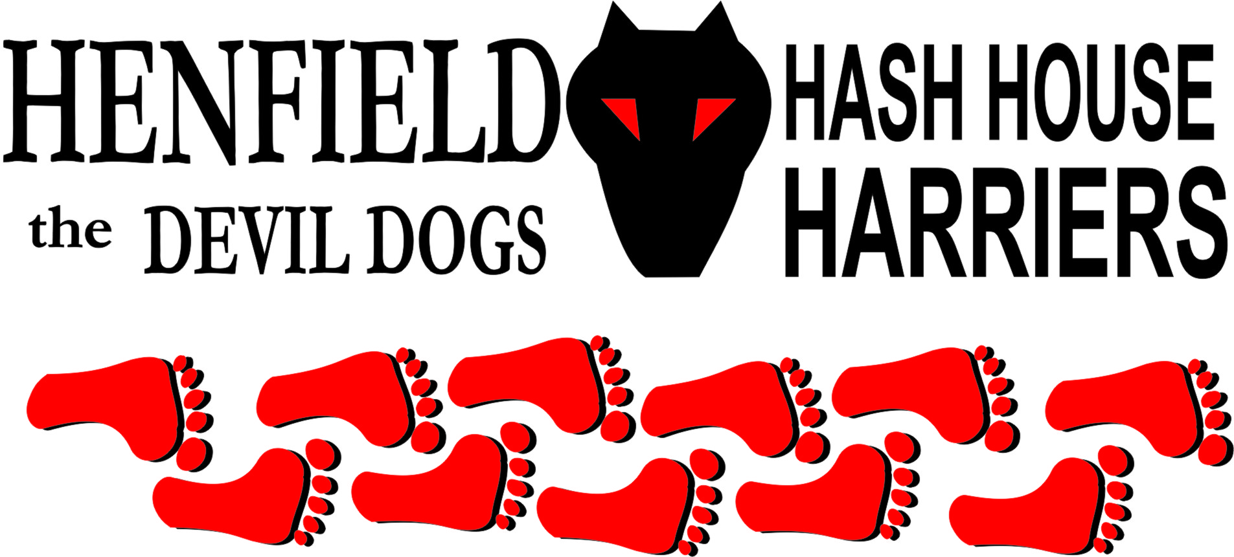

Henfield Hash House Harriers Run #78

Sunday 19th July 2009 12.30 pm
Bolney

Scribe: Ratstail

A good turn out - Snotty delighted with the turn-out (19?) but I'm not convinced that counting dogs (the 4-legged variety) is ethical? Is he looking for a career in politics? With the pack approx. 50/50 runners and walkers, a walkers trail had been set. It was good to see visitors Bushsquat and Cliffhanger from the Hastings Hash (Bush squatter's photos) and Brent and Kayleen from the Brighton Hash. Lucky dog and Under-dog from Antigua/US hashes made a return visit.

With the threat of rain we set off from Butchers in Ryecroft Road, heading east into what was apparently new territory for H4, the pack hit a series of checks before it headed down an underpass under the A23. Bollocks was out in front - but then disappeared from view.

At this point dear reader the hare would like to explain something. For the rest of the hash there were complaints (mainly Snotty and Bollocks) about the lack of flour. The trail had been set the day before but heavy overnight rain had washed out quite a few marks. However, anticipating this problem your intrepid and very sensible hare had used chalk and made marks on posts etc. This advanced use of technology seemed to be too much for Bollocks and Snotty and marks on fence posts like 'Run X' were run through and then wondered why they were lost?

(This is classified as Whining and is worthy of a down down at the next run for Ratstail)

Anyway, back to the pack, who following the very clear chalk marks, were making excellent progress! While the walkers turned North just after the A23 the runners carried on to Buncton Lane and then turned North. After a few check points the pack hit a 'Back-check 5' and had to retrace their steps before picking up the footpath back towards the A23.

Up a field parallel to the A23 we caught sight of the walkers, who should have been way out in front as the runners had just put in the best part of an extra 3/4 mile. Maybe the H4 runners are faster than thought? (more likely the walkers were dawdling....!).

At the top of the field we 'regrouped' with Bollocks who having become temporarily uncertain of his position, i.e. lost, had decided to wait. On on, romping across the A23 bridge, we caught the walkers at the end of what we call the 'donkey field'. If you are confused by this term, we call it this because it is a field and it has donkeys in it. Seems logical to us.

The runners now ahead moving swiftly, spurred on by the promise of a beer stop. Across open fields with panoramic views to the South Downs and passing Wykehurst Place (picture a Gothic pile built by Germans in the 1890s, featured in Oh! What a lovely war, The Eagle has Landed and The Legend of Hell House) - we reached the B.S. The spot had 2 attractive features: Beer and a great rope swing.

After a short stop, on on was called. Through 'Sherlock's' garden. At this point the walkers headed South and runners North. For the runners it was on up Cross-Colwood lane and then South passing the apple farm and back through a newly planted vineyard (by the way this is part of Bookers Vineyard website , one of the larger and the most modern vineyards in the UK - wines available in Waitrose).

At the vineyard we intercepted the walkers trail - who had had a short cut - and headed for home - but not before another fiendish back-check, which got the pack back together (apart from Homer and Snotty who, struggling with the complicated marks then set off on the walkers trail in reverse!). Emerging from the path back in the centre of Bolney, it was a quick 'on in' back to Ryecroft Road.

As we arrived back and got BBQ lit, the rain started and got harder and harder. Fortunately the awning kept off the worst. Eventually Snotty and Homer turned up (just in time for the food - now there's a surprise!). The run was given a resounding 8/10 - or something like that! - because it it's a well known fact, 8 out of 10 Hashers prefer Stork Chalk!

On On!

RATS TAIL

The Henfield Hash House Harriers cast in no particular order, nor importance to anyone other than the hare:
Hares | Ratstail
Runners | Sir Snot, Bollocks, Homer, Ollie Frost, Bushsquat, Cliffhanger, Brent, Kayleen, Luckydog, Underdog and Wildbush
Walkers | Splitpin, Rattrap, Sally Mackinlay, Linda Bailey
Drinkers & Hounds | The above +Monty, Dillon & Tess
Apologies | Cum Lately (another excuse – Don’t ask!)  Forrest (for living in France).
Large Wildlife | Donkeys and Horses
Twin Town | Who would want to!
Hashshit | Snotty (for forgetting to elect a Hashshit. Again. And probably for spelling people’s names wrong)

NEXT HENFIELD HASH # 79 to be arranged by --
Bollocks - 19th August – 12:30 at Franklynds Arms Washington– watch the website.

