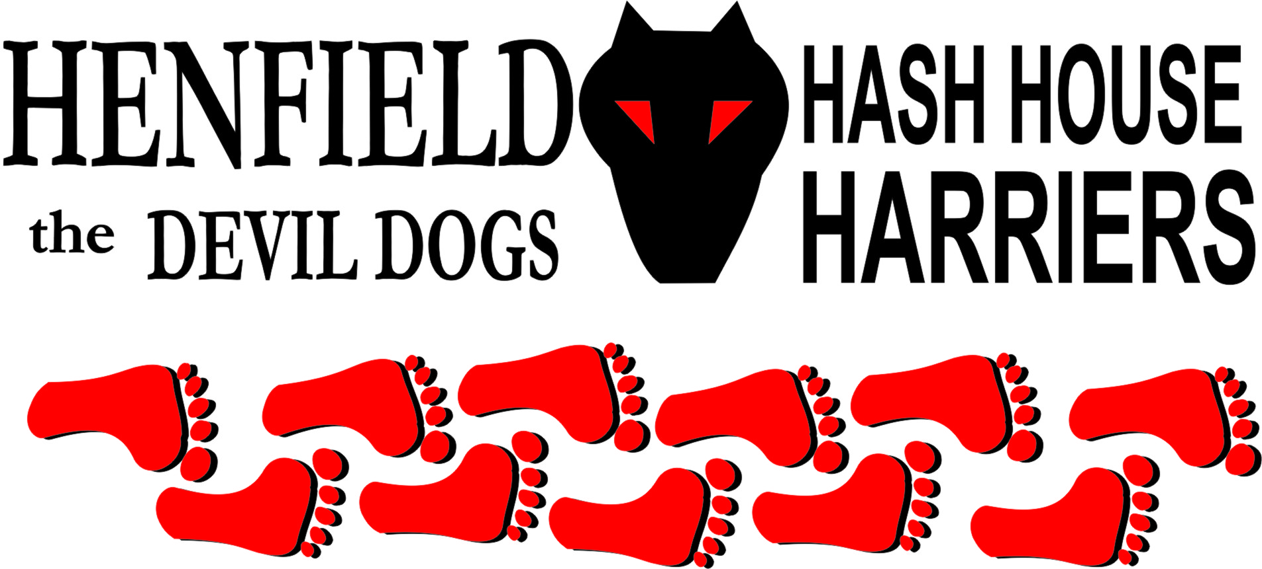

Henfield Hash House Harriers Run #77

Sunday 21st June 2009 12.30 pm
Shermanbury

Scribe: Moneypenny

The time: June 21st, Sunday, 12.30 pm.
The place: The Bull pub, Shermanbury

Midsummer Day arrived, , and the Henfield Hashers celebrated the longest day and latest sunset of the year in time-honoured style by having a Hash at lunchtime.
A large pack gathered at the Bull, a mile or two north of Henfield. For the second time in a row, we had over 20 (including the dog). It may have been more, but Snotty ran out of fingers – he can’t count higher than 21….

Moneypenny had been out early to finish setting the trail, and set up the Beer Stop, and was sitting outside the pub with a half of Harvey’s when the pack arrived. Numbers rose steadily, and then Nightmare reported that he had seen a small grey car with a Hash sticker, looking lost a mile down the road. It turned out to be Mrs Moneypenny, the Walking Hare, and Alex, who couldn’t find their way to the start. Not a good omen for the Walkers!

But Mrs M duly arrived, a little late and embarrassed, followed by Bollocks and Splitpin. Moneypenny was getting worried, as rumours spread that there were dozens of people arriving, and the Beer Stop was only designed for 16 (Snotty having said “cater for 8-10 !”). However, most of the arrivals were people just going to the pub, inexplicably not wishing to run for an hour before lunch.

The Hare was asked to explain the rules for the new virgin hashers. Although surprised to find that there could be rules on a Hash, he gave a short discourse on “The Symbology of Flour Marks, as used in the Weald of Sussex”.

The pack were split into Runners and Walkers, and the runners set off across the road and along by the river towards Shermanbury Place, (Snotty ignoring the trail, but luckily rejoining further on). Then across the river, back to the road, except for Ratstail, who decided to ignore the X for a false trail, and headed for London before turning back, and onwards towards the Downs Link disused railway line, catching and passing the walkers on the way. The walkers had a nice stroll, with Monty behaving well.

At this point, it is customary to write some drivel about runners finding falsies, Snotty leading the way, Bollocks finding true trail, etc., but I can’t remember, and can’t be arsed to pad it out any more !

At the railway, the runners followed a cunningly planned loop to allow the walkers to catch up, but after a longish stretch of straight trail, with few convincing checks, they missed another runners loop, and found the Beer Stop 10 minutes before the walkers caught up.
The beer was hidden under a bridge over a stream: Keith had nearly worked out where it was before the Hare arrived, but didn’t brave the nettles. It had been hidden early in the morning, when nobody was about, because it could have looked as if he was planting a bomb under the bridge! Luckily it was all there, and there was enough beer and water to go round, including Monty the Hound. It was an idyllic spot for a sociable bevy, spoilt only by Snotty trying to sing filthy songs.

The trail then led back to the pub, with the runners again arriving well before the walkers. We found tables out on the patio, and the Hare/Scribe/ Dogsbody ordered up jugs of beer, slices of pizza, and (a first for Henfield Hash) a gin and tonic ! Snotty called the Circle to order, and awarded down-downs to the Hares, and the visitors, including Helen, Catherine, Keith and several Dogs.

Marks for the Run were surprisingly high, ranging from (+) 3 to 10.
Negative comments were: too short ! (Lucky Dog), and the Beer Stop was a bit close to the On-Inn (Don). Responses – a) the run wasn’t too short if you’d been round twice in the same day, and b) you set the trail then !

Positive feedback was given on the generous use of flour (Bouncer please note – it does help if you actually mark the trail before the pack attempt to follow it!)

In another first for the Hash, Mrs Moneypenny and Joyce then put on a Plant Sale, explaining that they have entered the Race for Life, and would be doing a 5km sponsored run to raise funds for Cancer Research UK. (They are running for a team called Twinkletoes, made up of ladies from the Burgess Hill & Cuckfield Ballroom Dancing Club. Luckily no-one told Snotty this, or they would have had more down-downs !)

Several plants were sold from the display, and over £13 donated to the collection: thanks to all who put in, especially Snotty, who coughed up a fiver, but was disappointed to find that buying a Hash pot plant didn’t mean he was getting cheap drugs.

The GM forgot to award the Hashshit to anyone, again.

Ratstail generously offered to set the next run at Bolney, and to invite everyone back to his place for beer, champagne and use of his swimming pool and sauna, followed by a slap-up meal, dancing, and partying into the night. (Check Hash website for exact details, and dress code)

On On

The Henfield Hash House Harriers cast in no particular order, nor importance to anyone other than the hare:
Hares | Moneypenny and Mrs Moneypenny
Runners | Bollocks, Don Mackenzie, Joyce M, Keith M, Homer, Oliver Stimpson, Moneypenny, Alex (mini-Moneypenny), Helen Hughes, Catherine Preedy, Ratstail & Sir Snot
Walkers | Mrs Moneypenny, Splitpin, Lucinda, Nightmare, Lucky Dog, Under Dog, Karen, Elanor and Monty the Hash-hound
Drinkers | The above
Apologies | Cum Lately (another excuse – this time claiming to be in Red Square !),  Bouncer, Angel and brood. Forrest ( for living in France).
Large Wildlife | Pigs, piglets, cows
Twin Town | Henfield South
Hashshit | Snotty (for forgetting to elect a Hashshit. Again. And probably for spelling people’s names wrong)

NEXT HENFIELD HASH # 78 to be arranged by --
Ratstail - 19th July at Bolney– watch the website.

