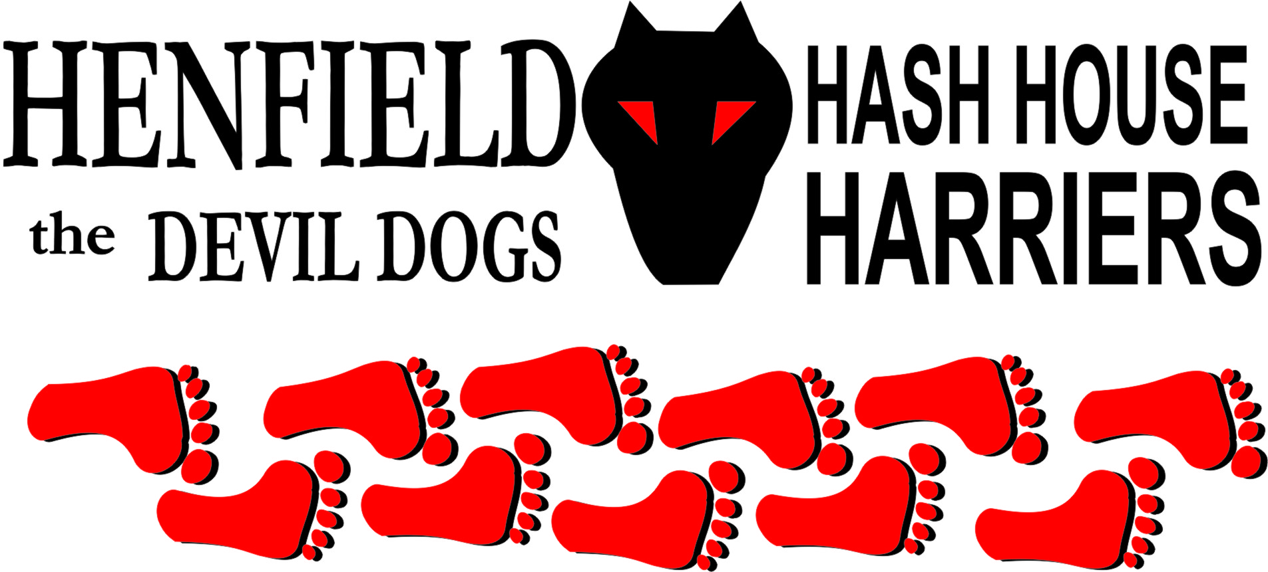

Henfield Hash House Harriers Run #76
Sunday 17th May 2009 12.30pm
Rising Sun – Upper Beeding

Scribe: Bouncer

In spite of the deluge earlier in the day, nothing stops the hash and there was a sizeable pack waiting for the off as Bollocks and Sir Snot attempted to gain an advantage. “Oy, you’ve still got 50 seconds to go”, yelled hare as he rounded the corner catching them in the misdeed of seeking trail.

Some explanatory from hare about markings where it transpired that H4 convention had been abandoned for a hybrid of other hashes with incorrect false trail marks and talk of fishhooks, and something about his pink stick! Early lead was taken by Bollocks with his advance info, but hare dragged him back advising him to let Snotty go. At the first check this deviousness became clear as Snotty tackled the nettles only to find Bouncer laughing at him from the far end reached by deviating around the road. As several set-off up the correct route at check 2, hare asked if anyone had gone over the road. This trap was intended for Bollocks but it was Snotty once again who fell for it and found the on on up the mountain for the former, with a U-turn recommended for the rest of the pack.

Up Windmill hill we were given the evil eye by a couple of alpacas, left in with the baa lambs to deter foxes apparently. Snotty was now a long way off the back but with a check-back at the next, found himself in front once again, only to make a complete FU at the next check and eliminate 2 of the three ways from enquiries, by which time Forrest had already used the process of elimination to find trail along the track. “Don’t worry” assured the hare as the fishhook was ahead. Only it wasn’t. Either eaten or rubbed out by front runners who couldn’t be arsed to return, it meant that the GM remained at the back as next check was found really fast. Fortunately the pack instinct to let one person decide where to check then all follow, meant that Snotty was once again at the front as all others went north to the false trail.

There was a lot of historical interest on this run and the first item was the Priory where another check was found. Can there be anything more satisfying to a hare than seeing the entire pack all heading off in the wrong direction? On this occasion there were a lot more than one wrong ways to go, and pack found them all! Split Pin had seemed confused by the presence of the dribble dropper on the run, which did prompt accusations that the trail didn’t exist and was only now being laid down, however, it proved it’s worth here. As we ran along the river bank, Forrest was heard to say to hare “I’d like to think of something witty to say but all I can think is Bastard! Bastard, bastard, bastard, bastard.” The regroup at the bridge was scarcely needed as only Snotty was late so Homer and junior headed off up the riverbank, clearly proving they had no idea where they were. Ratstail got it wrong at the next, presumably shy about the pack of cows (cowpack?). Didn’t deter Snotty though, who went into overdrive to get to the prettiest one first.

Inevitably as he was spearheading things he then lost the plot at the next point and ran through the false trail bars, despite several calling him back to head up the hill. Concentrating on the descent into the moat, then the climb up the other side it was hard to see how everyone got up, but get up they did, Ollie using a stick to great effect. Prize for most amusing must go to Homer though who worked hard to get up then gracefully slid back down on with all-fours fully extended, back arched to keep his body away from the mud! Once in the Castle grounds it was straight up the central mound only to find… no beer! Hare was worried now but Angel arrived at the Kamper just in time to sort out the sip having got lost on the walking trail due to oral overdrive. As everyone gathered for the beer, which was soon distributed, the rest of the walkers arrived with assorted dogs and horrors. Ratstail had sustained the most impressive wound from the scramble but something was missing? Eventually we worked out that, as there was an untouched beer it must be a person, but couldn’t decide who so as there was no GM present either, promptly elected the beer GM and awaited next instructions. We were just about to give up when Snotty appeared from who knows where, tipped the GM away and promptly poured a fresh beer.

On on was called down past the old church, through the old village and past the old curry house. Ratstail had found himself in the lead past St Mary’s House but then set off across the meadow with Moneypenny in pursuit. Meanwhile Bollocks was having a funny 5 having lost Split Pin who had decided to walk back. Back at the river newboot Don headed south seemingly forgetting that the pub was over the other side, but soon repaired the damage when he spotted us all on the opposite bank. Local knowledge gave wings to Snotty’s feet once again, which meant of course, that he went wrong. As Moneypenny headed off across the field, Ollie came screaming past but did better than Forrest at the check, who for some reason hadn’t spotted the pub 50 yards down the track. Pack and walkers arrived together at the pub for a well timed finish, not counting the SCB Snotty who was determined to “win” at all costs!

With a break in the weather just about large enough to fit in setting trail and for a hash to take place nobody was hanging around in the car park as rain clouds loomed, and we were soon tripping over each other in the conservatory, which some wag renamed the Malfunction Room. Down downs were awarded to new boots Ratstail (1.2 seconds), Don (12 seconds) and Joyce (15 seconds), then a straw poll revealed that marks for the run were:
Liked the Cossack dance but the lyrics were rubbish (Moneypenny); 10 out of 10 – Angel; 10/10 which equals nothing – Bollocks (prompting mathematical debate as it does actually make 1); 7.5; 2.5; cheesy chips and an average (declared) of 4.6 from peeved Snotty. So there. Snotty tried to award hash shit to hare but his 20 minute disappearance at the beer stop was enough to mark him!

Final dishonourarary mention should go to the pub for hunting us down to charge an extra £7.50 for the chips as they’d forgotten about the cheese! Better take our own next time to the Bull at Shermanbury on 21/06/09 under Moneypenny’s guidance, as that’s a pizza pub!

There is a pub called the Rising Sun,
Way down in Upper Beeding*
Where Henfield H4 went for some fun,
And Ratstail ended up bleeding.

Sir Snot he was a rambling man,
Just couldn’t find the right trail,
So everyone else had to wait for him,
And carry on drinking the ale.

Oh RA’s tell your hash hounds,
Not to do what Snotty done,
Taking a short-cut and claiming a win,
On a Henfield hash house run.

*Proof positive that Sussex was invaded by the Australians as Lower Beeding is considerably higher than Upper Beeding so this line does actually make sense.

Good time had by all

On On
The Henfield Hash House Harriers cast in no particular order, nor importance to anyone other than the hare:

Hares - Bouncer
Runners - Snotty, Bollocks, Spiltpin, Homer, Ollie, Moneypenny, Don, Joyce, Ratstail & Forrest
Walkers - Mrs Moneypenny, Monty (Hash Hound), Rattrap, Elanor, Angel, ET, Gooie and Crackerjack.
Drinkers - All the above + Nightmare and Leila
Apologies - Cum Lately (another sorry excuse), Lucinda & Rumpole
Hashshit - Snotty (For getting in first!)

NEXT HENFIELD HASH # 77 Sunday 21st June at 12:30. Hares – Mr & Mrs Moneypenny – The Bull Shermanbury, just North of Henfield

