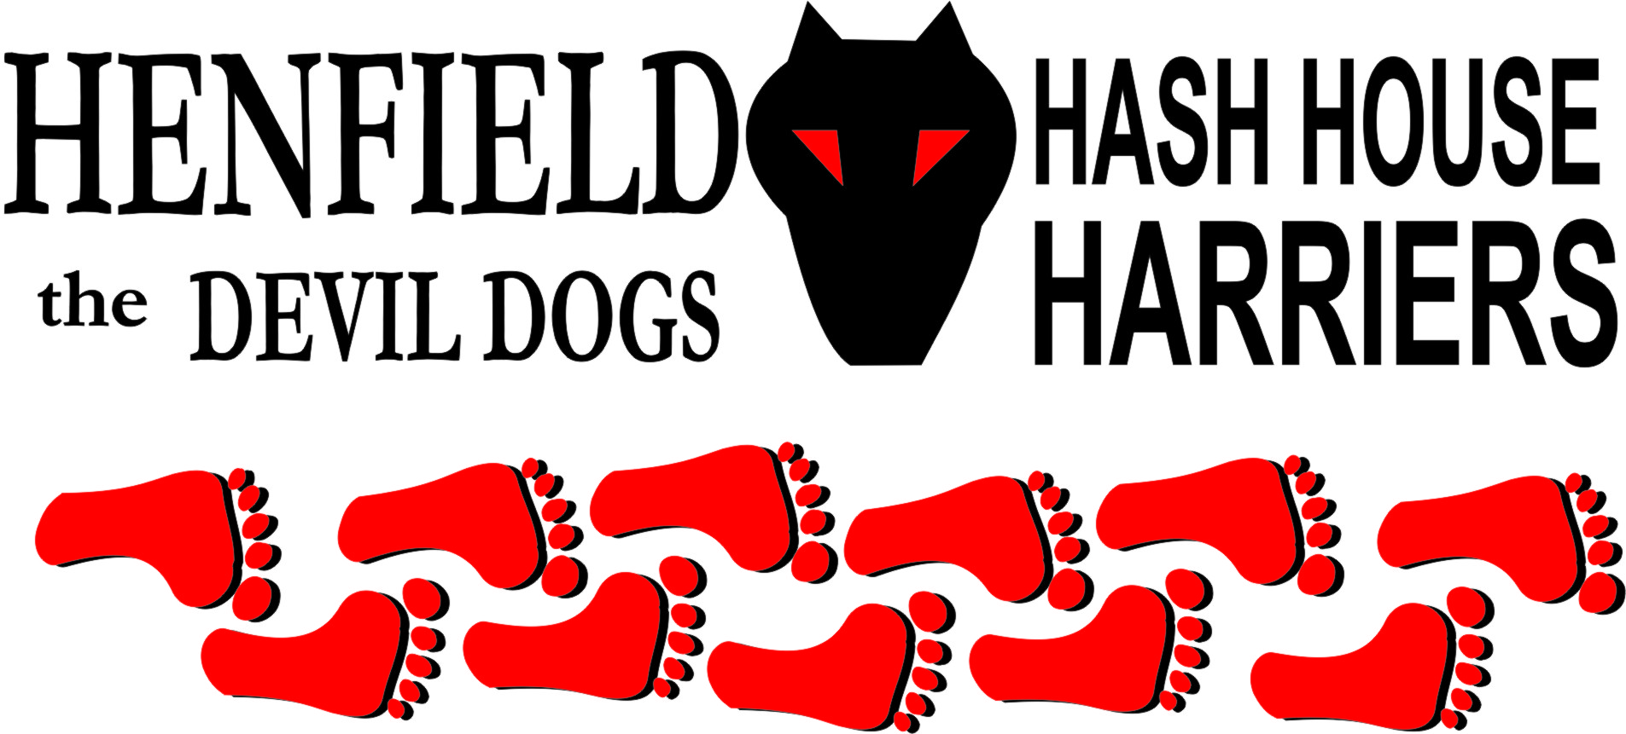

Henfield Hash House Harriers Run #75
Sunday 18th April 2009 12.30pm
Gardeners Arms - Henfield

Scribe: Sir Snot

The first T-shirt run of the year to mark the 75th Run of Henfield Hash House Harriers! – Eight years old this year! Even with the usual rebuttals from Cum Lately in Florida this time. – This man will do anything to avoid a run! We had 16 turn out for this lovely warm day. Even Bouncer Angel and ET and the other two mini – Bouncer hashers showed up to bolster the numbers! As we have said before we take anyone – even if you are crawling – but this is generally when you have too much beer!

Eventually every ready for the off waiting for Bollocks who arrived 5 minutes late have just completed the Portslade to Devil Dyke run wearing the number 117, all he was missing was a moustache and another runner wearing 117! Walkers were away while the runners were floundering on how to get going until Moneypenny found true trail, up to the first check and a pattern was emerging – Homer was waiting at each check directing his son Ollie to check out the trails – everyone he chose was a falsie, Homer did this at virtually every check as though he was training a dog! Splitpin and virgin Lucinda were treading carefully until Lucinda got into the spirit of the thing to find a few false trails.

Across the railway lines where Bollocks picked up trail rather quickly whilst Rumpole, Moneypenny and Ollie all chased smoke! Back they all came to follow Bollocks through two field and a couple of sty’s before the trail led the to the star check all runners being caught out, with poor old Ollie being made at least a mile down the railway tracks before being called back by his Dad Homer!

Eventually over a stream then right towards the old railway bridge, which coincidently the walkers had already reached and had found the beer! For this was the beer stop. Bouncer thought the beer deserved throwing at everyone from a great height, which was a cool refresher on a very hot day. A few songs had to be cut short to avoid young ears being infected with uncensored words!

The second half saw poor old Ollie being pushed all the way to the cross before returning to Homer the king of the circle! Splitpin and Lucinda were quick to follow Bollocks as Moneypenny returned moaning and griping – last again! After negotiating a boggy area with a gate, Bollocks managed to take the second gate right off its hinges – time to call 117 117! But no help arrived.

Walkers had assembled at the check on the railway line like a pile of lost cattle Bouncer, Nightmare, Alice, Mrs Moneypenny Angel with three mini hashers all enjoying the stroll in the hot sun, watching poor old Lucinda being brave enough to follow Bollocks again onto another falsie. Rumpole was lucky to head up the hill on private land and picked up true trail calling everyone up. One nosey landowner berating us all until I gave her the name of the farmer who gave us permission to cross his land – The fact he was overseas at the time is neither here nor there. The fact she did not know it made it twice as amusing!

Through a very nice set of private property down the road back onto trail and on in, Rumpole by now had made the check back but was quite a way ahead, with others not too far behind. Marks were left for the walkers but Nightmare was too busy finishing up the beer left from the beer stop. Eventually he led the walkers off trail back to the On On.

Marks for the trail were set high by the girls then came down to an appreciable level once all the runners gave their input. Down Downs for Homer – pretending he was a dog handler – poor Ollie! Plus virgin Lucinder who put on a good show with the other reprobates for various offences until food was served after a quick swing low was achieved.

Photos can be accessed form the web site form photos from some runs tab or just follow www.henfieldh3.co.uk/Photoalbum1.htm

Good time had by all

On On
The Henfield Hash House Harriers cast in no particular order, nor importance to anyone other than the hare:

Hares - Sir Snot and Mrs. Snot
Runners - Bollocks, Splitpin, Homer, Moneypenny, Rumpole, Ollie, Lucinda
Walkers - Mrs Moneypenny, Nightmare, Alice, Angel, Bouncer (ET + 2 mini- Bouncers)
Drinkers - All the above
Apologies - Cum Lately (another sorry excuse)
Hashshit - Snotty (for forgetting to elect a Hashshit)

NEXT HENFIELD HASH # 76 to be arranged by --
Bouncer for 17 May – possibly! –Details to follow – watch the website.

HASH # 77 Sunday 21st June - Hares – Mr & Mrs Moneypenny - Ditchling

