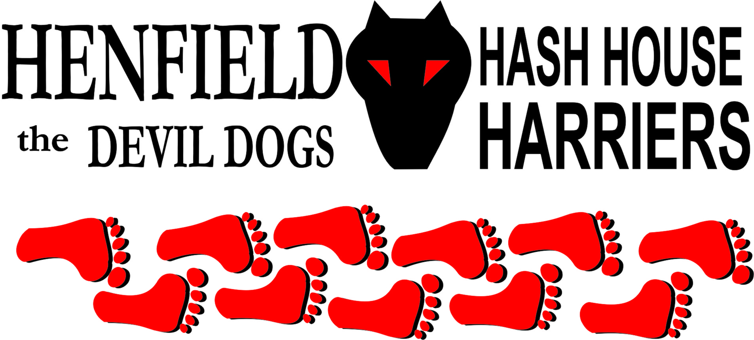

Henfield Hash House Harriers Run #73
Sunday 1st February 2009 11am
Eight Bells Pub Bolney

Scribe: Moneypenny

The first Henfield Hash of the New Year was certainly the best so far this year.
A motley group met up in the car park of the Eight Bells, including some younger faces than usual (they even had their own teeth and hair).

Bollocks and Splitpin had brought their daughter Alice, although she didn’t run, preferring to sit in the car with a laptop. Homer brought Nightmare, and Nightmare brought one of his large collection of well-filled colostomy bags. On closer inspection, this turned out to be our famous GM, Sir Snot (although still full of shit).

Mrs Moneypenny became very popular when she produced flasks of warm mulled wine, and even more popular when she got her flapjacks out (No - cakes for you American readers!). Just as the athletes were setting off, Bouncer arrived, with his younger son Ewan (hash name ET), as refugees from the Brighton Hash. It took a while to get the young lad’s shoes on, but Bouncer was soon properly shod, full of flapjack and ready to walk.

The running Hare was Moneypenny, and Mrs. Moneypenny led the Walkers.
The pack set off, heading out round the Church, and following the trail back round the other side to the start by the pub. This was a cunning trick by the Hare, but didn’t work as the pack all hid in the churchyard and frightened the poor Hare by jumping out from behind a wall when he went to look for them. Rotten lot!

By this time, Bouncer had managed to assemble Ewan’s pushchair, and the walkers were on their way. The runners overtook, and headed west into open country with lots of lovely shiggy. At Bookers Vineyard, the routes split, and the runners went south to have fun in the fields, while the walkers took a shorter route via the vineyard. The walkers had now realized what a brilliant idea it was for Bouncer to bring a pushchair on a route which was designed for the finely-tuned cross-country athletes of Henfield H3, including mud, stiles, bridges, kissing gates, electric fences, mud, ice, hills and more mud. But they managed to get the pushchair past all the obstacles, and even remembered to go back and get Ewan.
Snotty was forging ahead, and went wrong at the 5-way junction at Old Mill House Farm, managing to follow the only track which was not a public right of way, and had no flour at all on it. Luckily, Homer followed him, and led him back on to the true trail, which Bollocks had discovered nearby. Splitpin had also found the right way, possibly by recognizing the scent of Bollocks. The walkers had almost caught up at this point, but were left behind when they went a bit wrong (good try, dear).
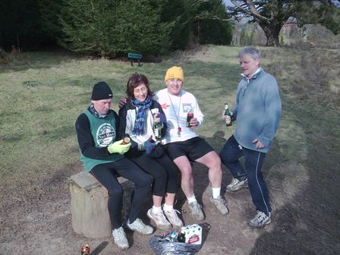
Splitpin and Moneypenny carried on and found the 4 Amigos at the Beerstop, which was on a hillside with a giant swing hanging from a large tree. They had already sniffed out the beer and were playing happily on the swing. No flapjacks this time, but the beer was appreciated (you can’t beat Lidl’s traditional Englischer Ale). The walkers arrived in time to share the beer, and Bouncer tried the swing. One hand holding his child, the other holding his beer. Excellent parenting – he didn’t spill a drop.
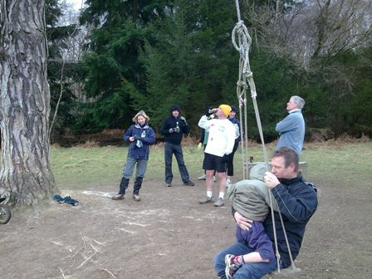
After the break, the trail led on down a hill, over a stream and up a grassy cliff to a cross-track, where the 3 Stooges sped on, to find themselves at The Bolney Stage (the wrong pub). Splitpin sensibly spotted the check, and turned right downhill, leading straight to the 8 Bells, followed by the walkers. The runners also made it back, despite complaints about the trail (unjustified – the Hare used at least a whole bag of flour), some lonely runners were found or were they walkers – The Henfield Hash will accept anyone!

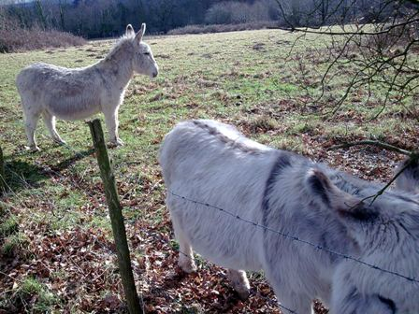
Everyone went in for refuelling. The Harveys beer was excellent. Unfortunately the food menu was limited – they don’t serve buckets of chips on Sundays – but there was a wide range of crisps, nuts, and other high-fat nibbles.

Marks were awarded for the run (negative 6.9), although not to the Hare, who was given a collection of everyone else’s dregs for a down-down. Thanks guys, I enjoyed laying the trail in fading light, with frozen fingers struggling to pull flour out of a bag….. it makes it all worthwhile when you’re given a glass of mixed beer, lager and orange juice, with crisps and peanuts floating in it.
The GM forgot to award the Hashshit to anyone, so he can have it till Forrest comes back from France.

Next Hash may be on 8th March. Or not, as Cum Lately has offered to organise it !

On On
The Henfield Hash House Harriers cast in no particular order, nor importance to anyone other than the hare:

Hares - Moneypenny and Mrs Moneypenny
Runners - Bollocks, Splitpin, Homer, Moneypenny & Sir Snot
Walkers - Mrs Moneypenny, Nightmare, Bouncer and Ewan (ET - mini-Bouncer)
Drinkers - Alice Splitpin-Bollocks, and all the above
Apologies - Cum Lately (another sorry excuse)
Large Wildlife - 2 white donkeys
Large Tree - Played by itself
Twin Town - Forrest-sur-Merde
Hashshit - Snotty (for forgetting to elect a Hashshit)

NEXT HENFIELD HASH # 74 to be arranged by --
da-da-daah ! –Details to follow – watch the website.
Note: Grand Master Snot promised T-shirts for the 75th Run - but they may have 69th on them, and last year’s date…..

