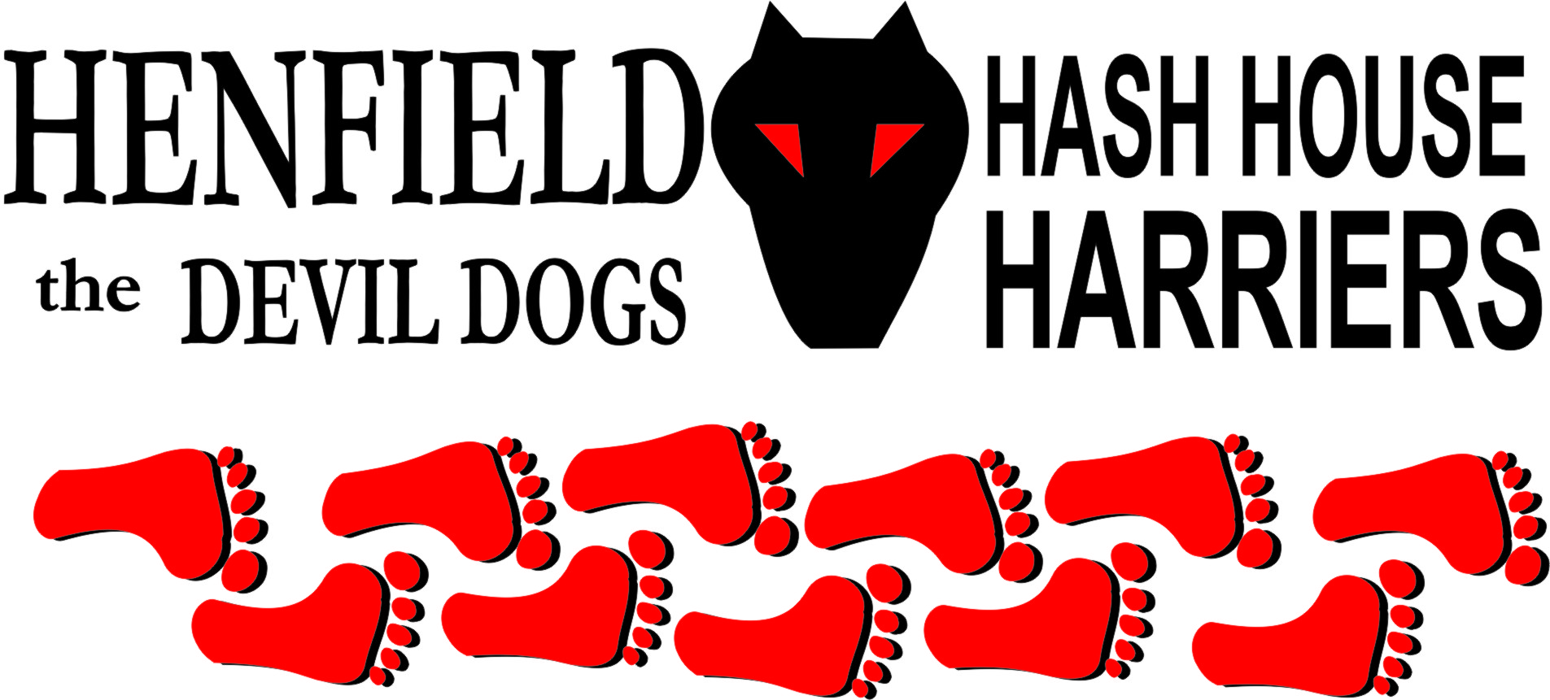

Henfield Hash House Harriers Run #72

Sunday 21st December 2008 12pm
Storrington

Scribe: Bollocks

December 21st, Sunday, 12 noon. A Henfield Hash run!! No 72 at Last! This fabulous combination of festive occasion and a long awaited assembly of the H4 faithful was sure to attract a big crowd. Much preparation by the Hare included a carefully planned run that extended for several miles over joyous countryside and delightful woodland trails ( and included shiggy) , enough to bring a happy smile to any Hasher’s hardened, reddened and booze-lined visage. So how many runners did we get?? 20 ?? 17?? 10?? No, only 4 and that included the Hare. 2 brave souls attempted the walking route to the beer stop and Nightmare avoided both the run and the walk and went straight to the pub.

The Hare was Bollocks, the runners were Snotty, Homer and Moneypenny. Walkers were Splitpin and Mrs Moneypenny.

After the traditional mince pie and mulled wine the runners set off with the pack finding false trails from the start, but encouraged by a vocal Snotty they persevered and eventually found a trail that led through Storrington, passed 2 pubs and headed off towards the South Downs across some very wet sheep pastures. Moneypenny took a trail with more than 3 markings, which, although incorrect, he decided he preferred and was reluctant to abandon even when shouted at. In the meantime Snotty had taken an early lead and was keen to show off to the pack. As the Alpha FRB he was quite awesome. Away he went, hard to catch across the long wet field to Chantry lane where he correctly guessed the next 2 checks and was obviously in his element as he disappeared off behind Waterfall Cottage whilst Homer bravely accepted the challenge of the check and was rewarded with a X. Moneypenny had by now caught up, but was grumbling about the false falsie he had chosen a mile back. Normally Homer would have been after Snotty at a fair trot but he was suffering with the Botticcelis after a suspicious sea food supper on Friday and was making sure his strides were short and his arse well clenched. This did make his pace rather slower than usual.
Meanwhile Snotty was away. He was obviously enjoying his rare status as FRB and was happily counting off the distance but in agrarian confusion decided he was covering acres rather than miles. I’ve done 2 acres! I’ve lead for 4 acres he squealed.
So onwards across the gallops and down a shiggy track to the next check where he went wrong and disappeared behind Barn Farm and was not seen to return. I suspect he had to sit down and recover for a while. In the meantime Homer had found the correct trail and with Hare and Moneypenny in pursuit he set off down New Farm Lane. After a long long time Snotty finally appeared but he was making no attempt to regain his position as Alpha hound and had slowed to a walk. Six months of inactivity had finally caught up with him.
At the next check point, as we waited for ages for Snotty to arrive we had a conference and decided that as Snotty was obviously showing signs of distress we should cut the run short and head straight for the beer stop. This was not a direct route, but did cut another mile or 2 from the run.
Arriving at the beer stop we met Splitpin and Mrs Moneypenny who had found the stashed ales and had ripped into them already. Homer declined any as his delicate state of intestinal chaos was not easing any. Snotty abused the beer. It was Caffreys and quite a fine ale I thought. Moneypenny tried to resurrect his complaint regarding the earlier false false trail but was ignored.
On to the second half of the run and a jolly tramp around the woods of Sullington Warren and eventually back to the car park, clean clothes and off to the Pub.
Beers and snacks were enjoyed by the pack and the recently arrived Nightmare. Excuses were received from Rumpole who was still in bed, lazy git. Frances who had a hangover, Dennis who was off doing his superhero bit and saving his company and Sally who had no excuse. Cum Lately had a birthday and was unwilling to share it with us so we didn’t buy him a drink.
All in all a poor turn out but as great run and the curse of Run 72 has finally been exorcised. Moneypenny promises a run in Bolney during February so there is plenty of time for www.davidlowrie.cum to delve into his excuse book for a suitable apology. The rest of you will I am sure already have made a New Years commitment to run more so see you there.
On On, Merry Christmas etc, Bollocks.

On On

The Henfield Hash House Harriers cast in no particular order, nor importance to anyone other than the hare:

Hare - Bollocks
Runners - Moneypenny, Homer & Sir Snot
Walkers - Sp;itpin and Mrs Moneypenny.
Drinkers - Nightmare and all the above
Hashshit - Forrest (Missing 3 Hashes!)

NEXT HENFIELD HASH # 73 to be arranged by Moneypenny in Bolney –Details to follow – watch the website.

