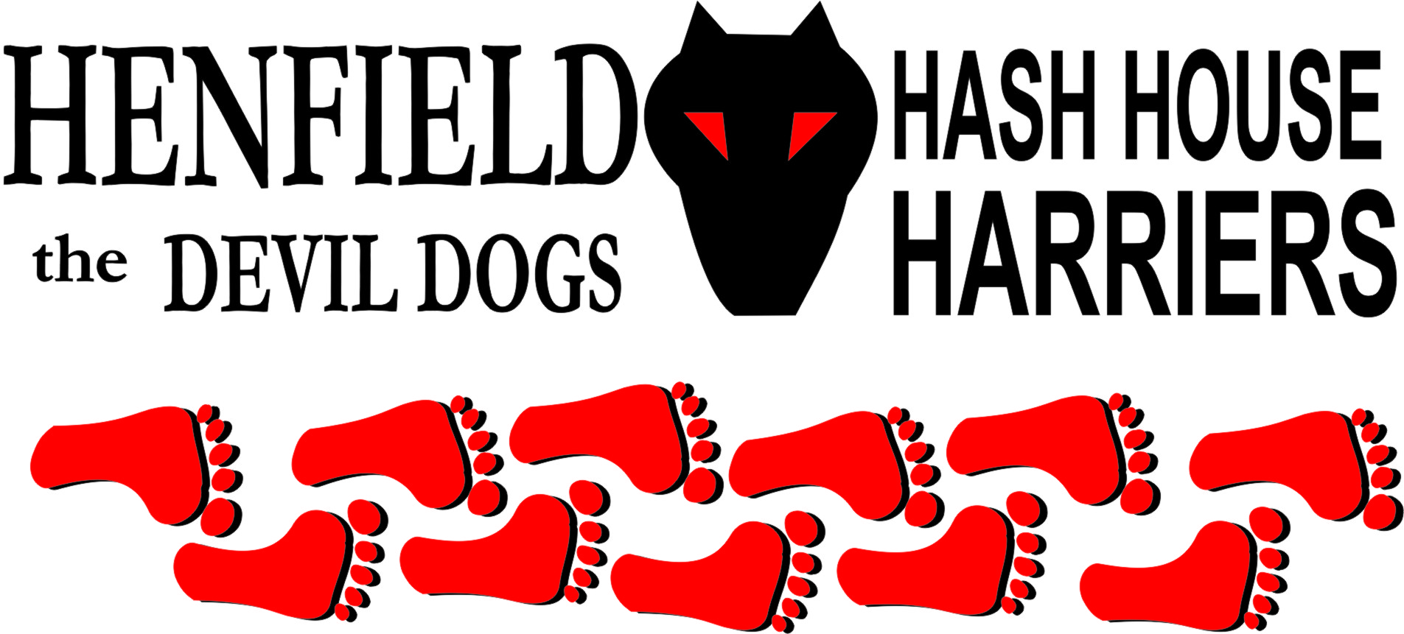

Henfield Hash House Harriers Run #70

Monday 23rd June 2008 7pm
George Hotel Car park Henfield

Scribe: Snotty

It must have been the warm weather, the promise of good food and a T-shirt that got 14 of us to turn out; we could actually form a circle or two! Cum Lately brought Olga who was two weeks late and was going on the walking trail, it was a good job that Mrs. Nightmare being a trained nurse and all that was around. For the record this will go down as a 15 turnout, even though one failed to turn OUT for the down down, but he or she was well down and almost out! Good luck to Olga when the day arrives. – She needs all the luck she can get with Cum Lately as a Dad!

Everyone ready to go except Dave (Cum Lately’s only mate), who was to show up for the down down and Moneypenny. Well Moneypenny called to say he was on his way and finally showed up 15 minutes late! – After doing a quick change in the car.

The runners set off on trail at the back of the George, with Bollocks and Moneypenny starting completely in the wrong direction with Denis in tow. Frances & Sally together with Homer, who because he had not shown up for 6 months had forgotten how this works, watching and waiting whilst Rumpole had took off on true trail and Cum Lately close behind. Walkers led by Nightmare, with Marilyn (Mrs Nightmare), Olga and Amy in good old running flip flops set off shortly after.

At the end of this short trail, walkers and runners split up, again with Bollocks Moneypenny and Denis (The three lostketeers), taking the wrong trail. Rumpole got lucky yet again, with Sally, Frances and Homer discussing the best nail salons in Henfield! True trail went west towards Furners Lane, Rumpole eventually got a check wrong and disappeared up someone’s drive (They must have been having a barbeque! Homer now got into second gear (Saab people do have stiff crutches oops I meant clutches), and was away like a beagle, The magnificent three again went the wrong way down Furners Lane and had to be called back. Sally and Frances were going at a steady pace at the rear saving themselves for a fast sprint towards the beer stop.

The best check of all took the pack past true trail, and had the hounds forgetting how cunning the hare was, as the two tortoises at the back – Sally and Frances found themselves at the front – if only for a short period. Homer and the fantastic three (Bollocks, Moneypenny and Denis) plus Rumpole were all heading for Blackstone. As for Cum Lately he was all over the place shouting on on, and phoning Olga to see if he was a Dad yet! Eventually true trail was found and the pack eventually led through another couple of falsies led to Swains family area where Nightmare had still not found the well hidden beer! Sally and Frances still arrived before the beer was retrieved, thus making the perfect beer stop.

Olga was still made up of two, Amy was talking to the pigs, which was better conversation than Rumpole whilst Nightmare was trying to get the donkey’s to drink beer, whilst Mrs Nightmare, was keeping it all together. Cum Lately was comforting Olga, for the shock of Son of Cum Lately about to arrive No mention of the ‘you know what bag’ on Nightmare had been mentioned, then it came out – no not the bag just a joke, now nobody can ever say nightmare is full of crap, as he can just throw the whole lot away. It was volunteered as the new fresh Hashshit – I think the only thing we still like to see fermenting is the beer! Anyway enough beer (just) for everyone and joke and songs were sung, photos taken as proof of this auspicious event can be seen on the Photo’s page on the site.

On out was interesting as all went in the wrong direction out of Swains (courtesy of the Hare), whilst Frances and Sally took the lead once again, meanwhile the walkers of Mr & Mrs Nightmare, Flip flop Amy (Could be a Hash name!) and Olga all trundled back to the George, whilst the runners all went over Southdown view (Nightmare tells me it is called something different), where one major check fooled all allowing Sally to catch up and watch Denis going off in totally the wrong direction. Frances took another route and created her own trail parallel to the walkers. Eventually true trail was taken through a private farm, with Rumpole shortcutting through a hedge – literally and flattening a whole crop of ‘stuff’ to get back on trail – who was going to get in the way anyway! Bollocks kept ranting and raving about false trails and Cum Lately was shouting On On again in the wrong direction.

Eventually all ended up in the George beer garden where many down downs were given, two in particular for Cum Lately for turning up in yellow attire with no hash regalia printed on, again he struggled on the down down and even Amy put him to shame! Homer got one for not showing up for six months and was awarded the Hashshit, but this was not serious enough to warrant the fresh stuff volunteered by Nightmare, who also got a down down! Dave (Cum Lately’s only mate) turned up for the beer only – Another down down there. Rumpole sunk a quick down down in true rugby fashion for demolishing half a field imagining he was going for a try, together with Moneypenny for holding up the start. Food in the way of sandwiches and chips showed up and was enjoyed by all, and Hashcash in the way of Bollocks did a fine job in beating Rumpole to the food! Still Olga was holding onto Son of Cum Lately, but did some great work with the camera.

Thanks to everyone for a great turnout and a fun Hash!

On On

The Henfield Hash House Harriers cast in no particular order, nor importance to anyone other than the hare:

Hare - Snotty & Nightmare
Runners - Bollocks, Moneypenny, Cum Lately, Rumpole, Homer, Denis & Sally
Walkers - Nightmare, Mrs. Nightmare, Olga, and Amy
Drinkers - Dave (Cum Lately’s only mate)
Hashshit - Homer (for turning up only once this year)

NEXT HENFIELD HASH # 71 to be arranged by Cum Lately in Brighton – somewhere, Details to follow

