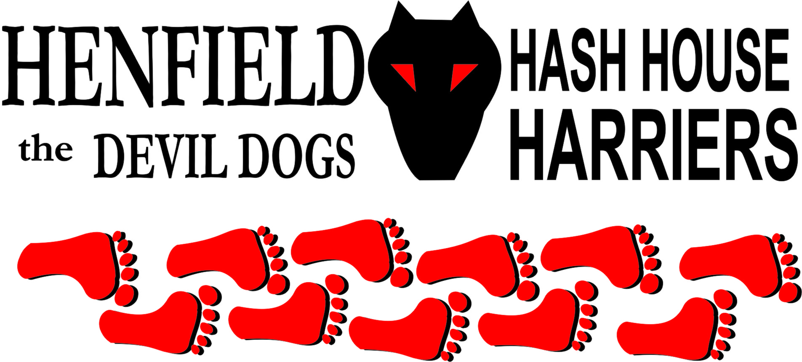

Henfield Hash House Harriers Run #69

Monday 28th April 2008 7pm
Gardeners Arms Henfield

Scribe: Snotty

With the feint smell of summer lurking, which abruptly came to end with the appearance of Cum Lately, was this an apparition or had he turned up for another event near by. No he had been thrown out of his house by Olga for making her pregnant and had no where else to go! After I collapsed in the middle of the road – luckily no cars coming, I got up to test my eyes again, yes it was that wanker from Brighton!

Bollocks and Split pin nearly crashed their car upon seeing Cum Lately (Split pin must have been driving) and Moneypenny nearly ran him down, Nightmare was happy as it was someone else who could listen to his bum story. Ali Chapman came out to keep Nightmare company on their walk to the beer stop, I am sure she is now a qualified proctologist (Bum doctor for the uneducated), after listening to the Nightmare bum story, I am surprised the Argus have not come up to take before and after pictures.

Rumpole had an essay to write and Homer, well after saying he was coming – Again. He failed to show up so I suppose Hashshit was the inevitable consequence.

Walkers set off, and the pack led out to the Roffey with Cum Lately going straight across the field before being called back, up into the high street, into the marsh, where Cum Lately took a short cut and was up to his socks in mud and water – ho ho! Across the A281 up around the southerly view and back across the A281 in one big circle jerk, which Cum Lately guessed quite well. Jane was hanging around for clues making sure she was around to call back Moneypenny and Bollocks. Into the woods and Cum Lately was off, the rest of the pack short cut across the field into the thicker woods, with Cum Lately yelping, “hey I’am following trail” the next few checks outfoxed all the hounds going off in different directions until they found true trail up into some ploughed fields, finally into an open area where Ali and Nightmare were still hunting down beer.

Good ale was drunk, with Nightmare explaining that a colostomy bag would be a better choice for the Hashshit and he was happy to donate. Well what that boy does not know about bottoms is just not worth knowing. Eventually Nightmare stopped talking a pile of shit and jokes were exchanged. Nightmares operation is on the 19th May, when he gets back suggest we all get together for a good curry, and Nightmare nobody wants to see the bag – honestly!

The on in was amusing with the joke being on Cum Lately getting lost and arriving back last, only to find Forrest at the bar with a beer! I had a bad cold he said! – whimp!

Marks for the run were outstanding averaging out to 6.9 very appropriate for the 69th run and boys plus Splitpin and Ali the T-shirts are in the post! Hashshit awarded to Homer – suggest you attend the next run as the Hashshit will have live cultures next time!

Good luck to Nightmare on the operation, we hope they don’t confuse your rectum with your scrotum. Although I have heard Maralyn on the odd occasion saying she would like to see your balls in a bag! (Squash I mean!)

On On

The Henfield Hash House Harriers cast in no particular order, nor importance to anyone other than the hare:

Hare - Snotty
Runners - Bollocks, Split pin, Moneypenny, Cum Lately
Walkers - Nightmare and Ali
Drinkers - Forrest
Hashit - Homer

NEXT HENFIELD HASH # 70 Details to follow

