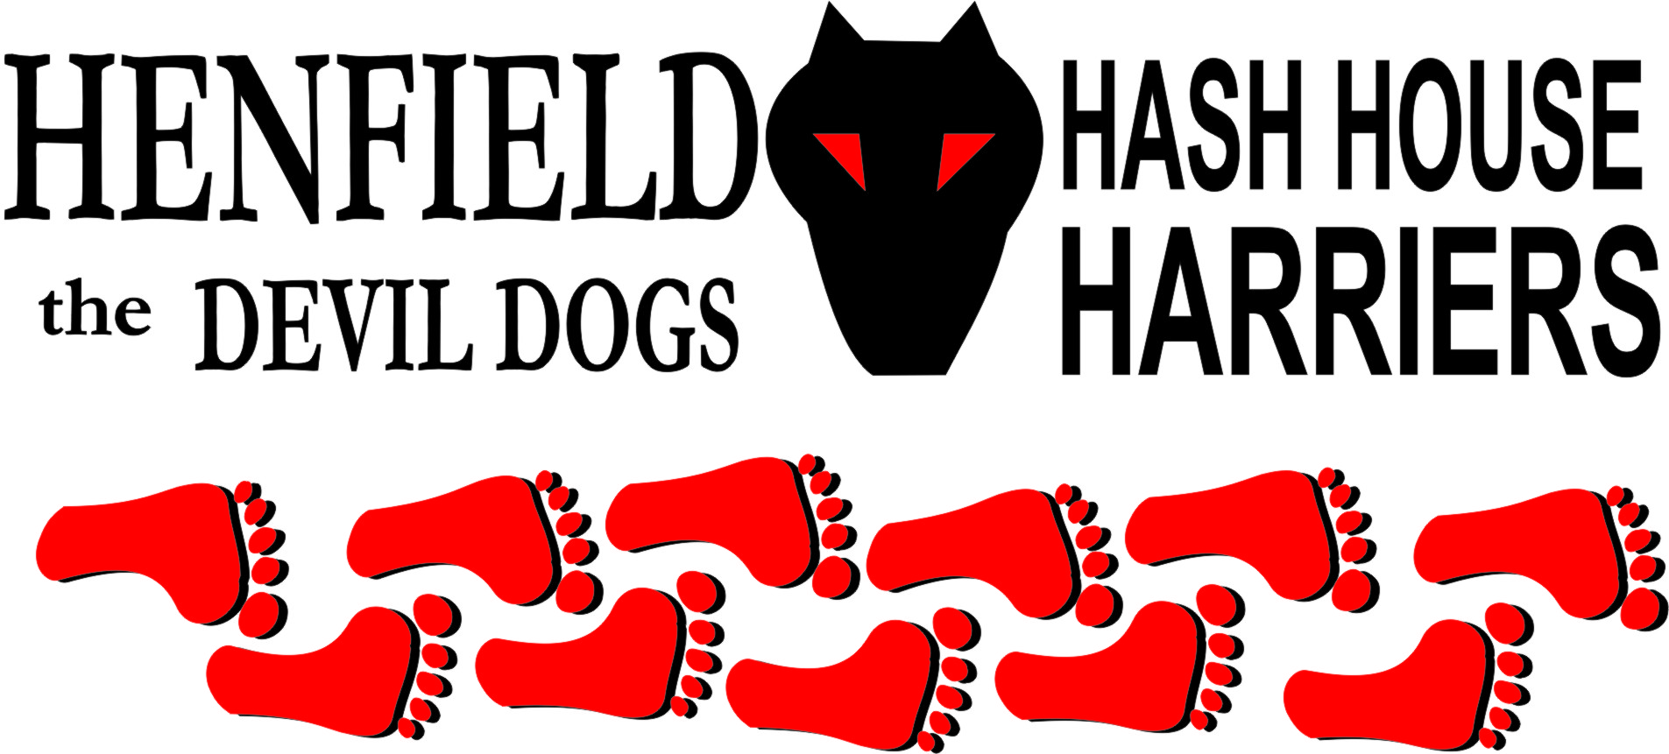

Henfield Hash House Harriers Run #68

Sunday 23rd March 2008 11am
Gardeners Arms Henfield

Scribe: Snotty

Easter it was and in good old British tradition the Snow started to fall early morning, which meant the hare (yours truly) had to get out of his warm cosy bed and relay the marks.
Usual last minute excuses from Bremner and Lowrie (Lowrie’s are just getting worse), surprise excuse from Homer who preferred the company of his in laws over the Hash!

After getting back from relaying most of the trail, Moneypenny was the first to turn up his eyes now almost now fully repaired from his detached retina; he was going to keep Nightmare company on the walking route. Finally Bollocks, Splitpin and Forrest showed up, and Nightmare turning up, with Rumpole close in tow after nearly mowing us all down in his car!

Nightmare was not fully fit having told us this could be his last run/walk for a while before he gets a colostomy bag fitted, hopefully only short term whilst his problem heals up, but this could be a real live alternative to the Hash shit – we could call it ‘Shit of Nightmare’ Lowrie could be the first recipient – if he ever again turns up. But credit to Nightmare who turned up, a lesson to some others with feeble excuses!

Some local runners were threatening to come but decided against it at the last minute – We think Bollocks scared them off! Anyway the off was sounded and the pack went all over the place with nobody picking up true trail until Rumpole stumbled across it and Forrest ran past an obvious turn before the pack picked up the trail around Southdown view, on trail onto another check with Forrest getting lucky and speeding off on his own waving his arms in the distance instead of calling on on!

The walkers had set off in another direction towards the beer stop; Forrest got the right trail from Shiggy lane, but was soon to get totally lost chasing another falsie through some sheep fields. Bollocks and Splitpin were going to follow when Rumpole stumbled on true trail and headed off. Bollocks and Splitpin son followed but Forrest just loves to run in the wrong direction! He eventually returned with the hare putting him on true trail.

Onto the railway lines after a few false trails then onto a new sign ‘backcheck trail 4’ where runners had to return 4 marks and pick up true trail to the beer stop where Moneypenny and Nightmare were hanging out in the cold breeze, some good old IPA was downed and jokes exchanged with Nightmare telling us how they probed him with a lance and condom or was it the Doctor’s dick!

On back was slow through some deep shaggy with everyone ankle deep and sliding around for a good mile in the best shiggy for some time, only Rumpole caught true trail and disappeared over the dunes not to be heard by the rest of the pack who continued into some knee high shaggy, with Splitpin moaning about mud up to her knees I could contain myself no longer and told them to listen for Rumpoles calls of On On.

Up the hill to Roffey football (soccer for the USA readers) field and on in to the Gardeners. Nightmare and Moneypenny already in the warm supping a warm pint of Harvey’s (Not quite as good as Bondo beer but close).

Marks for the run varied with comments of too dry to mud was too thick (moan and bitch) the eventual mark was a 6.8. Hashshit nomination by Bollocks awarded to myself for failing to set the last run – I cannot argue, for once! Food was very good with Splitpin downing a breakfast gut buster and Nightmare showing us that there was nothing wrong with his guts, downing beer, chips, garlic bread and pork belly!

Next run is No.69 so SusSEX is the place to have it, a date to be decided as shirts will be in free flow.

On On

The Henfield Hash House Harriers cast in no particular order, nor importance to anyone other than the hare:

Hare - Snotty
Runners - Bollocks, Rumpole, Split pin, Moneypenny, Nightmare and Forrest
Walkers - Nightmare and Moneypenny
Drinkers - The above
Hashit - Snotty

NEXT HENFIELD HASH # 69 Details to follow

