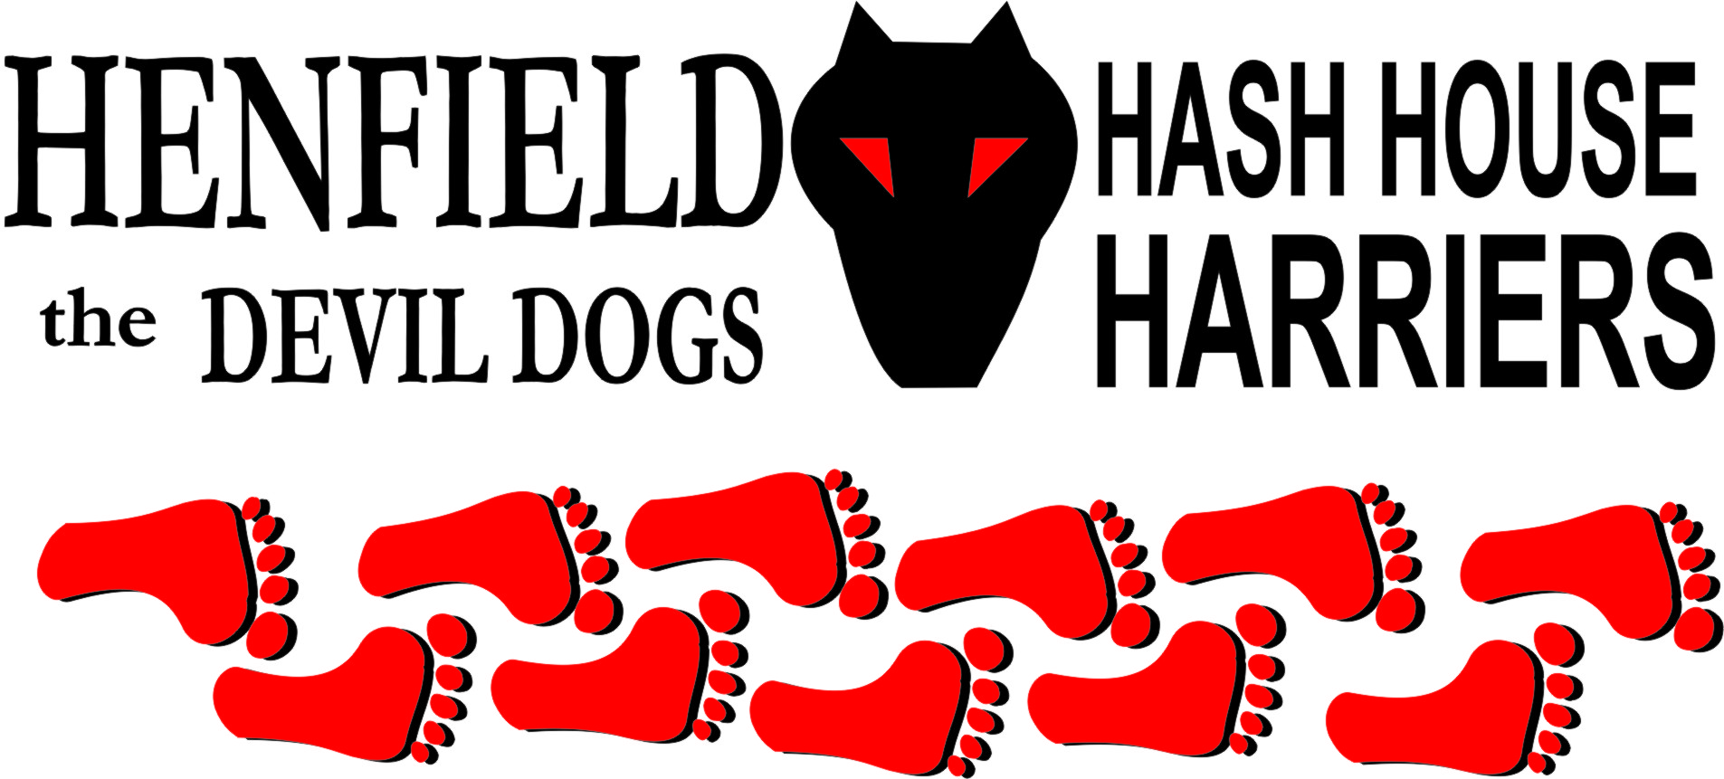

Henfield Hash House Harriers Run #67

Sunday 23rd December 2007 11am
Somerfield Car Park Storrington

Scribe: Bollocks

And it came to pass that on the eve of Christmas Eve a gallant band of Hashers and Harriettes assembled in the hallowed Somerfield Car Park to drink the mulled wine cup and munch the mince pie and prepare for the occasion of the Christmas Hash.
Henfield Hash, not known for their multitudinous following, had extended the floury hand of friendship to those known as the Brighton Hash and we were delighted to welcome so many new Hashers to our small and struggling group. Two Virgins in the guise of ‘curious onlookers’ were welcomed, well done Jan and Jeremy for listening to the rambling preachings of Forrest and joining us.
It was good to see Rumpole Foreskin back after a long time in the wilderness making cheesy chips and other such unhealthy fayre for the fat bastards at the Dyke Pub. His punishment over we expect to see him more often on our runs.
Cum Lately was not missed as we only see him on a run once in a blue moon, Moneypenny informed HM that he was only partially sighted and unable to attend, but surely he could have brought Mrs Moneypenny as his assistant and run the course. As it turned out the fog was so thick that poor sight was not really a disadvantage.
Homer is getting perilously close to being a Hash Wimp as his recent excuses of domestic requirement are not acceptable.
So there we were at 11am, five Henfield Hashers, two Virgins, fourteen Visitors plus three Sprogs fired up and ready to take on the trail set by Bollocks and Forrest.
A quick run down of the rules and regulations was thought to be of benefit as we were unsure of how Brighton signed their runs, sadly there were only looks of bewilderment and confusion so attempts to explain the trail were abandoned. Stupid headgear suitably attached and victuals consumed the off was it a north westerly direction through Spierbridge Road and the Horemare estate. It was apparent early on in the run that there were two distinct camps in the Brighton Hash and one or possibly two FRB’s set off at a blistering pace and were not seen again. Normally this behaviour would be considered admirable if the intention was to get to the beer stop or the pub ASAP, but to run the trail at breakneck speed and then go home is suspicious.
Most of the hounds were more cautious and were more than happy to hang around at the checkpoints whilst a couple or three athletic types checked out the falsies. My apologies here for not identifying Brighton Hashers by their handles but a combination of not having met them before and CRS (cant remember shit) means that apart from Mudlark, Bouncer and Angel the only face I remember having a name was Charlie!
The pack began to stretch out as we got into the glider field, HM Snot was attempting to bring some kind of order to the pack with his horn, however the combination of not being able to get a proper note out of it and a complete disregard of the code of the Hash Horn meant that no one was any the wiser as to the identity of the false trails or the correct one!
On-on through the fog to the Beer stop where a fabulous quantity of Tesco’s bargain beers was waiting in the bushes. Forrest played a game on the thirsty pack of ‘Find the Beer’ which was quite bad form. He has been known to interfere with the beer stop on previous runs and must be watched closely from now on. Sadly the reputation of the Brighton Hash as an ‘Animal bunch of boozers’ turned out to be quite unfounded and only a couple of their number partook of the amber nectar, is there a religious explanation for their abstinence?
Sir Snot in between songs suggested that we might spend the rest of the day at the beer stop as we were unlikely to run out but as responsible hares we had to continue and get the pack back to the pub.
A few more false trails, a bit of shiggy and some swearing found us back at the cars where clean clothes were exchanged for the mucky ones and a few (sadly only a few!) Hashers continued onto the New Moon for some well deserved beer and food. Brighton Hashers at the pub kindly gave the run a score of 7 which was reward enough for the hares. There was no circle as the majority had slipped away from the car park and avoided the head wetting they may well have deserved.
We look forward to the return cultural exchange visit to Brighton for our 69th and their 1550th (I think!) If the only way we at the Henfield Hash can get our numbers up is by gate crashing other hashes then so be it! Hopefully Jan and Jeremy wont have been scared away by Sir Snot and will come again.
Finally, hurry up and get yourself back to the hash, Nightmare. We miss you Buddy!!

On On

The Henfield Hash House Harriers cast in no particular order, nor importance to anyone other than the hare:

Hare - Bollocks & Forrest
Runners - Snotty, Rumpole, Split pin, Bouncer, Ratt, John hemming, Wiggy, Jo
Charlie, Mathew, Popeye Bloodlust ?, Matt, Mudlark, Max, Hugh, Elaine and George.
Walkers - Angel, Crackerjack, Gooey & ET
Drinkers - The above
Hashit - Cum Lately

NEXT HENFIELD HASH # 68 Sunday 27th December 11am in Henfield Details to follow

