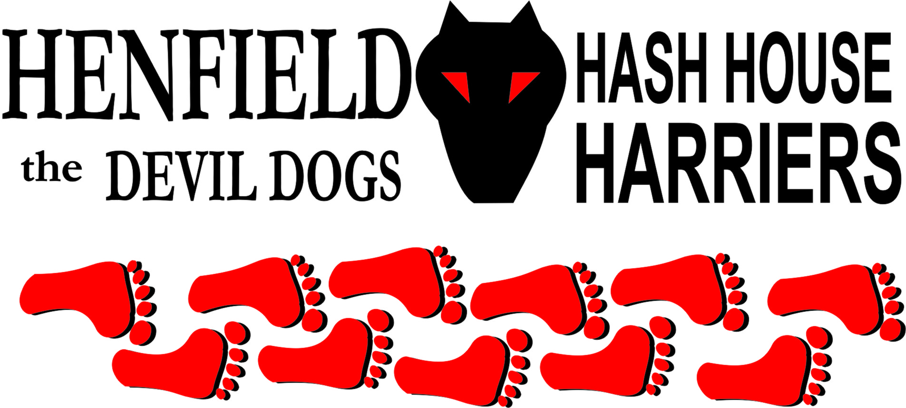

Henfield Hash House Harriers Run #66.6

Sunday 25th November 2007 3pm
The Tavern, Devils Dyke

Scribe: Bouncer

After the motley crew had finally found parking spaces (a task not made easy by the RA’s success in organising the weather which had dragged muggles aplenty up from the townships), and got round to assembling, and Angel, horrors and buggy had opted for an early start, Bouncer did some waffle about the Devil Dogs celebrating their 666th hash from the devils own pub and explained the dribble dropper markings. Markings were then explained to Cums Lately again as he’d clearly forgotten how to hash (as well as how to cum according to Snotty shortly into the r*n).

The on marks led west towards the hill fort then south to the trig point, which immediately threw most of the pack who plundered straight on not understanding the turn dots. Hare had evidently abused the ‘never check down’ guideline by not actually setting a trail from the trig. Eventually he gave in and pointed the hounds on to the South Downs Way. “Must be straight on as there’s no check” said Snotty, then: “Oh a check.” Straight on was right though and bodies came flying in from all the wrong directions, notable Homer, who then went off on a deviation of his own devising claiming an Eagle Split. As Snotty and Forest contemplated the golf course at the next check, Cums Lately went bounding off gaily calling and prompting all to follow until he reappeared giggling to head back up to the check. Joke was on him though as trail was called on down the hill after the Mudlark found the falsie.

Mudlark also found the next falsie as B-llocks called on up the hill and Cums Lately’s bizarre behaviour continued with him heading over the edge and pissing into the wind. The next check went left down to Saddlescombe and Forest flew off to the right for about 20 yards having previously decreed that the hare sets the on’s quickly. As no-one else found it that quick, despite Sir Snot viewing a barbed wire fence lustfully, hare then pulled a bluff dragging all back to the check (except the Mudlark who was halfway up Newtimber hill by then) only to find the mark through heading back down to an untested style. A short tarmac stretch then followed until the footpath veered off to the left. Hounds went in all directions at this point with some left some right and others straight on. For once Mudlark got it right calling on to the next check where cleats and rope were called for as we scaled a vertical cliff. The climb was short though and soon we were once again descending down to the road just outside Poynings.

Call went left again, round the church yard and north up the road, where Cums Lately was given some inside information enabling him to get ahead at the check, a position from which he would never really recover. Sir Snot stopped to show way too much attention to the horses as B-llocks pointed out the problem for Stan was that he had to go round the front to kiss them. Reaching the Royal Oak there was a call for a beer stop, hare having confessed that time had not allowed him to drop the necessary, an admission that had prompted Homer to ask every Muggle we passed if they knew where the beer was. After a re-count we still didn’t have any cash so off we went on trail again, by now apparently following Cums Lately’s route from the summer in reverse.

And so from here on in there were few surprises as we hit the base of the Dyke and headed right and up the steps to Forests disappointment. “I wanted to go up a dyke” he confessed. “Round here we call it the cwm or devils quim” Bouncer said, “so I guess I can understand that!” B-llocks, Forest, and Cums Lately then left the trail behind choosing to take their own route home to the pub, as Mudlark, Bouncer, Sir Snot and Homer took the final ascent straight up to the style at the top, from where the distant sheep appeared to have formed themselves into a gigantic mooning, which can only have been aimed at us. As we crested the brow we could see Lowry in the distance, coming in the wrong way, so we burst into a gentle jog only to see him sprint the last few feet of his climb in his desperation to be the first back?!

After a fair bit of faffing around, B-llocks and Forest were located in the pub, calling into question Cums Lately’s claim to be first back, and we headed in to the trees, in case there was any more shelter there (there wasn’t), for the down-downs.

The customary award went to the hare for the r*n, which earned various marks averaging to 6.66 according to Snotty’s brilliant mathematical mind, and the beer was duly, and very slowly put away. “Watch this, I’ll show him how to drink” then claimed Cum Lately, being punished for racing and stealing the hares tail and setting it three months earlier, then taking even longer and three separate visits to the glass to neck his beer. Other punishments were then meted out to Mudlark as a guest, B-llocks and Forest for attempting to by-pass the circle, and Sir Snot for only informing the hare that the r*n started at 3pm the previous evening. Homer somehow missed out completely, which in itself was amusing given his obsession on finding the beer throughout the r*n.

Next r*n was announced for Sunday 23rd December at the New Moon Storrington, hared by Sir Snot and B-llocks at the traditional time of 11am, which only left Bouncer to locate the rest of his family who were still out on trail over half an hour after the rest of us had returned. “I’ll go and look in the bar near the blazing log fire” offered a concerned Sir Snot! At least he got them all a beer when they finally arrived, although CL choking his chicken in front of the children was bad form. Rumpole showed his face and offered us some burnt chips and garlic bread to consume with the grog, well at least they did not run out of chips! Susan Shocks
The Devil Went Down To Sussex
The devil went down to Sussex
He wanted to cause a flood
But soon found out,
When the hash were about
They were happiest in the mud.
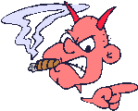
I bet you didn't know it
but I'm a hasher too,
And if you care to take a dare
I'll make a bet with you
Now you lay a pretty good hash there boys
But give the devil his due
I'll bet a barrel of ale I can ruin your trail
'Cause I think I'm better than you."

The Devil took hold of his trident
And pointed it at the ground
With a lightning strike
He left behind a Dyke
Which, still there, can be found
The waters of the channel
Were wary of the Devils heat
But the Henfield hash
Enjoyed a splash
And the Helfiend knew he was beat

Satan went back hellbound
With his tail between his legs
And the hash, with one mind
Were left behind
To polish off his dregs
Fire on the mountain, r*n boys r*n
Devil's on the hash, let’s have some fun
Gather together and splash in the mud
Then drink his beer back in the pub,

On and on and on and on …

On On

The Henfield Hash House Harriers cast in no particular order, nor importance to anyone other than the hare:

Hare - Bouncer
Runners - Snotty, Forrest, Cum Lately, Bollocks, Homer & Mudlark Walkers - Angel, Crackerjack, Gooey & ET
Drinkers - The above + Rumpole!
Hashit - Cum Lately

NEXT HENFIELD HASH # 67 Sunday 23rd December 11am in Storrington Hare – Bollocks Christmas lunch after!

