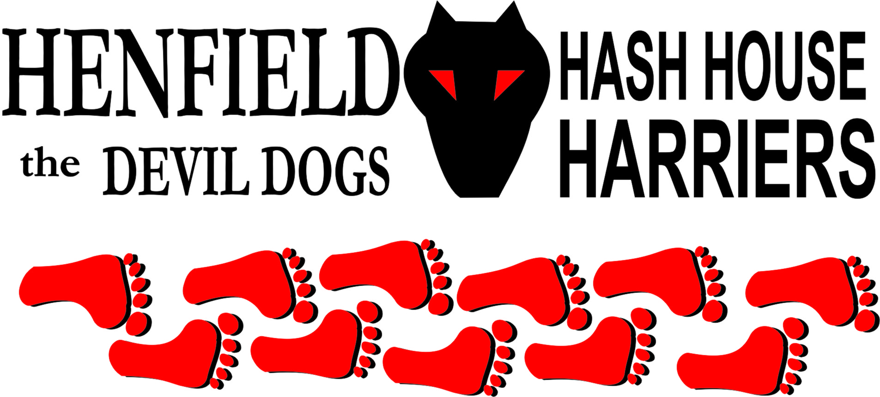

Henfield Hash House Harriers Run #65

Sunday 28th October 2007 4pm
The Partridge, Partridge Green

Scribe: Snotty

With the Weather just easing off a little, wind and driving rain was never going to be attractive for our fair weather runners, however Bollocks had apparently bought some good beer and that was enough for the war hardened runners of Forrest, Moneypenny, Bollocks and yours truly. The usual feeble excuses raised by David Bremner and David Lowrie. With Homer saying he had to do baby sitting! Or was it he did not want to get wet! – Definitely gets the Hashshit vote!

Even though yours truly had refereed to games that day and was a trifle sore I raised around Bollocks’s trail like a Ghazel – with a limp! The trail was all virgin territory with an abundance of wildlife around. One huge stag made an appearance plus four dear were around the beer stop waiting for a pint of Badgers! Prior to the beer stop yours truly led the pack for quite a while before Forrest and false trail Moneypenny finally caught up. Moneypenny was in fine form for heading in the wrong direction most of the time. Forrest finally lit his back burners and gradually stretched out the pack to the beer stop.

Beer was great; Bollocks even had a Fosters for Homer! Even the local cows turned their noses up at it and meandered away. At the beer stop the rain eased a little and it was starting to get dark so we all drunk up and waded through a horses field, we looking at the horses and the horses looking at us to work out who were the biggest idiots in the rain! The run by the river in twilight was actually really nice with loads of winter shiggy! Bollocks then led us through a cow’s field where Forrest and I were almost trampled on by the herd. Luckily Forrest shit himself and I stunk real bad and the cows managed to avoid us! With Bollocks and Moneypenny chuckling at the gate!

On In was on Southdown way and into the Partridge where a few beers and nuts were consumed whilst marking the run. With a maximum of 6.7 being awarded for the run being too dry and too much flour in parts! (It was like he was snorting coke off the road!) Homer was awarded the Hashshit for a pathetic excuse.

Future runs during the winter months will be on a Sunday at around 3pm (except Christmas run – see below)

On On

The Henfield Hash House Harriers cast in no particular order, nor importance to anyone other than the hare:

Hare - Bollocks
Runners - Snotty, Moneypenny and Forrest. Walkers - All from time to time
Drinkers - The above
Hashit - Homer

NEXT HENFIELD HASH # 66: Sunday 25th November 3pm Venue to be announced.

HENFIELD HASH # 67 Sunday 23rd December 11am in Storrington Hare – Bollocks Christmas lunch after!

