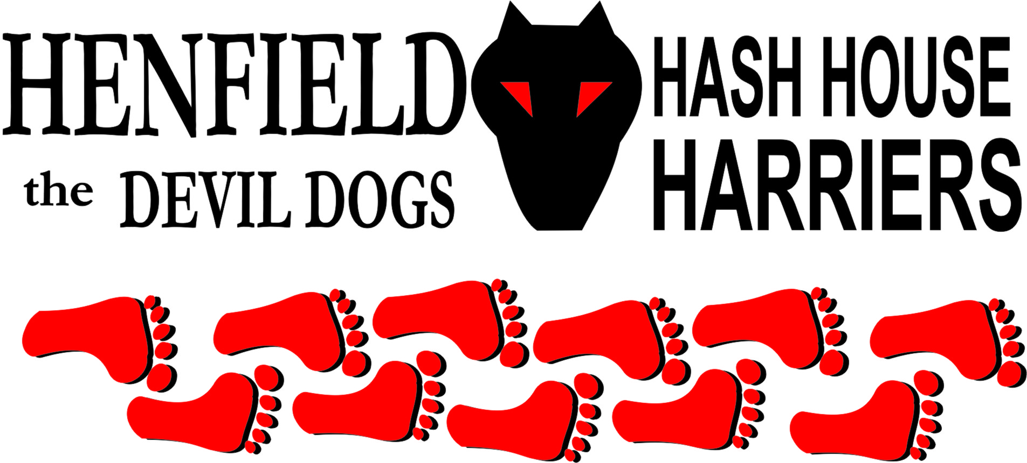

Henfield Hash House Harriers Run #64

Tuesday 2nd October 2007 7pm
The Star Steyning

Scribe: Snotty

With the excuse from Cum Lately that he was working – yeah right! Rumpole with “I had rugby training” and Forrest was running in France – I suppose that was a different excuse but as we all know Forrest just likes to run! The only valid excuse was from Nightmare with a boil on his bum, I think all parts of his body are on strike and each part of his body is trying to beat the other, as we can see the brain is losing out or is it growing!

Well next run is on a Sunday in daylight so we look forward to a good turnout as we all know most of you do not come at nights because you can’t afford batteries for your torches!

Homer laid the run on Sunday and that very morning at 5.30am, to set fresh trail. That may sound keen, but afterwards we found out he lost a 20p coin on the first setting!

The off was delayed by 5 minutes while Moneypenny struggled to get out of his suit in the car park luckily it was dark and no dogs were sniffing around. Yours truly had a bruised leg but still managed to turn up, the beer stop had been a tease from day one so expectation was running high, marks were clear – it is difficult to miss a mound of flour! We all thought they were fresh squirrel graves! Out from Steyning centre to the edge of Bramber on route passing a famous American monument – The White House, the closest we got to the ‘Bush’ was when Bollocks relieved himself!

We ventured through a secure area that has cameras as an area safety feature, unfortunately someone had ‘nicked’ the cameras and taken all the bulbs out of the lights! Moneypenny was leading the pack with Bollocks whilst I was hobbling about at the rear, until some cunning checks caught out Moneypenny and Bollocks and the ‘Hobbling whining Snot lead the pack on out to the beer stop! All you shirkers out there missed a treat, Homer had done a good job even laying on wine for our fairer sexes! Beer was in plentiful supply and the four of us shared some good joke. The owners of the said property garden were apparently distantly related to Homer, but three of us believed he had killed the owners and stole the booze! There was a suspicious smell coming from a tardis looking building – But the beer was more interesting. Back on through the back of Steyning to a Cum Lately look a like – The thinker-looked just like him actually, bald head, small willie and no money or BEER!

Right at the last yours truly caught up with Bollocks in a final sprint down the high street back to the car park and more beer, you see even we part time injured referees can turn it on if we have to!

Marks for the run varied from 9 to crap, but high visibility marks were not in question, next day an anthrax alarm was raised! Bin Laden has Bin here with the McDougal brothers! – If any of our American cousins want an explanation ask me on November 5th when I am back in RI to check out your sorry Hash!

A Sarah Hole has located us through the web site and although she missed the last Hash she is going to show us all how to drink beer I am told – Look forward to meeting you on 28th October!

On On

The Henfield Hash House Harriers cast in no particular order, nor importance to anyone other than the hare:

Hare - Homer
Runners - Snotty, Moneypenny and Bollocks. Walkers - All from time to time
Drinkers - The above
Hashit - Cum Lately

NEXT HENFIELD HASH # 65: Sunday 28th October 3pm Venue to be announced is in Shoreham area – Hare Bollocks.

