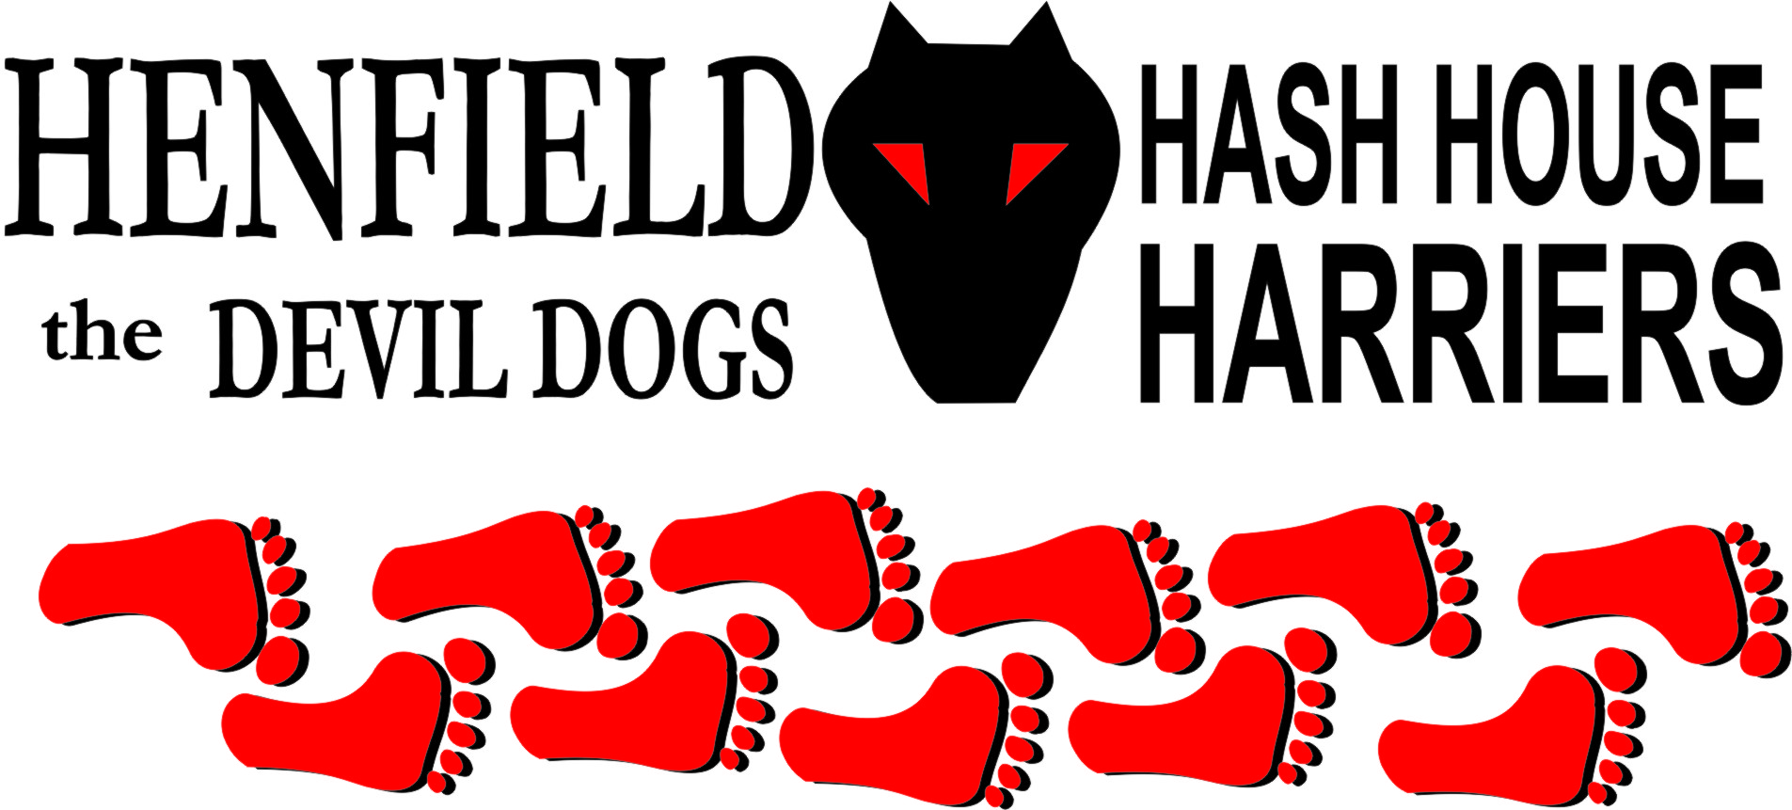

Henfield Hash House Harriers Run #63

Tuesday 11th September 2007 7pm
White Horse Pulborough

Scribe: Snotty

With the excuse of I have a cold from Cum Lately in a week where nothing but sunshine has been blazing down we all found that a little pathetic. Dennis was held up at a meeting, which at least had some credibility. Nightmare now losing his reputation of Henfields second most attended Hash House Harrier! But he was feeling poorly, bit of a bummer really. We all hope he recovers for the October run.

The weather conditions for once were perfect and Bollocks had done a good job laying trail. A number of falsies at the start caught yours truly out but onto trail in the heart of Pulborough, narrow trails with brooks and small lakes, deep enough to drown Cum Lately in were delightful scenes away from any houses. The trail ran us through a farm area and through numerous fields containing sheep cows and the odd bull, who was named curly due to the odd shape of his horns. Homer was leading trail together with Forrest until one check caught the front runners out to leave me to lead the field for some time until I took another wrong turn to find myself behind Splitpin yet again! Forrest had not taken too many wrong turns and arrived at the beer stop first only to hide the beer! Could have been a Hashshit offence had it not been for Cum Lately’s excuse. The beer stop also had a small bonfire with glowing embers and Splitpin put her Brownie skills to good use in rekindling the flames. So a warm night with a fire, and the only downside a mass of smoke! But the beers supplied were able to overcome this small inconvenience.

After a few beers of which there were many (Cum Lately please note!), the darkness was starting to come in and we set out back through more fields containing horses sheep and more bulls called curly! On the way back Forrest commented how he loved to run in the dark! Bet he wouldn’t have said that if he did not have a light on his head!
Back into the pub, which had some fine ales and our Hash Cash man Bollocks arranged some good old pub grub that was demolished by all. Marks for the run came in at a high 15----out of 100, but the great scenery pushed this mark up to a staggering 81! Forrest told us how his camper van could sleep two doubles, well take out the beds and fill it up with beer for next time!
Homer was keen to start next months run, even though it will be in darkness, but I am sure he will have plenty of beer at the beer stop – No Carlsberg Please!

On On

The Henfield Hash House Harriers cast in no particular order, nor importance to anyone other than the hare:

Hare - Bollocks
Runners - Homer, Snotty, Splitpin and Forrest. Walkers - All from time to time
Drinkers - The above
Hashit - Cum Lately

NEXT HENFIELD HASH # 64: Tuesday 2nd October 7pm Venue to be announced is in Steyning area – Hare Homer – bring torches!

