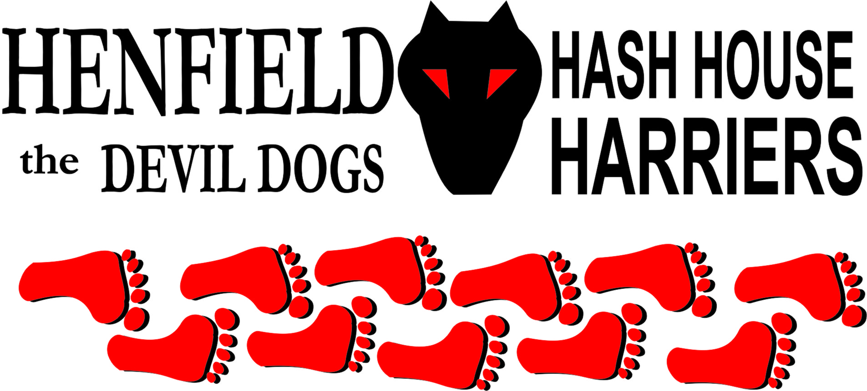

Henfield Hash House Harriers Run #61

Monday 30th July 2007 7pm
Royal Oak Pub Car Park Poynings

Scribe: Snotty

The call of Cum Lately setting a run with free beer was bound to attract a big crowd and we were not disappointed even though the venue was away from Henfield! Forrest had been in the car park all night in his camper van so he would not miss the event, I drove down Mrs. Snot, Nightmare, Homer and David Bremner, also arriving around the same time was Bollocks and Splitpin followed by Moneypenny (who had run out of excuses) - but the free beer was attractive! A new visitor Joystick joined us from Brighton for a real hashing experience. Then the king of excuses David Lowrie – aka - Cum Lately appeared with his newly wed wife Olga. A total of 12, wow we should be able to call ourselves a crowd now – well done to everyone for making the effort! The question was; where was the beer stop!
The pack set off in the wrong direction to start with, whilst the hare was briefing the walkers, eventually great mounds of flour (at least two) before the half bag Cum Lately had bought had run out, and the pack was chasing grains, Cum Lately had to steer the group around a few times due to the lack of or poor placement of flour. Never the less a very scenic surround, with yours truly taking the lead from Forrest and Bollocks, only to have a vanishing hare bemusing us with a disappearing act that only Joystick saw and kept quiet (and was to pay for later!)
The trail eventually wound around to the map reading of the Shepherd and Dog, where Joystick went into an open door and ordered some drinks but forgot to call in the rest of the pack! However David Bremner, Homer and Moneypenny recharged their tanks – and a good job they did!
Bollocks, Forrest and I kept plodding up hill until eventually came to great location for a beer stop but very little beer. The three of us arrived just before the Hare who showed us some sample bottles of beer – 10x100ml to be precise. The beer stoppers eventually reached us and the walkers had almost arrived when we ran out of beer! – What an offence! Outrageous! We always knew Cum Lately was cheap but this took the biscuit! With such a great view and no beer!
With no beer some singing broke out and burning at the stake was suggested, the walkers were told to go back the same way they had came! Yes a lot of thought went into that one. Both Mrs. Snot and Splitpin wanted to cut his wotsits off, we cannot repeat what Nightmare said and Olga told us she would make him suffer later – interesting comment, any chance of a write up in Russian?
The runners continued to climb towards Devils Dyke pub with the Hare leading the pack like a rugby training jog! Cum Lately has missed so many Henfield runs he has not quite got it. However the scenery was stunning and we did not have to look for any flour as by this time the hare had run out and was leading the pack! The trail from the peak could only be downhill and apart from yours truly landing on his behind leaving a deep impression in the ground the pack eventually came back to the car park where the walkers had already ordered the beer, David Bremner obviously smelling beer charged to the front like a Hasher possessed. Homer was unusually lagging the pack but quickly recovered when the beer was served as did Moneypenny.
It was unusual for the Henfield Hash House Harriers to form such a perfect circle; Joystick as a visitor and for not telling us where the hare vanished to (because the hare told him to say nothing!) got two down downs, which were well drunk. The hare had a beer and salad cream concoction, Olga obviously used to down downs but said she preferred vodka and told us Cum Lately looked better after a few! David Bremner who was getting married in a few days was persuaded to re-think but even after a few down downs he was going to go on!
Marks for the run were far reaching just like the flour from high to none at all! They averaged out to 1.9 the hare over dinner demanded a recount! Hence after the drop from 1.98 we decided to round down for ease of the write up! Food and beer was quite good and the lifetime award of the Rhode Island cock (up) as well as Hashshit was awarded to Cum Lately which he must bring to all future runs and must not abuse the poor creature! Cum Lately must now sing ‘My Big Rhode Island Cock’ at his next attendance. (We are hoping Basket Boom Boom from the RIH3 chapter will forward the latest version).
Finally well done to Cum Lately for starting to get his act together, great run shame about the beer and flour as with his school report ‘ has potential, gets diverted easily, needs to concentrate and drink more fluids!’
All agreed the next run should be in two weeks as most of us are on holiday at the end of the month and we all now like forming circles and not triangles, plus we can catch up on our missed run!
Everyone had a good time and Photo’s should be now up on the web site including one of David Bremners stag night with the stripper!

On On

The Henfield Hash House Harriers cast in no particular order, nor importance to anyone other than the hare:

Hare - Cum Lately
Runners - Snotty, Mrs. Snot, Bollocks, Splitpin, Homer, Nightmare, Forrest,
Joystick (Mark), Olga (Mrs. Lately), Moneypenny & Dave Bremner. Walkers - Nightmare, Mrs.Snot, Olga & Splitpin
Drinkers - The above
Hashit - Cum Lately

NEXT HENFIELD HASH # 62: Tuesday 14th August 7pm Venue to be announced is in Ditchling – Hare Moneypenny.

