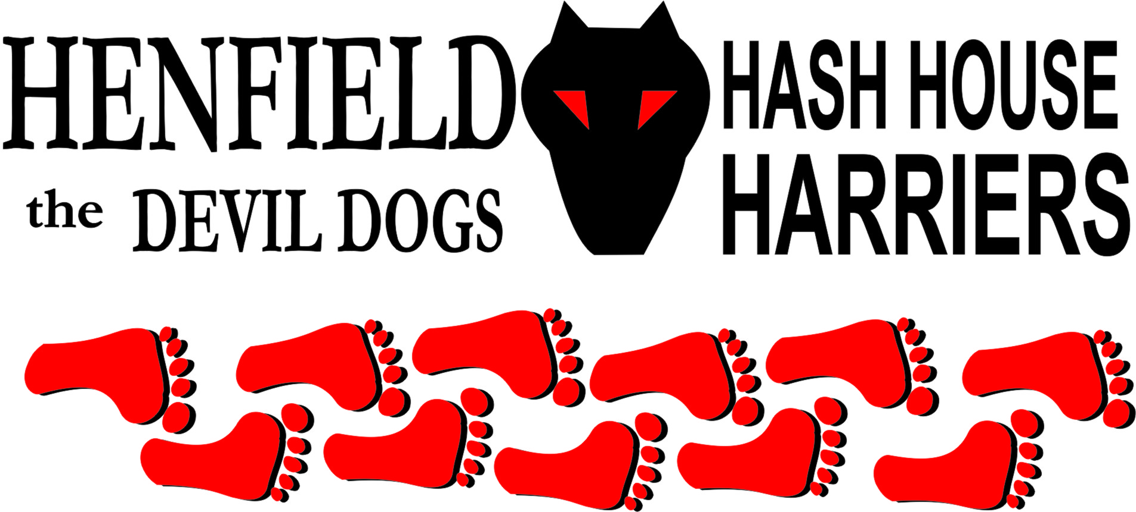

Hash #60

Monday 11th June 2007 7pm
White Hart Pub Car Park

Scribe: Snotty

The Hounds gathered at the White Hart pub car park for another auspicious run with the Henfield Hash House Harriers. Excuses from the usual reprobates Cum Lately, suggestions to change his handle to Evercome? His excuse revolved around his good wife who nobody has ever seen, is he really married or just using the title to get married tax entitlement.

One of our newer runners David Bremner rung at the last minute to say the cat he run over 2 days previously had come back to see if he could do a better job with the front wheels this time. The cat needed to be put to sleep, I guess to make an easier target and avoid swerving all over the road.

Nightmare returned for this run with his normal vigour and Rumpole put in yet another appearance, Dennis and Sally were very keen as it was Dennis’s birthday and Sally thought bringing him to the hash was a nice present – So did we! Bollocks arrived disheveled after a quick change on route and Homer managed to get the last parking space in the car park – Again!

The pack set out to get this 60th run on the road with Rumpole shooting off into the distance before being called back and Dennis just running off forgetting to call on on up Furners Lane, a devious right turn which Bollocks and Homer picked up with Sally preserving energy at the rear with Nightmare. Two checks further on Sally picked up true trail past the bowling club with the rest of the pack scattered, Dennis and Bollocks blew right through a cross and were heading off toward the High Street in totally the wrong direction, and even the hare lost sight of them! Back on true trail Rumpole was showing us how fit he was leading the pack (actually only Homer) eventually finding true trail past the cricket ground and across the main road with Nightmare and Sally just keeping a steady pace at the rear, the fast boys went on a huge circle jerk to be greeted at the top of the field by Sally, Nightmare and the hare supping the brew of the week.

However no sign of Dennis and Bollocks, we waited a while drinking the Snot’s home brew (best this year) to see the two lone runners having found true trail come towards the Beer stop then turn back on finding the big ‘X’ and also doing the huge circle jerk that Homer and Rumpole suffered. Even Sally hid in the trees so her hubby Dennis would not miss the big circle jerk, she said “He needs the exercise; I don’t want him too active tonight!” Up the hill came Bollocks hurling abuse at the hare for a little circle run followed closely by Dennis. Brew totally consumed by the hounds whilst telling the odd joke or three.

On back was through Henfield common with the last few checks throwing Homer and Rumpole off trail with Dennis and Bollocks being a little more cautious and following Sally’s lead. Rumpole impressed us with his leaps over the fences - must be the frog spawn in him! Nightmare finally got into a trot to impress the locals down the high street and back into the White Hart beer garden where marks for the run, which came out to a respectable 5.4 and 9 for the beer stop and home brew! Hashshit was nominated to Dave Bremners cat but Moneypenny just got in by a whisker – from the cat! Munchies were served in the way of Garlic bread and chips with Dennis trying to buy us all a round first with Euros’ then Scottish money – none of which was accepted – we knew it was too good to be true. Happy Birthday to Dennis I am sure it will be one he does not forget.

On On

The Henfield Hash House Harriers cast in no particular order, nor importance to anyone other than the hare:

Hare - Snotty
Runners - Bollocks, Homer, Rumpole, Nightmare, Dennis & Sally Walkers - None! (Nightmare did run for at least 100 yards)
Drinkers - The above
Hashit - Moneypenny

HASH # 61: Monday 30th July 7pm Venue to be announced.

