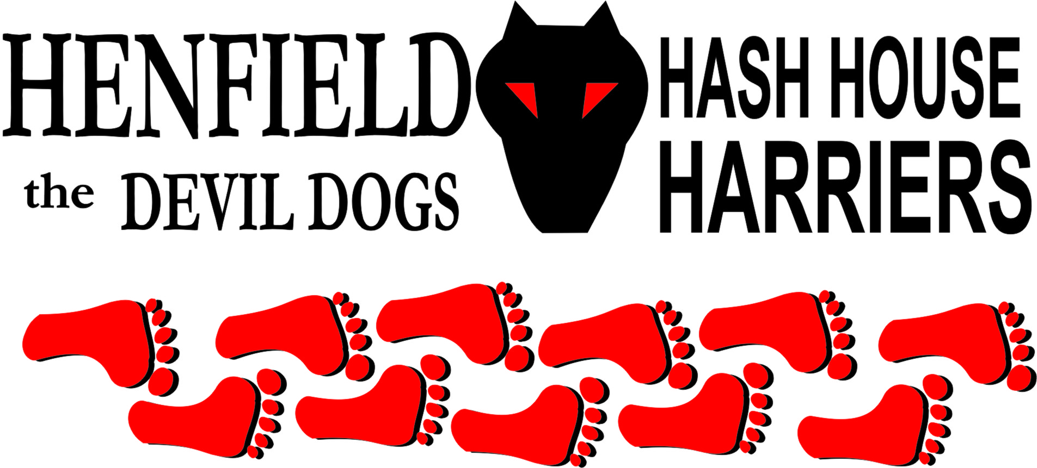

Hash #55

Sunday 24th December 2006 11.00
Summerfield Car Park Storrington

Scribe: Bollocks

When the going gets tough, the tough at least turn up. So it was that six devotees of the Henfield Hash amassed in the Storrington car park on a cold and overcast morning, sort of prepared to accept the task ahead of them and determined not to appear too wimpish at the checkpoints.
The theme was seasonal, Splitpin, Bollocks and Forrest wore Santa hats, Moneypenny preferred a Himalayan Yak hat, and Snot and Homer declined to wear anything remotely unusual. (Sir Snot was apparently wearing furry girly underwear but wouldn’t show us!) A quick shufti inside Snot’s motor indicated that Homer had prepared himself by downing a bottle of blue WKD on the way to the run. Now that is the sort of grit we need on the H4 runs, but he could have brought more for the rest of us…..
After a fortifying pre-run cup of mulled wine and a mince pie, the pack set off apace up Mill lane and into the Wantley lane estate.
Homer showed his usual sense of adventure and attempted most of the trails. Sir Snot, running on fresh legs, gallantly ran off from several of the early checks and was not too vocal in his disappointment at finding nearly all of the early falsies himself. Moneypenny shuffled along with his hands in his pockets tightly clutching the assorted loose change he had brought with him to exchange for beer later on.
Before too long we were out of the houses and into the green fields on the Northern edge of the village. Hardly had we begun to get into the shiggy when Snot began to get twitchy and started to ask where the beer was. He said he was sick and had a cold, we all believe it was a hangover and he needed more alcohol to feel better.
Bollocks helped Splitpin up a treacherous slope by holding her hand, on seeing this Snot feigned an attack of gaiety (of the Kemp Town variety) and demanded to be assisted in a similar manner. He was told to ‘Piss off’.
On passing the Jehovas meeting hall (which by the number of cars outside meant it was probably full) it was suggested we knock on their door and try to offer them some leaflets proclaiming the good work and benefits of devout Hashing. But alas not enough time, there was pub to get to later…..
So over the Thakeham road and eventually up the steep rise onto the ridge, at this point we were missing Splitpin and Forrest. Splitpin had been allowed a short cut, but not Forrest. Eventually arriving at the back of the Abingworth hotel we found the errant Forrest who had also short cut one of the most demanding and scenic sections of the run. His clown shoes with the flappy toes were quite unsuitable for running up hills, and so he was let off.
With several miles still to run we pushed on to the next section where Snot was delighted to find that, a) some wandering B.A. hostie had left her headscarf for him to model, b) there were no marks. A growler with a taste for flour had diligently wiped out all the spots and checks and so it was we arrived sooner than expected at the beer stop.
Snot told a good joke. Beer was downed. It was only Carling but it was on offer at Somerfields.
On leaving the beer stop and with the taste of malt in their mouths Moneypenny and Homer steamed off ahead, obviously keen to get to the pub. Moneypenny displayed all the signs of ‘Old Hasher Wisdom’ and totally ignored all the remaining checks (bar one where he was sniffed at quite attentively by a stray growler. Splitpin was concerned that the mut was lost and checked his I.D. medal which was inscribed with the name ‘Barny’ and the legend ‘The only Gay in the Village’; A lucky escape for Moneypenny!).
Snot did his best to keep up and eventually we arrived back at the car park. Shiggy shoes and clothes were exchanged for more acceptable attire and we headed for the New Moon and some fine ales and food.
A text from Cum Lately would have had us believe that he had been waiting for us at the pub earlier but had gone home to Brighton. We went outside and the smell of Bullshit was over-powering. Snot sent him a reply to the effect that H4 thought he was a self-manipulator. We toasted him with empty glasses, then had them filled up again!
Marks for the run were quite high, whatever that means. Forrest & Bollock’s efforts as hares were appreciated by the small pack but we must increase numbers.
The next run date is as yet undecided. We will approach Chichester H3 in the next few days and try to arrange a cultural exchange visit to one of their runs. If it goes well we will invite them to one of ours. Increased numbers by default!
On-on and Merry Christmas to you all. Bollocks.

The cast in no particular order, nor importance to anyone other than the hare:

Hare - Forrest & Bollocks
Runners - Splitpin, Homer, Snotty & Moneypenny
Walkers - Splitpin in parts
Drinkers - The above
Hashit - Cum Lately

HASH # 56: Sunday 28th January 12pm at the Gardeners Arms, possible mid month run with Chichester H3 to be arranged by Bollocks.

