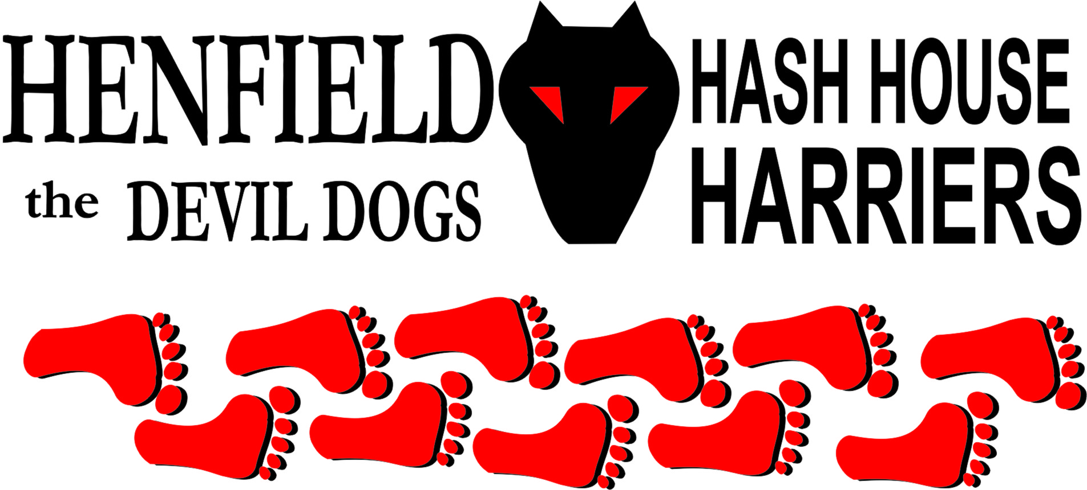

Hash #54

Sunday 26th November 2006 12.00
Gardeners Arms

Scribe: Snotty

Sun out temperature high for this time of year and shiggy up to your ears, perfect running conditions for any Hash. Hare set off early to negotiate the run through sheep, bulls, horses and pigs! (No mention of anyone at this point!). Just getting back in before runners started arriving, first on the scene was a somber looking Homer, then Nightmare, Marilyn and Mrs. Snot showed up without daughter (Frances) who was a little worse for ware, still sleeping with peas and carrots! Then came Bollocks, Splitpin and Forrest.

Excuses – MoneyPenny, Rumpole (working), Cum Lately (anyone surprised?)

Mrs. Snot and Marilyn set off on the walking trail towards the beer stop, whilst runners soon found true trail away from the Gardeners. On keeping the walkers company for a while we stumbled across Forrest who was well and truly lost! On past the scout hut and through Martyns Road into Parsonage and up onto the farm. Forrest at this time had caught up the pack with Homer leading; Bollocks soon fired his retro’s and was quickly up to his ankles in shiggy but was first out onto the old railway tracks. A brilliant check had the hares going around in all directions with Bollocks accusing every one of cheating and being an SCB!

Forrest now put on a charge and was way out front guessing the next two checks spot on and building up quite a lead heading South down the railway line track and past the kennels. Nightmare smelt beer and decided that these 2 miles was his allotted run for this month! Splitpin decided to chase on and before long, we spotted Forrest getting slowed up by a check allowing the rest of us to get in front. Splitpin wanted to see the pigs I had mentioned and we soon cam upon them, to see if they matched up with Bollocks (I thought they were better looking!). The three pigs had stopped playing with a soccer ball (Latest David Beckham replacements) to check out this set of Hashers, Bollocks was able to communicate with them quite well, but they soon realized his snorting and grunting was a load of Bollocks and decided to tell Splitpin what improvements she could make! (Lost cause and not much meat on the bone!).

Down to the beer stop where Mrs. Snot, Marilyn and Nightmare had just arrived, beer was distributed and lots of chatter was made, without anyone realizing that Homer was not drinking! He looked a little down but we just thought he was a little tired. On in was past the three upright cars in the ground, which is a memorial to one of the son’s that died. Someone should have told him he cannot drive to heaven and even if he could no need for spares!

Up past the old farmhouse, through a field with a few bulls sizing us up and down, with Splitpin making a dash for the gate, Bollocks was encouraging them to chase her – What a pig! Bollocks got caught on the only check back on the run, with the others heading towards the On In.

Back at the Gardeners Forrest decided to show all in the car park, just at the time the only two virgins in the village went passed, ruining their lives forever. Swing low and hang low all came together! – Quite the exhibitionist! We were a bit slow with the cameras and the Kodak moment was missed! Whilst in the pub sirens could be heard all around, the police looking for something or someone! Pub grub was a mass of sandwiches the Landlady had put together for us, and the circle up was had with down downs awarded to Homer for refusing his beer at the beer stop and Hashshit went to the best excuse for missing the run – you guessed it Cum Lately – can they get any better!

Bollocks volunteered to set the next run on Christmas Eve, which falls on a Sunday – mulled wine and mince pies promised!

See you there!

ON ON

The cast in no particular order, nor importance to anyone other than the hare:

Hare - Snotty
Runners - Bollocks, Nightmare, Homer & Forrest
Walkers - Mrs. Snot& Marilyn
Drinkers - The above
Hashit - Cum Lately

HASH # 55: Sunday 24th December 12pm at the Somerfield’s car park in Storrington. Prizes awarded for best Christmas apparel!

