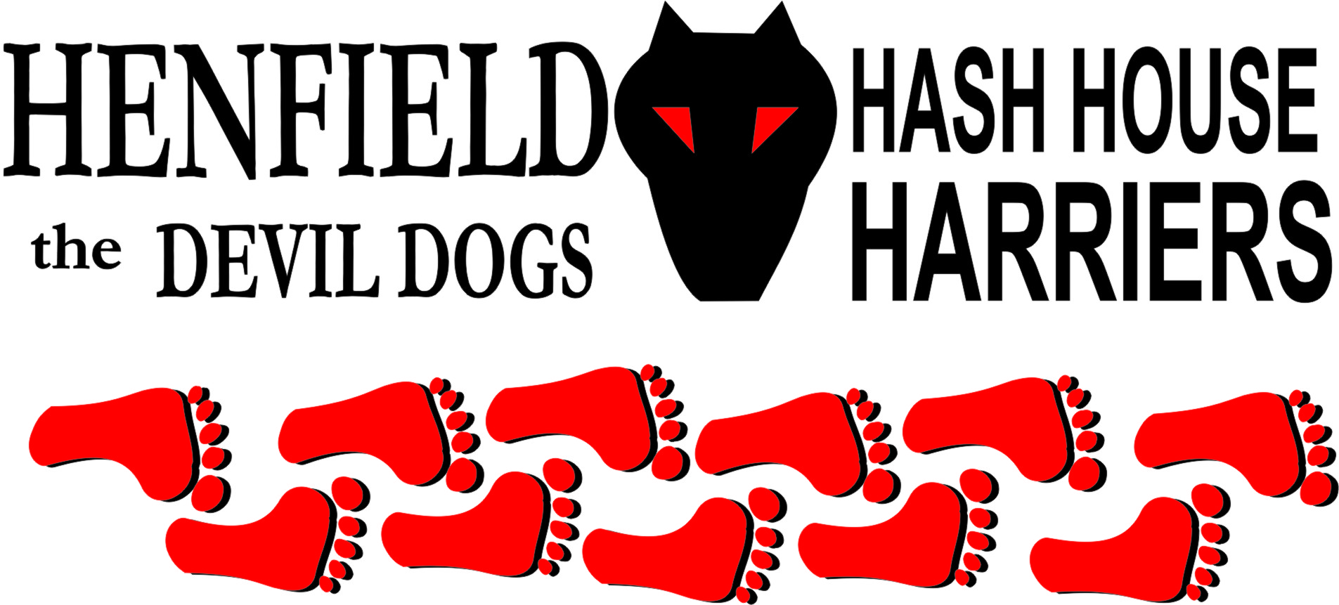

Hash #53

Sunday 29th October 2006 14.00
Gardeners Arms

Scribe: Snotty

After putting off the run for Forrest until 2 pm when he could make it, he still did not show up an instant Hashshit offence, especially on the 5th year of existence of the Henfield Hash. On this day Cum Lately said he was still looking for a curry house, Moneypenny said he forgot to put it on his Playboy diary and this month’s tits were quite distracting!

First up was Bollocks keen as mustard to get a quick beer in, Nightmare ran (rare site) up to the pub once the drinks were being paid for by Hashcash Bollocks, and we waited there beer in hand until the hare returned from laying the beer or was it the Mrs?

The run set off in a westerly direction down and around the old railway line where Bollocks and yours truly were caught off guard by the cunning checks, with Nightmare doing a brisk pace next to the hare! Wildlife was evident with Friesians or whatever Bollocks thought they were, but it smelt, pissed and crapped like a cow.

The trail ran dry in some virgin fields with the hare doing a figure of eight in one of them trying to remember where he set trail, Nightmare helping at every step! Eventually passed some horses who tried to lick Bollocks but he just was not up for it, even though this one horse had a 12 inch tongue.

Sorry girls unless you come on the trail I cannot tell you where this wonderful animal is!

Eventually Bollocks and yours truly set off blowing through now most of the obvious checks to find the beer stop overlooking the Dyke and the South Downs. The cunning hare hid the beer so well that we could not find it until Hare and Nightmare got there.

Beer was sunk upon old Mr. Whites seat, made especially for Hashers, as this was a spot of beauty many male passers by were interested in the beer until the female counterpart dragged them away.

Nightmare was worn out after this long walk and wanted to carry the remaining beers back for the hare! Yes we all believed him! The next part of the run was long but great fun, with Bollocks getting lost in Henfield woods and eventually leading out to the water treatment plant, it was obvious to me we were heading into some serious shiggy and I took the high ground with the hare leading Bollocks into some ankle high mud! Being smart (like Forrest) gets you called a SRB.
Through another set of woods on the northern boundary of Henfield back through the village and back to the Gardeners for a gastronomic feast of beer and nuts!

Down Down for the SRB – guess who and Hashshit for Forrest. It was agreed that Cum Lately could bring the curry he keeps promising on the next run, fat chance of that!

Until the next time where the H4 continues!

ON ON

The cast in no particular order, nor importance to anyone other than the hare:

Hare - Homer
Runners - Snotty & Bollocks
Walkers - Nightmare
Drinkers - The above
Hashit - Forrest

HASH # 54: Sunday 26th November 12pm at the Gardeners Arms in Henfield.

