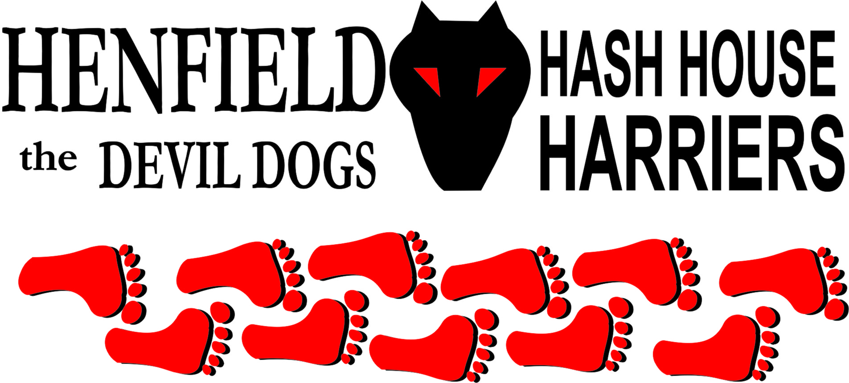

Henfield Hash House Harriers Run #109

Sunday April 29th 2012 11:30 am
Waitrose car park Storrington

Scribe: Bollocks

If Noah ran for Henfield Hash then his excuse for not running #109 because he needed to get on with his boat would have been valid, but for everyone else it was business as usual. It was very rewarding to see so many turn up to the start in Waitrose car park, but the majority were late for the 11.30 start so I wonder if there was some strategy amongst some of the pack to turn up, find the hare had left, and go straight to the pub!

But we were not going to allow anyone to miss out and eventually, at 11.42, we set off with 13 runners , 2 walkers and 2 dogs.
Heading along Riverside Walk the snapping hounds soon found the fresh trail and the first check which was investigated with enthusiasm. A distant on-on call had the rest of the pack continuing alongside the river to the second check where the walkers were instructed to head North.

The trail led down to the torrent that was the river Stor and onto the third check which had been found a small soggy pile of shavings and called the pack on towards Hurston Lane. Cystpit found the next check and ran off in the wrong direction with a big grin and sploshed his way through the deepening puddles.

As the rest of the pack arrived we noticed Pirate had been missing for a while. Splitpin offered to go back and find him whilst the rest set off across the horse paddocks towards the exceptionally wet fields where Roadrunner immediately set off on another falsie. By now all hope of trying to keep dry had been abandoned and Hashers shed years and inhibitions to jump around in the streams and puddles like children. (Especially Angel)

On up the fields to what had been marked as a HOLD, nobody was sure what this was all about Hold onto your hat? Hold on to your shorts? Hold onto the fence and avoid being swept away??? Hold what??? Only Bollocks knew what to Hold!!!

Unfortunately the Hold marks had been washed away, but it would have made no difference as nobody knows what a hold is (Snotty pinning down Bouncer at the 100th – that was a good hold!) and there was no sighting of the walkers (Moneypenny and Splashback + dog) so Cystpit and Wiggy set off to try and find them.

Eventually these two returned alone but with the miracle of the Mobile managed to contact Pirate and Splitpin, and before long the pack was back at full strength. We collectively decided to abandon the search for the walkers, the thinking being that as Splashback was a local she should find her way home if lost…. But Splitpin upheld her duty of care as co-hare and set off on the walkers route to try and head the wandering 2 off at the beer stop.

On along the Ridgewalk towards West Chiltington and some frantic trail chasing from Wiggy left him abandoned by the masses who had sensed that the beer was going to be back towards Storrington village and had headed off towards the hills. Wiggy was eventually called back and after a few false trails and chats to civilians trying to unblock flooded drains we eventually met up again with Splitpin who reported in that the walkers were well and truly lost as there was no sight of them.

Cystpit and Pirate shot off towards the beerstop, but when the rest of the pack arrived they were no where to be seen. The rain had almost erased the BS sign and they had run straight through. The beer was gathered in from its place under the Great Oak and the FRB’s called back. By this time the rain had stopped and although thoroughly soaked the pack were in good spirits. The taste of beer in their throats the pack headed south. Only the FRB’s Cystpit and Pirate ran the full trail, the rest of the pack happy enough to fly like crows back to their vehicles and warm dry clothing.

Arriving at the car park we found the itinerant walkers supping vintage ale from tins with all the subtlety of a pair of street lushes (The only part of the pack with any brains!). They even had a dog looking suitably mangy. During his debriefing Moneypenny confirmed that he had identified the beer stop, and had even spotted the black bin bag containing the beer, but the altogether not-very-clever Numbskulls on duty in his head that morning told him the bag was too small for a Henfield Hash beer stash and instructed his legs to keep on walking. Doh! (Retract the brain part)!

Off to the Moon for well deserved beer. Down downs to Bollocks and Splitpin for a magnificent trail, Pirate for his inventive all weather footwear, Steve for being a Virgin, Splashback for being a newbie to H4. Moneypenny for running past the beer and the Hashshit went to Snotty – what for who knows but he just deserved it!

On On

The Henfield Hash House Harriers cast in no particular order, nor importance to anyone other than the hare:
Hares | Bollocks and Splitpin
Runners | Snotty, Bollocks, Splitpin,Homer Roadrunner, Pirate, Helen, Steven Hunt, Cystpit, Gillette, Angel, Karen Crosby, Slashgordon, Wiggy & Tosser.
Walkers | Moneypenny, Bouncer Crackerjack, Gooie, ET, Splashback
Drinkers | The above
Apologies | Cum Lonely (The weather & Gout)
GrandMaster | Snotty
Religious Adviser | Bollocks ( self-appointed)
Large Wildlife | Fish
Twin Town | Warmington-On- Sea
Hashshit | Snotty

NEXT HENFIELD HASH – 110 Sunday 24th June at Franklands Arms in Washington Hare Bollocks & Splitpin

