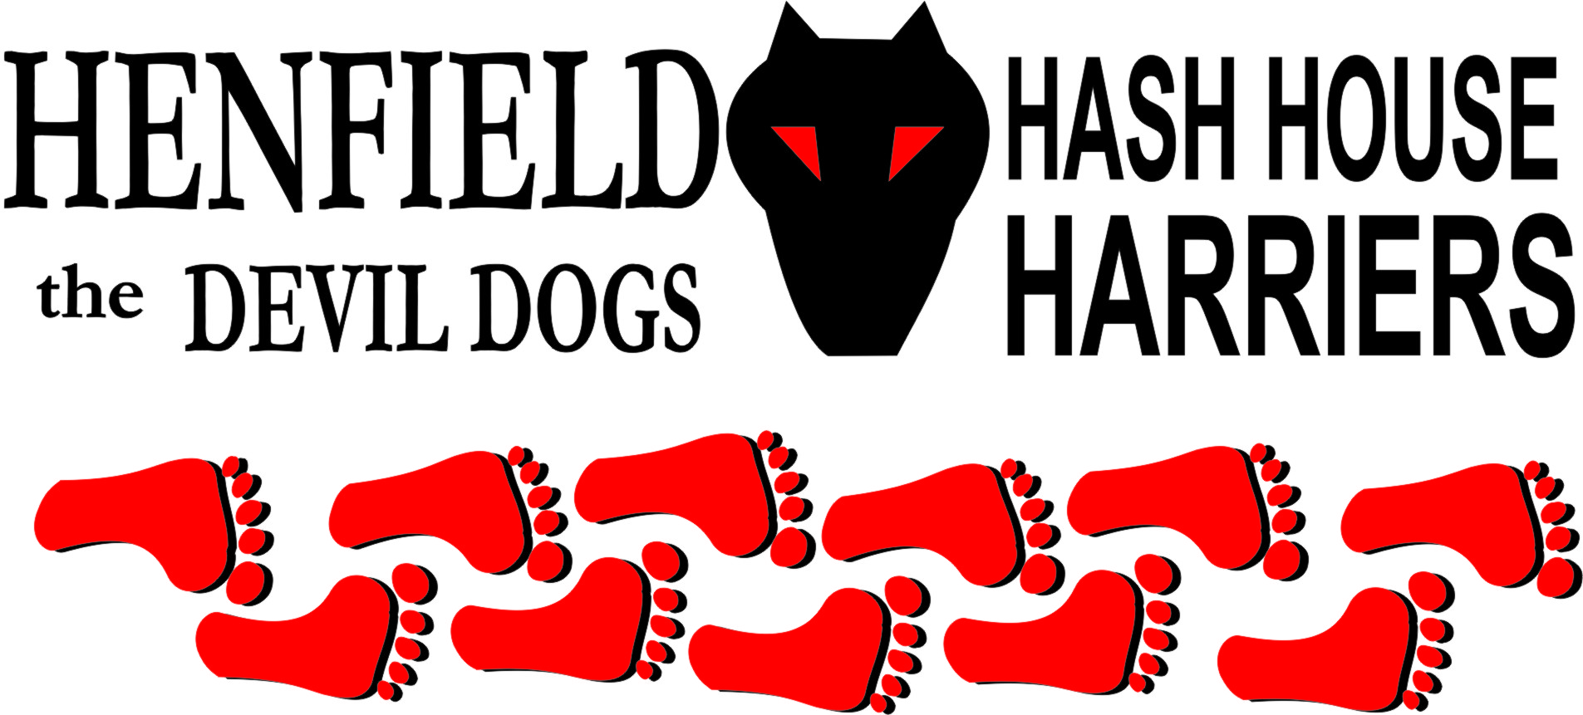

Henfield Hash House Harriers Run #108

Sunday March 18th 2012 11:30 am
Royal Oak Wineham

Scribe: Tosser

A combo of Mothers’ Day and lousy weather led to plans for a short run for a few mad orphans. Climate change, maters fobbed off with a brief phone call, and, hey, we had a turnout. Graced by Malibog, tame Swede, plus a contingent of visitors via the Hastings Hash and a few new faces coerced by Splitpin, the finely honed athletes strode out across the fields of Wineham. OK, I lie! In truth, the only evidence of anything remotely athletic was Bouncer, obviously delusioned by Olympic marketing, challenging fashion in a stretched (not manufacturer’s intention) bright green lycra “T”. Dishevelled and chaotic as expected, the stroding became trundling after obscure flour, on-on around a veritable maze of purpose built paddocks, normal tenants of which hadn’t yet made it back from Cheltenham leaving one nag to fertilise the lot.

On down through the nothingness of Waterperry. A big check picked up by Bollocks, who unfortunately spotted a distant mark before nearer one and completely bypassed a sojourn through adjacent woodland. Further proof not a trail design fault came at next check where front pack boldly went where none been before, least of all the Hares, and had to be called back on-on in diametrically opposite direction. Some seriously overdue eyetests. Trail then straddled River Adur and over soggy patches of flood plain to Beer stop.

St Paddy remembered, Riverdance might have been appropriate but mercifully settled for well known stout and surprisingly drinkable Irish Whisky. Blarny in the chatter not stone and not a plastic saint in sight, suitably fortified, the pack then endured a minor detour, more suspect checking and a short jog to the pub.

Warm in the sun, excellent cask ale and Circled-up outside. Good marks for the run, esp en-route pause, although when the lady with Hastings said she usually liked it longer, it took several minutes to return to the subject in hand (so to speak). Down-downs for Hares and new faces, plus the reprobate of the day, Pirate, living dangerously leaving Circle on a mobile call (mum???); technology on the Hash compounded by telling GM to hang on a minute, meant unanimous award bestowed mid-conversation – Hashshit for foreseeable future – Classic!

On On

The Henfield Hash House Harriers cast in no particular order, nor importance to anyone other than the hare:
Hares | Tosser Lorna & Robin
Runners | Snotty, Bollocks, Splitpin, Gillette (Hound), Pirate, Cliffbanger, Bushsqatter, Wildbush, Bouncer, Cleverdick & Devil Kinevil
Walkers | Kingfisher, Queenfisher, Malibog, Ruby (Hound), Tilley (Hound), Henry (Hound), Emma, Jules, Robbie & Cat
Drinkers | The above
Apologies | Homer & Roadrunner – Football??
GrandMaster | Snotty
Religious Adviser | Bollocks ( self-appointed)
Large Wildlife | Cattle
Twin Town | Warmington-On- Sea
Hashshit | Pirate

NEXT HENFIELD HASH – 109 Sunday 29th April in Storrington at the back of Waitrose car park – Hare Bollocks & Splitpin

