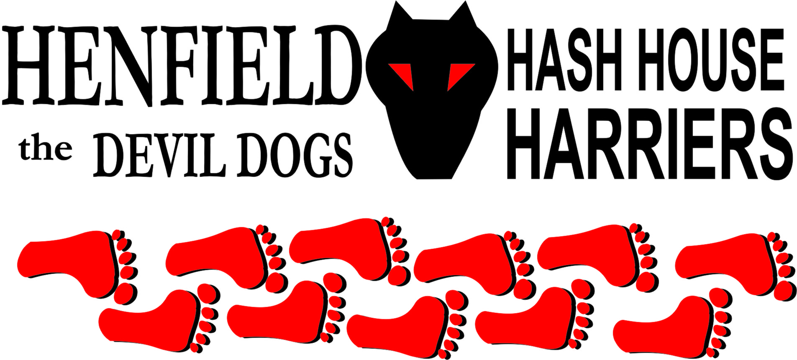

Henfield Hash House Harriers Run #107

Sunday January 22nd 2012 11:30 am
Cat & Canary Henfield
Burns (No 3)

Scribe: Mr & Mrs Slash Gordon

Undeterred by all the Alex Salmon independence rantings up north we had some 21 hardy “ loons quines and bairns” (men, ladies and children) turn up for this mid winter cultural event. We also had a couple of keen “tykes” (dogs) straining on the lead “rarin” for action and a lick o’ the Budgens best self raisin.

Best dressed arrival prize went to Mrs Bouncer who turned up in bright reddish tartan kilt. As a counterbalance to this height of Princess Street fashion the knee of her running slacks could have benefitted from a stitch in time!

The Henfield Hash isn’t famed for punctuality and it was some 20 minutes after the designated 11.30 am before the hare (Slash “McSporran Gordon”) the Braveheart style call to arms / on on . Following an admirable translation from Mrs Slash G in more refined Sussex tones Wiggy then turned up in a big Merc breaking all records for lateness. Another 15 minutes later after pub car park shunting and snails pace change into hashing gear – off set the intrepid poetry lovers – with the runners heading west and the walkers due south.

The Run (Slash G scribe)
A somewhat confused start saw a couple of walkers (Woman with the long fuzzy hair and an old boy) head off with the runners determined to keep pace. Cyspit also set off with the “speedsters” with his twa wee bairns , only to quickly respond to an “on back” from the walkers who promised a more adventurous, obstacle ridden route.

Down past the kennels went the hashers heading towards the River Adur. A hanger left over a grass field and onto West End lane kept the punters guessing, then a quick right then left onto a leaf strewn lane brought them to a medieval style uprooted copse with a few contented Gloucester Old Spots reminding Pirate of his recently consumed breakfast.

Another left and another tree lined path took the hashers out at a cross roads giving a chance to catch up on Robin who had taken over the Mo Farah role in the absence of Roadrunner.

Mind you Lorna was not far behind – looking more like a typical British first round Australian Open Tennis exitee than a diehard hasher.

At this junction Bollocks demonstrated an unusual sensitivity to the equine kingdom - demanding “ a bit if hush” from his high spirited jogger companions as they careered through a field of inquisitive Shetland and Welsh Mountain specimens.
Half a mile later the flour seemed to go in all directions with checks galore. One of the more experienced international globetrotting hashers (American guy) was heard to complain that the Homepride dobs were too close together - having picked up a later trail zig zag and had to double back !

Next came another small path beside the old railway line heading south. At this point an overly energetic Sir Snot decided to abandon normal flour chasing protocols by heading off completely in the wrong direction to follow a couple of Sunday strollers who he mistook for Hashers.
Nothing in a hashers life comes easy – so before the crew could savour their half time refreshments stop came the 1 in 5 gradient climb up the field towards King James Terrace.
Mrs Slash G’s red Renault Scenic with open boot full of Celtic fare was a much welcome sight.

Some of the walkers were already there, although the Moneypennies were still out on the trail, being on a new year resolution fitness kick and putting in some extra loop mileage. The McEwans beer cans Glencoe real ale and Glenfiddich nips went down a treat, most coming back for top ups! A hearty serving of Dundee cake, shortbread and Aberdeen Angus flavoured crisps helped to soak up the booze with Capercaille background music keeping the toes tappin.

With the stocks now duly polished off and noses a bit redder – off set the runners ?? again. With coordination diminished and sense of direction vanished they were soon spotted making a beeline for the Cat and Canary on the walker trail! Soon however they were spotted by Slash G on car park duties who steered them back on the right route not wanting to see his saturday afternoon flour laying efforts wasted.

Their next wrong turn saw the gang head off down to St Peters Church with repentance on their minds. The Tosser family being among the more sober contingent went the right way past the Scouts hut and took sadistic pleasure in surveying their weaving , groaning compatriots on the double back. Next a left onto Church lane where a local householder was heard to shout an “on back” from his bedroom window. We later discovered this to be Trevor Hodgson of the Brighton Hash, a notoriously late riser and prankster.

Past the cemetery they went with more complaints from Sir Snot about no left turn through the gravestones direct to the pub. Down past the new estate building site, through the fields and onto the railway line went the well oiled crew. Who should they then meet but Bouncer. He had arrived at the pub an hour late being on parental football duties and tried to do a trail catch up on his own. Needless to say he had gone completely the wrong direction by following the river – but at least he had the satisfaction of being one of the fitter looking specimens on the home straight.

The Walk and afterwards(Mrs Slash G scribe)
Seven hashers, two bairns and a dog set off on the Burn’s Bash. Everyone kept up a good pace and soon arrived at the drinks stop. It wasn’t far enough for some, who decided to do an extra loop whilst waiting for the runners to arrive. Banger and Oomie stayed behind as they had the true hashers ethos of ”why walk when you can drink, eat and be merry! During our break, another mud incident occurred, with poor little Vinney going knees down in a rather squelchy puddle. However his anguish was soon diverted with another piece of cake – he’s a growing lad! The second half of the walk followed round the footpaths of Henfield village and making to the pub just as the runners arrived.

With both walkers and runners?? now back at the Cat and Canary it was time to celebrate Rabbie Burns on his 259th birthday. Sir Snotty while arranging the down downs got in to trouble for leaving drinks on the billiard table – tut tut! The pub had laid on a great spread of haggis neeps and tatties. The haggis was “piped” in by Bouncer and the chef managed to down his large whisky in one.

Oomie caught Slash on camera reducing Vinney to tears by stamping his foot so hard during the Ode to the Haggis Vinney almost fell out of his high chair with fright. Slash played his usual traditional Scottish music during the meal, only to receive a cheer from the hashers when it was turned off – you can certainly have too much of a good thing! Another Haggis bash was over and with all the second helpings cleared up the hashers went their ways with stomachs ” bent like drums.”

On On

The Henfield Hash House Harriers cast in no particular order, nor importance to anyone other than the hare:
Hares | Mr & Mrs Slash Gordon
Runners | Snotty, Bollocks,Splitpin, Tosser, Lorna, Robin, Angel, Gillette (Hound), Pirate, Stavros & Wiggy.
Walkers | Cystpit, Vincent, Louis, Oome, Auld Banger, Moneypenny, Margaret, Belcher, Emma, Henry(Hound), Keeps it up and Wildbush.
Drinkers | The above + Bouncer
Apologies | Homer & Roadrunner – Football??
GrandMaster | Snotty
Religious Adviser | Bollocks ( self-appointed)
Large Wildlife | Cattle
Twin Town | Warmington-On- Sea
Hashshit | Bouncer (For not bringing it!)

NEXT HENFIELD HASH – 108 Sunday 19th February Old Mill Car Park Storrington

Run 109 Sunday March 18th from Bolney Area

