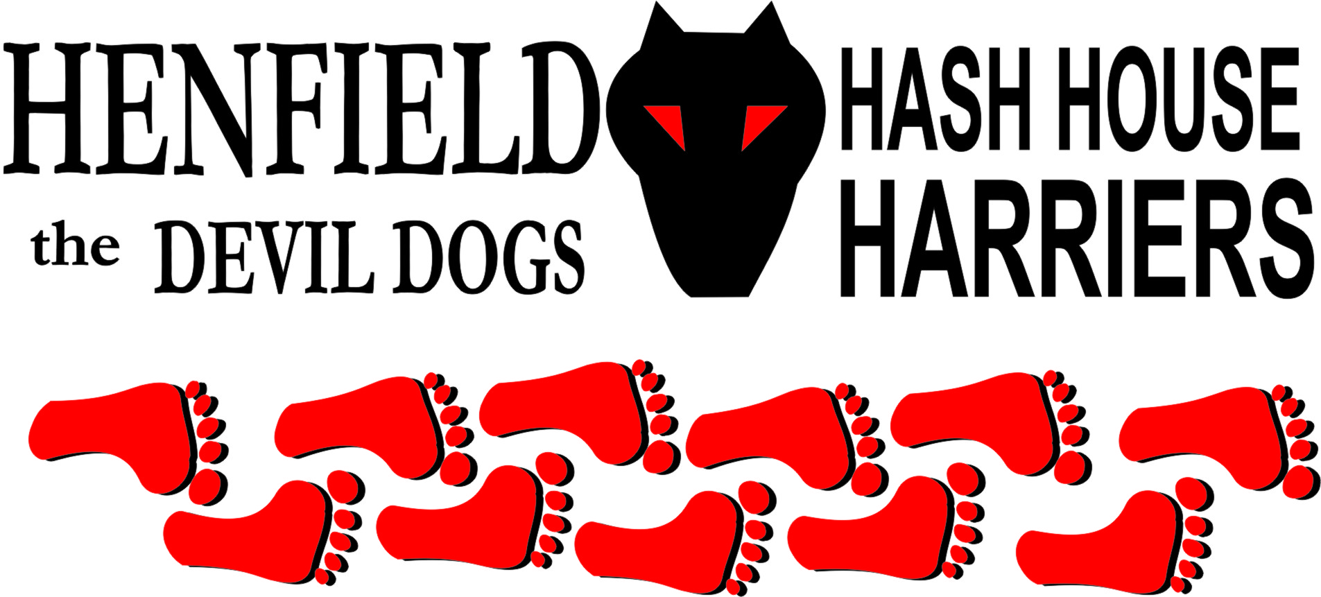

Henfield Hash House Harriers Run #106

Sunday 20th November 2011 11:30 am
Miller & Carter Lancing

Scribe: Bouncer

In an attempt to make life easier for Old Banger, Snotty suggested a Lancing r*n and I was the half-mind who offered to hare. This was, on the whole, a very lovely run in territory new to the Devil Dogs, on an exceptionally warm and sunny day.

A respectable sized pack met in the car park of the Miller & Carter ready for the off and a walkers maps were passed to Nightmare and Cyst Pit with appropriate instructions on short cuts. On was called up the alley for the remaining 6 actually running and Bollocks and Stavros were 1st victims to a falsie, as trail went left and up the hill. At the next check it was Radio Soap who went wrong, but Snotty had by now lumbered so far ahead we couldn’t hear his calls. Trail led off road to the right before a sharp left and scramble up a slippery slope took it back left to the Lancing Ring car park. Hare at this stage was so concerned with the GM’s absence that he missed the turning before Split Pin called the on. Criss-crossing the nature reserve the stunning views had us forgetting all about Snotty who still had not appeared 3 checks later. After a bit of confusion when Radio Soap ran through false trail marks, it was down the hill to the play park and finally Snotty was seen on a distant hill. Getting his attention we were then persuaded to hide by Bollocks until he was down at our level. Strolling up the next hill to give him a chance to get close unfortunately meant that the r*nning Storrington three were too far ahead to hear the call back, and did the whole of the long on-back as we took the rough route to the top of Steepdown. With Snotty’s arrival he fretted about the walkers going wrong and insisted I should speak with them despite the protestations they had maps, as they had apparently followed him like sheep the wrong way down.

From the trig point the GM took over and insisted on going the wrong way back, however, having had a glimpse of Split Pin, Bollocks and Stavros through the fog I went back to find them, eventually, coming round from the correct route. We were back on flour heading up to the clump but Bollocks proposal that they could use the kids rope swing to strangle hare had hare deviating off trail and into the sip, where the walkers were well into the beers. Once again Snotty attempted sabotage proposing a return down the hill, but I persuaded them to stick with the trail for a very attractive return round the back of the leisure centre.

Ever since the hard time I gave Snotty at the Henfield 100 I’ve been anticipating the payback, and his incitement of the pack convincing them that they’d had a terrible time was obviously it! I’d like to answer the charges so, using the old insurance maxim of Proximite Cause (finding the ultimate cause of an incident), do so for the ones I actually understood:

Snotty – badly marked trail. Snotty was lucky twice at the checks but rode it too much when he got so far ahead of the pack that he couldn’t hear the calling. Having gone for quite a distance without dust he met the return trail, only realising his error when it finally occurred that he was on his own. Blame lies with … Snotty.
Snotty – dust on the wrong side of the trees. You were going the wrong way!

(Snotty’s comment – Sounds like whining to me – what a tart)

Radio Soap – not enough flour. First time this occurred was when you ran through the bars marking falsie, therefore off-trail, which you admitted seeing on the return. The second time was because you went with Snotty who was not on trail (again), therefore no dust. Proximite Cause – Snotty.
Bollocks – had to r*n the long on-back with Split Pin and Stavros. Hounds should expect to take the same route as the hare did in setting! Admittedly this was a long way to go just to retrace and my intention had been to cut it out but as I’d waited for Snotty…

Split Pin & Stavros – lost dust. You were on trail after the trig point but seeing us on a different path cut across. Due to Snotty’s short-cut (see above).
The walkers – Had a map and instructions but followed Snotty instead, getting lost in the process.

So as you can see, for every charge Snotty was ultimately to blame, a clear case of deliberate sabotage your honour.

(Snotty’s comments – still sounds like whining!)

However, he had one more card up his sleeve. Hare having avoided contact with the Miller & Carter due to the bijou pack size measured against hassle value and the fact that they had a big enough bar area as well as plenty of seating outside reported that the (ex) pub may prove unwelcoming unless we were eating (and incidentally suggested in e-mail that we might like to repair to the Red Lion in Shoreham). Snotty charged in incurring the wrath of Mr Bouncer2 who chucked him out. Ooh Me, Old Banger and kids were already sat peacefully outside and Bouncer2 said I could grab a beer but the damage was done, so the Red Lion it was!

Marks awarded were horribly low with an average of 2 until Split Pin suggested 30, bringing them back to the usual 6.9. – Only Just!!!!!

(Snotty’s song - with apologies to Bonnie Tyler)

I was lost in Lancing
In the trees the birds were singing
I was lost in Lancing
And the hash was just beginning
As I stood there in the blazing sun
I realised I’d b*ggered up the r*n
I was lost in Lancing, on the Ring.
I was lost in Lancing
On the hills the hash were playing
And the hounds all chanting
Didn't catch what they were saying
When I looked down they were waiting there
I knew I should, but didn't care
I was lost in Lancing again
Oo la la la oo la la la lance
Oo la la la Lancing
I was lost in Lancing
But I caught the pack on Steepdown
Didn’t know what I was doing
And avoided the flour on the ground
At the trig point whilst on the phone
I led them all the wrong way home
I was lost in Lancing once more

Oo la la la oo la la la lance
Oo la la la Lancing

Song for Bouncer from Snotty (To the song my baby shot me down)

I was aged and he acts like six
We ran on byways made of sticks
He wore black and I wore white
Snotty always wins the fight

Bang Bang, Snotty shot him down
Bang Bang Bouncer hit the ground
Bang Bang That awful sound
Bang Bang, Snotty shot him down

Seasons came and changed the time
Flour was laid which was never mine
Snotty would always laugh and say
Buy some flour I will pay

Bang Bang, Snotty shot him down
Bang Bang Bouncer hit the ground
Bang Bang That awful sound
Bang Bang, Snotty shot him down

Bouncer ran with all the power
Just never laid any bleedin flour
People were chasing after dust
Flour on a run is a must

Bang Bang, everyone shot him down
Bang Bang Bouncer hit the ground
Bang Bang That awful sound
Bang Bang, everyone shot him down

On On
Bouncer (Bang Bang Song by Snotty)

The Henfield Hash House Harriers cast in no particular order, nor importance to anyone other than the hare:
Hares | Bouncer
Runners | Snotty, Bollocks, Splitpin,Stavros, Radiosoap & Bouncer
Walkers | Nightmare, Cystpit, Vincent, Louis, Oome, Auld Banger & Oome Clan.
Drinkers | The above
Apologies | Cum Lately, Moneypenny
GrandMaster | Snotty
Religious Adviser | Bollocks ( self-appointed)
Large Wildlife | Cattle
Twin Town | Warmington-On- Sea
Hashshit | Bouncer

NEXT HENFIELD HASH – 107 Friday 23rd Henfield Xmas Pub Crawl 7:30pm White Hart

