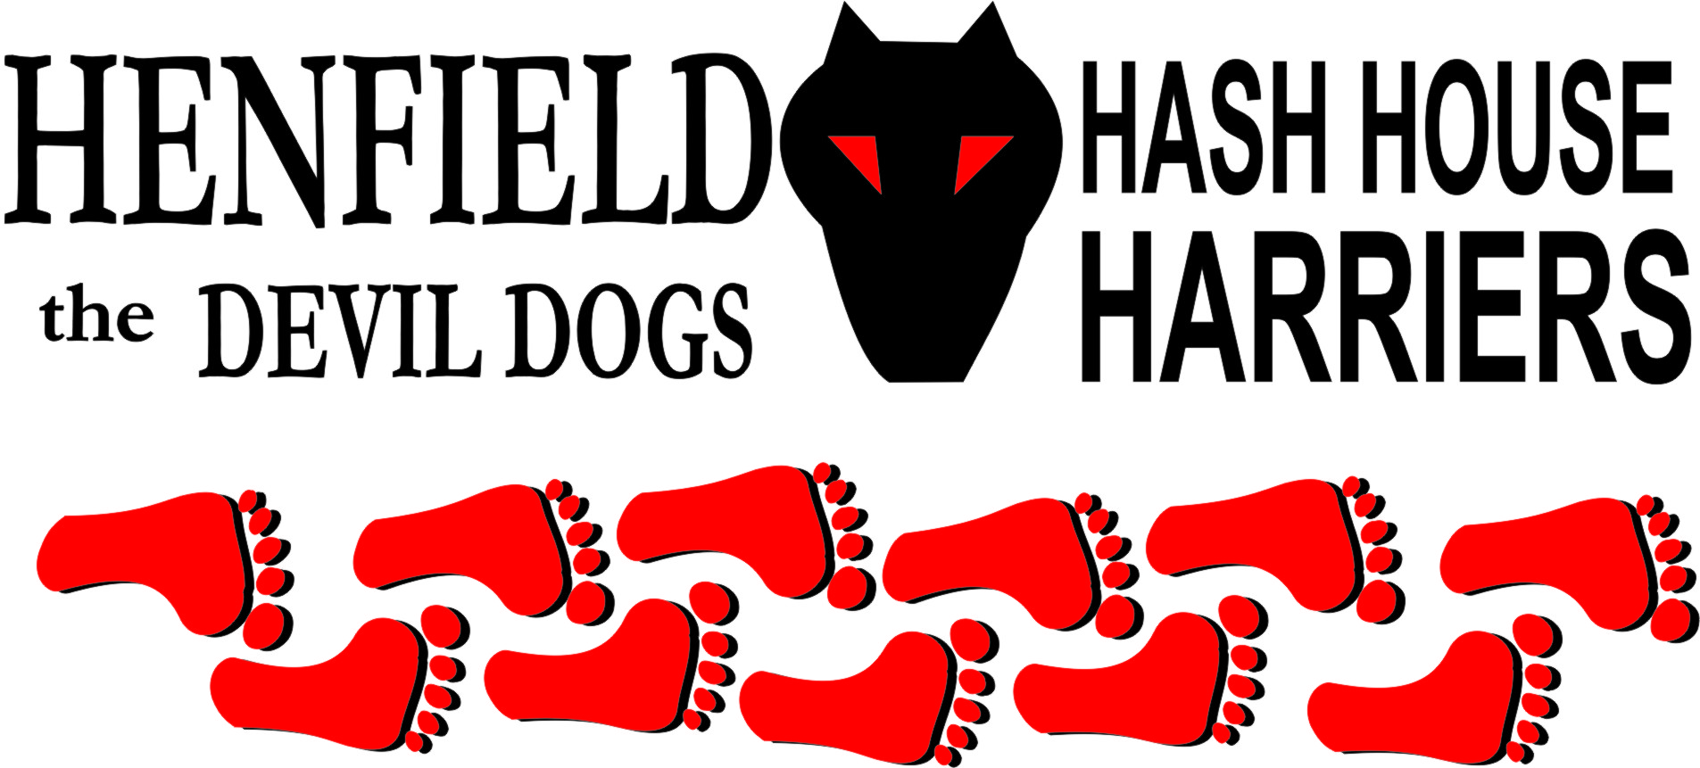

Henfield Hash House Harriers Run #105

Sunday 16th October 2011 11:30 am
Sportsman Pub Goddards Green

Scribe: Moneypenny assisted remotely by Tosser

How to describe this Hash.............. A bit of a hash-up.

The trails were laid beautifully by Tosser and Moneypenny, who spent days preparing the choice of trails, and used two whole bags of flour to mark them .

The day of the Hash dawned bright and beautiful, and then went downhill. The Hares arrived at the start in time to go round the trails once again, to tidy up the flour marks..
However, as none of the Mismanagement were present at 11.30, we were leaderless. Moneypenny went to see if anyone had parked on the wrong side of the pub, and to try to contact the GM, the RA or any other of our great leaders of the Henfield Hash. Or at least to find out who had the register, the risk assessment, and the Hash Cash kitty.

Snotty and Homer arrived half an hour late, after going out on the golf course, but being unable to find their balls. Bollocks had the feeble excuse that he was doing a run that morning - what sort of apology is that for missing a Hash?

Mrs Moneypenny acted as Walking Hare, but with no walkers, Moneypenny had to drop out of the run, leaving Tosser to keep the rabble on trail, and do the Walk, so Mrs Moneypenny had someone to lead!

A visitor called John had come to do the walk (apparently he used to be a dedicated Hasher but had retired – just what is he trying to say about Henfield Hash? However Bouncer also came to do the Walk due to calf problems – (he should keep away from farmyards). They set off early, to walk round the running trail – but without telling the Hares that they were leaving!

That left a pack of 10 runners, many of them able to call Tosser "Dad", plus Gillette the faithful hound.

Wiggy and Pirate broke away first, without waiting for Snotty to arrive, or for the Hares' presentation on how the route had been planned and marked (3 blobs of flour is On for the run, and we used Homer's idea of doing 2 long flour-marks to show the walking route. Just in case anyone cares – Nobody does).

The main pack of runners set off as soon as Snotty and Homer arrived (having finally located each others’ balls), with Tosser and Dave supervising their getting lost. There may have been a few funny incidents on the run, but nobody told me, and who cares?

There was a fine Beer Stop, next to a pond, with a choice of bad beer, worse beer, or water, kindly provided by Tosser. (Gillette kept well clear of the geese who live in it, having been chased off by them when he went for a swim in their pond during the recce).

The walkers arrived first (well done Mr & Mrs Moneypenny), followed by the runners, and finally by John and Bouncer, who had walked the run, but missed out on the lovely, scenic bit by Cobbs Mill, as Bouncer missed the trail. After a break for drinks and crisps, spoilt only by Snotty singing, everyone set off towards the On-In, with nobody getting lost this time.

Bollocks had turned up, and was sitting outside the pub, drinking beer, but luckily he buggered off again before Snotty could take 2 quid off him and give him a down-down.

The beer at the pub was very good (10% off for CAMRA Members), as were the cheesy chips.
Marks were awarded for the run – 15 out of 10 for flour marks, and minus 10 for not being muddy. Or 6.9 on average, as usual.

There were a few down-downs, but your scribe can’t remember the details. Except for Thumper and Vera Vomit (Who Snotty complimented on their "nice half jugs", as he gave them their down-downs).

Snotty was awarded the Hashshit, deservedly so for awarding Homer the Hashhit award in the write up when it was in fact Bollocks, all has been amended for the records.

On On
Moneypenny & Tosser

The Henfield Hash House Harriers cast in no particular order, nor importance to anyone other than the hare:
Hares | Tosser and Gillette the Dog (for Run); Moneypenny and Mrs Moneypenny (for Walk)
Runners | Snotty, Homer, Robin, Helen and Lorna (the 3 Tosslets), Wiggy, Pirate, Thumper and Vera Vomit.
Spare row in table:
Walkers | Moneypenny, Mrs Moneypenny (on trail), Bouncer, John (on a different walk !)
Drinkers | The above plus Bollocks and Julian
Apologies | Snotty (late), Homer(late); Bollocks (for running somewhere else)
GrandMaster | Snotty
Religious Adviser | Bollocks ( self-appointed)
Large Wildlife | Horses
Twin Town | Warmington-On- Sea
Hashshit | Snotty

NEXT HENFIELD HASH --
The 106th will be held at Miller & Carter Lancing set by Bouncer on 20th November 2011– watch the website for details.

