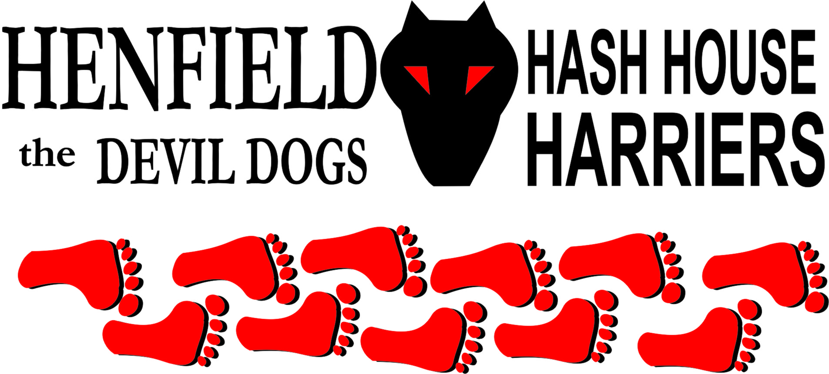

Henfield Hash House Harriers Run #104

Sunday 25th September 2011 11:30 am
Partridge Green

Scribe: Mr & Mrs Slash Gordon

The start of the “Indian Summer” meant a good turnout for this event – 24 in all including the two dogs – “Dave” the Schnauser on the run and a new squat entrant in the walk, friendly old Henry. A big contingent also amongst the kids, ranging from an 18 month “babe in arms” to three fit siblings in their late teens. We also had new Hashers trying their luck . One of these Paul, a friend of Pirate immediately showed his mettle with a roll up before kick- off and several heavy breathing stops bent double en route ! The other lady was an old friend of Splitpin, Emma who will hopefully become a regular of the walkers fraternity. - - - - - - -

This time round the “haring” responsibilities fell to Slash Gordon and Mrs S G – the former leading out the runners and the latter the more sedate walkers.
Setting out from “The Partridge “ pub the runners headed on on to the old railway line, across the fields heading for a tributary of the Arun , before looping back to the Green Man pub on the other side of Partridge Green. With Roadrunner missing due to Dragon Boat Racing commitments it was the turn of a more venerable hasher “Sir Snot” to lead the way.

At the Green Man the Hashers and Walkers converged and onward sped to Littleworth via the football ground and hedgy lanes . Once in the village came the drinks stop in the picturesque tiny common near the Windmill pub. There was an excellent selection of beers for consumption – mostly left overs from previous events – “St Omers” from the Henfield 100 weekend and even McEwans from the Burns day do. Homer was again tempted with the Tennants 9 percent proof, but a vision of soup kitchens and park benches steered him towards the healthier Mackeson option. The wide variety of Budgens crisps and Quavers kept the youngsters happy. Bollocks and Pirate seemed to be in the party mood, with two cans each and set to stay in situ for the afternoon.
Bouncer also turned up for the half way refreshments looking in a bad way having run all the way from Shoreham as part of his marathon practice! Needless to say – using the excuse of “must get back in time for the boy’s football – Bouncer then nobbled long suffering Mrs Bouncer and the twa bairns to head back to the Partridge pub in Mrs Slash Gordon’s hijacked Renault Scenic !

A blast from Sir Snot’s fox hunting horn and on the troops sped off for the second half of the Hash. This turned out to be a longer loop than the first thanks to some confusion in the Haring ranks from the previous day. In an effort to raise the tone the runners went past the Monastery – being a silent order the “on on s” and horn blasting were put on hold until back into the woodland. Two of the Hashers - Moneypenny and Splitpin did need some persuasion to leave the sacred venue however, being convinced that some Benedictine wine would help in recouping energy levels.

With the heat and longish route causing energy levels to sap – Sir Snot quickly dashed from last to first place, missed a critical check (easily done with typical measly Aberdeenshire sized flour portions) and led the sweating bunch on a shortcut back to the pub. With the Dark Star local beer now in their nostrils a sprint finish involving Pirate, Slash and Sir Snot ensued over the final 200 yards – the latter amazingly entering the hostelry door by a short head !

Now it’s over to Mrs Slash for the walk report! The poor walkers are often forgotten in the reports or if mentioned, usually come in very low profile compared to the runners, speed it not everything! With the winkies out numbering the oldies, we sent off at a sedate pace only to be pushed to one side by hordes of cyclists out on a sponsored ride along the the Downslink. One young lad managed to misjudge his distance and caught the backpack of Cyst Pit and his little boy Vinnie. Luckily our intrepid walkers were only shocked and not harmed, unfortunately the rider ended up off the track a little worse for wear. Perhaps a lesson learnt, slow down when you go past walkers and take a wide berth!!

After this event, all went well to the drinks stop but shortly on restarting things went horribly wrong. Having had too much of the peachy water, Greg decided that a call of nature was needed. He let his mum know that he was going off piste to find a suitable site and no more was thought about it until we heard a yell, only to see him knee deep in mud. He had mistaken a semi dried up pond covered with leaves for the more solid ground of a wood. Oomie and Mrs Slash managed to tug him out before he sunk any deeper, while our intrepid paparazzi, Banger, took action shots.

Poor Greg was just covered in dark squidgy mud, but put a very brave face on things and managed to plod all with way back, what a star! This earned Greg.the new hash name of Oomie Bog and he did a very good job of glugging a glass of coke for his down down.

Nothing else could go wrong or could it? In Banger’s haste to get photographs, she managed to pull out her car key with the camera. She only realised this as we were about to walk on, so then we were delayed again looking for the Banger’s banger key! As you can imagine, Banger was very despondent, ever looked for a single key on the floor of a wood strewn with autumn leaves – needle in a stack comes to mind! Amazingly, the eagle eyes of Oomie spotted it and thankfully all went smoothly after that! I never realised what a responsibility it is leading the walkers!

The weather was so fine, we could all sit out in the pub garden in our tee shirts and enjoy the down downs in the warm autumn sunshine. We officially had our youngest down down this time from Vinnie? for surviving the cyclist attack, definitely a hasher in the making!

Dave the Dog was finally given his Hash Name Gillette due to his fine close haircut, only the second hound to be named on the Henfield Hash! (SC was the first!)

On On

Down Down and On On
Mr and Mrs Slash Gordon

The Henfield Hash House Harriers cast in no particular order, nor importance to anyone other than the hare:
Hares | Mr & Mrs Slash Gordon
Runners | Bollocks, Split Pin, Snotty, Slash Gordon, Angel, Paul A, Homer, Moneypenny, Robin, Laura Helen, Pirate, Dave (Gillette), Henry (Hound)
Walkers | (Bouncer), Mrs Slash, Greg (Oome Bog), Oome, Oome Mud, Auld Banger, Devlin, Emma, Cyst pit, Vinnie
Drinkers | The above + Bouncer
Apologies | Roadrunner
Grand Master | Snotty
Religious Adviser | Bollocks ( self-appointed)
Large Wildlife | Henfield Residents
Twin Town | Who would have us!
Hashshit | Bollocks

NEXT HENFIELD HASH --
The 105th will be held in Bolney area set by Moneypenny on 16th October 2011

