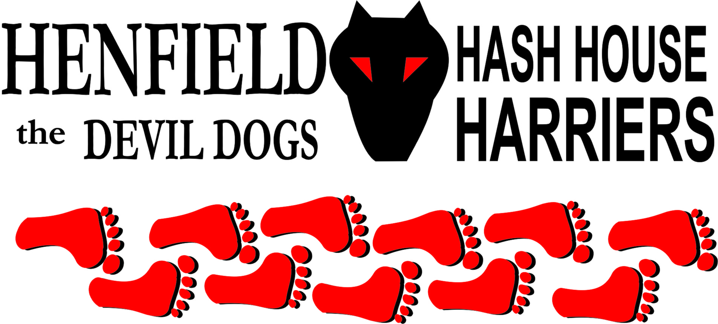

Henfield Hash House Harriers Run #103

Sunday 28th August 2011 11:30 am
Cat & Canary Henfield

Scribe: Sir Snot

The weather was perfect for a Sunday run and considering it was a bank holiday a good turnout – one Grant Posthumus all the way from South Africa (Auld Bangers Brother) who actually walked the course in flip flops! – Did not want to wear any decent shoes in case he was mugged in the village! – This is not Joburg Grant!!

Everyone was surprised at the fact no duck tape was on Auld Bangers car – at all! Except where Grant had wrapped it around her laughing gear!

We had a newbie Sue from around the corner (another walker) Moneypenny and Margaret with 5 dogs we heard, but Dave was the only mutt, together with Tosser Helen and Robin.

Bollocks and Splitpin rolled up and Homer was with SC (any excuse for a walk) with Roadrunner come to strengthen his joints! (Take that however you want). Slash Gordon was with us and Charlie together with Mrs. Snot made up the squad.

After brief instructions on all the Henfield Phallic symbols, the walkers set of North up the railway lines with the walkers heading west over the potato field after checking out every other route before hand – great job the hare!

A quick left down Stone pit lane then right onto Upper Station then a left into lawyers lane, Slash was convinced we were going down the river and kept heading West only to be called back a few times.

At the bottom of Lawyers Lane - Helen headed off up Shiggy lane, Roadrunner was off over the horse field and Bollocks found a route not even marked, marks were stretched out to give the walkers a chance, but soon all were on South down view before turning north back onto upper station road, prior to that some were caught wrong footed going over farmers walk before being called back. Tosser was actually on trail but returned only to be asked why! – What a Tosser! Splitpin picked up the reins and led the pack for a brief while.

Slash Gordon kept on grunting like a hog and heading river bound – again only to be called back with Robin standing on the check as he had done on many others! Eventually trail was found past the old vineyard back onto Stone Pit lane, eventually heading left towards the river – Slash finally got that one right! Roadrunner was streaking away as usual only to be foxed at the first bridge with a false beer stop sign, it was the only way the hare could think to slow him down – but it worked!

Along the riverbank to where the walkers had already arrived and beer and frivolities were had. The sun was shining and the wind was up but it was a pleasant day – especially for Grant as he was feeling naked without his gun and was surprised he had not yet been mugged – just wait until you get back to the pub!!

The return for the walkers in part was along the river over the two wooden bridges and back up to the Cat & Canary, the runners had a few circle jerks around Wrights farm and over the railway line into Parsonage farm, where Splitpin and Hare took a leisurely stroll up the railway line to meet the runners going over into Parsonage farm, last through the sty was Tosser being pulled along by Dave!

The runners went through the dead centre of Henfield to come back past the school to the On in where the walkers were not far behind. Then Nightmare showed up recovering from a nasty operation – but coping fine after downing a lager!

Down Downs for the newbies Sue – who struggled with the coke, Grant who could not neck it as fast as either Auld Banger or Oome (Who was absent) and Robin for circle hugging! Roadrunner just for running too fast and falling for the old false beer check routine.

Bollocks pointed out that Homer who walked the whole thing with SC – whimp, had still not produced write up 102 or in fact write up 86 so down down and Hashshit duly awarded!

Slash Gordon for grunting worse than a hog all the way around!

A classic 6.9 made it a pretty average run and a scenic walk and a good time was had by all.

On On

The Henfield Hash House Harriers cast in no particular order, nor importance to anyone other than the hare:
Hares | Sir Snot
Runners | Bollocks, Split Pin, Snotty, Slash Gordon, Roadrunner, Tosser, Helen, Dave & Robin
Walkers | Homer, SC, Sue, Grant, Auld Banger, Miss Wingealot, Devlin. Moneypenny, Margaret, Mrs Snot & Charlie
Drinkers | The above + Nightmare
Apologies | Oome Clan
Grand Master | Snotty
Religious Adviser | Bollocks ( self-appointed)
Large Wildlife | Henfield Residents
Twin Town | Who would have us!
Hashshit | Homer

NEXT HENFIELD HASH --
The 104th will be held at Partridge Green set by Slash Gordon on 25th September

