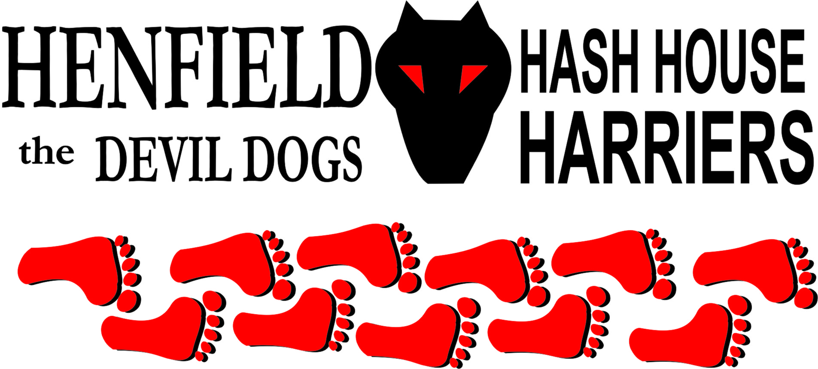

Henfield Hash House Harriers Run 100th Weekend

Friday 17th – 19th June 2011

Scribe: Bouncer & Snotty

CRAFT #37 – Henfield, and the Henfield Hash House Harriers 100th run weekend.

Red Dress Run

In true CRAFT tradition, June means an event crash, although this time we were actually invited! As part of the Henfield hash 100th celebrations Bouncer hared the Friday night red dress pub crawl. It’s not often CRAFT actually do any running, but hidden amongst the various e-mails before the main event was one from Bollocks about including in the literature that this would be a run! With the closure of the Gardeners Arms we were limited on watering holes so the decision was made to include the Bull at Shermanbury, and have separate walkers and runners trails meeting at pub 2.

So on a foul afternoon armed with a dribble dropper full of flour mixed with red powder paint Bouncer set off to mark trail cross country to the Bull, getting a severe drenching in the process. The return to town was somewhat hazardous in the conditions so after hare almost getting run down by Pirate in a lorry the Bull was aborted.

Despite a move towards a halfway sip at Snotty’s house, the appropriately dressed pack, after meeting at the Cat & Canary, wandered on to #2 the White Hart. Some were actually running including P!ssticide and Cyst Pit, while others embraced the rain to such effect that they stood in puddles waiting for cars to pass. Apart from the 30 odd registrees there had been talk that some CRAFT extras may turn up such as the Rats, Budgie and Adrian Scott as well as other Henfield Joggers. Presumably conditions put them off but it was good to see Bob Patton finally make a CRAFT after years of promise.

With the Gardeners Arms now closed and the George Hotel shut for a private party our route was now severely limited, but most had imbibed well before setting off so no-one grumbled. Almost next door to the White Hart was #3 the Plough from where many moved off in search of food, either fish & chips or, for the majority, the curry house which became #4 with the purchase of a cobra or two.

Worlds strongest man, Rumpole looked distinctly uncomfortable after finishing off Bouncers Madras, before the announcement from Snotty that the sponsors had agreed to pick up the cost! As we fell out the door there were only a handful who actually managed a beer in #5 the Bell where Pirate turned up for a late start, but there were many more already back at the Cat & Canary and a darts contest was quickly organised.

The evening was rounded off with round 1 of the dancing back at the guide hut with Auld Banger impressing, although the old adage about dancing being a vertical expression of a horizontal intention gave us concern when Snotty did the Big Daddy on Bouncer!
Ononononononononononononononononononononononononononononononononononononononononononon

Henfield H3 100th Run
Coming round grudgingly from our hangovers on Saturday, it was off to the pub for an excellent cooked breakfast, which did the trick! Back at the guide hut, Bollocks was heard to swear heartily about the rain. Despite using sawdust his trail had been washed, it was that biblical. So hurried discussions took place with Cyst Pit offering to carry the bags of trail material gathered at short notice, but in the end hare set off on his own for a live trail.
Hash 100 started from the Henfield football club so a short stroll before the introduction and welcome from the GM, followed by hash warm-up Father Abraham led by the amnesiac Bouncer, and off we went.
There were bodies everywhere, but eventually the first mark was found and we left the sports field, only to run into similar problems 2 or 3 more times more as we bumbled south through the town. Once out into the countryside, and with the weather still attempting to foil our day, things got a lot easier as we meandered further and further south.
Wiggy commenting on how attractive the Downs were looking. After a held check, Road Runner called us on nothing, giving the SCB’s a chance to get ahead. Well Moneypenny had the option but had soon worked his way through the pack to the back again.
Eventually we hit the track at Small Dole and made the turn towards the river, the crossing having been announced at the start, but once again at the bridge we were foiled by lost trail. West led to a falsie, and there seemed to be nothing either bank of the river until a distant P!ssticide finally called from the far side of a herd of cows, causing Little Bear some consternation, and having to wait for her hero Daffy Dildo to catch up and save the day.
Alleged sweeper Bouncer received a call from Snotty at the sip at this point to the effect “Where the F*ck are you?”. Hare had apparently made contact with the walkers and was making his way back down to lead us to the beer. At the next bridge we met Bollocks, who said we’d come the wrong way, then crossed over to take us up the east bank. The injured Boggers, who had clearly stated that he would not be doing the river crossing, saw us using the bridge and deduced that the dry route was west. Which is why when he hobbled into view as we necked the ale, he was on the wrong bank! Snotty had put his money where his mouth is and crossed there and back a couple of times, at least once naked, but Split Pin had been concerned about the amount of rain coming down from the hills and high tide, and talked Bollocks out of it – Only a few were miffed at not doing the river crossing – which according to Snotty was warmer than standing in the rain! All we did was follow! Rumpole’s bottle opening technique impressed to ensure everyone was sated and off we went again, the walkers pack being somewhat larger than previously!
The runners then headed further west through a slurry filled farm, where T bar rightly expressed concerns about the care of the calf’s, especially as one of them was loose in the yard, so we jammed the gate shut after passing through. After crossing the bridge on the Ashurst road it was through some more lovely fields to Shermanbury, and finally the pack made it to the Bull.
No time to stop though as we were on the final stretch, which strangely was very well marked in red flour from the night before. Eventually we made it for the hero’s finish across the field back to the club house, to receive a medal. That’s novel for a hash, but so is a 12 miler for anyone other than ballbreakers! As Boggers had said several hours ago, “Well we didn’t come all this way for a 3-miler”! Inside we were given a substantial refreshment of sarnies and beer before heading out for the circle.
Before the hares are given their just rewards on Henfield hash, there is always a vote from the pack. It’s sometimes unclear why as the end result is always 6.9 average! On this occasion Bollocks and Bouncer were awarded even though the latter had little to do with the trail, but the terrible two responded by sharing their beer with the GM!
Inevitably this meant they then had to do it again with Snotty out of the picture. No problem, Cyst Pit could have the drenching for his spillage call! Further reward beers went to T-Bar and P!ssticide, the only ones to make the Bull, albeit a day early.
Snotty then punished Bollocks for his alarming wet weather condom costume, Boggers for the river cock-up, Oohme and Auld Banger and others from the walkers group when he could get a word in as Bouncer reading from the Big Book of Bouncer was in motor-mouth mode!
Daffy received for sniffing the flour to determine which way trail went (introduced with an anecdote about Tonto and Little Bear for frizzy hair worries prompting a shopping trip; Road Runner for various name related sins; Moneypenny for seeking protection from an umbrella then sliding on his arse; Call Girl for saying it wasn’t proper rain like where she came from; Homer for carrying the camera all the way round and not taking any pictures; Snotty for naked river crossing; Snotty for child abuse (with Oohme’s kids being forced to stand in the wind and rain at the sip);
At some stage Boggers managed to interject a Down Down for Bouncer after CRAFT received radio publicity, Bollocks to award Snotty Hashit, and Cyst Pit frequently interjecting for Bollocks for hats in the circle, as well as ‘one hare drinks all hares drink’, which meant Bouncer again. The weather gods smiled kindly on the unfortunate pack to bring rain and save further pain.
After showers at the Leisure Centre it was back to the site to catch our breath before the hash games started. In a stroke of unspiration, Snotty had managed to persuade Bouncer to organise something but the weather put paid to outside fun so it was all inside where teams led by Snotty (Henfield H3), Split Pin (the ladies), Ollie (the kids*), and Cyst Pit (visitors) partook in a series of Olympic school sports day competitions which involved a lot more alcohol (*and lemonade) than you might recall from growing up.
As all teams won an equal amount of points from the sack, egg and spoon, bean bag and mat races it was down to a tug of war final, in which the Henfield team triumphed. The tug of war rope then provided a lot more amusement for the assembled with lots of tugging, wrapping people up and eventually as a skipping rope!
As the DJ was now setting up his gear, and food was on its way, we were all forced to calm down for a short while to bolt some burgers and chips down. Good carbo meal for beer soaking again provided by the Cat & Canary, but you can’t help feeling a pot chilli would probably have made life a lot easier and probably cheaper for them, as well as possible better received – must stop whining! As tables were cleared Snotty dished out namings for Oohme’s kids and some commemorative mugs for anyone who’d managed over 25 runs with Henfield, which meant Rumpole, Nightmare, Moneypenny, Bouncer, Homer, Bollocks, Split Pin and the GM himself.
The evening started in earnest with the arrival of Dilly and Jenni from the Hardy Hash in Olympic horse racing costumes! It didn’t really look like many others had bothered with the fancy dress with Angel and Bouncers cow racing hats showing a tragic misunderstanding of the theme, and although the Hagar the horrible drinking team was closer to the mark, the only worthy opponents for the best dressed prize were Daffy’s mankini, and Butt Plugs 2012 tee shirt and wig.
As the long-suffering DJ attempted for the 3rd time to get us up on our feet, the cabarets were announced kicking off with Boggers gently amusing interpretation of side-by-side.
Snotty then announced the arrival of ABBA ..er.. clones, ABBS (Angel, Bouncer, Bollocks and Splitpin), the two guys dressed as the two girls were clearly affected by their inebriation resulting in Bollocks doing some very sexy but completely unsynchronised dancing while Bouncer just pratted about looking fat. Video evidence shows that the only time they were actually in tune with each other was when they both took a slug from their improvised Becks bottle mikes at the same time. At least the On and On and On bit went down well!
The final act featured Snotty flanked by Oohme and Auld Banger performing Cheap Flights from Fascinating Aida, and a damn fine job they did too to prove there is some small degree of talent in Henfield if you scratch hard enough.
Round 2 of the dancing finals were at last underway as we demolished the beer, although unfortunately only until about 11.30 due to licensing restrictions, and then the assembled were presented with the shocking sight of the traditional midnight naked run, as ever led by Daffy Dildo.
Although, with only Bollocks and Bouncer pissed enough to take part, one of whom disappeared behind the hut, and the other behind the cricket screen, there was little to see, in more ways than one! For some reason, this seemed to be the last straw for the pack and very quickly people sought their pits and retired.
Henfield H3 Run 101
Morning dawned and once again we had a fantastic brekkie at the Pub, before the group assembled in their Sunday best ready for the service which was conducted in the vernacular by Reverend Slash Gordon. Bags of carrots were passed around the congregation, for the beer stop apparently.
Scottish rules, much improved weather, and having the hare present made quite a difference. Especially as hare operated an almost suicidal approach to checks regularly announcing which direction it would be long before it was called: running through the first check; wandering on for the second; calling everyone back when a rogue call had him shouting “och no, ye scunners it’s this way, the noo”; succumbing to patricidal threats from his daughter; and happily telling us just by being asked!
All good fun and soon enough we were at the sip where Snotty had arrived well ahead of the pack having only swam and walked the 100th – several times we are told!
ET discovered that what looks like Coke, isn’t necessarily Coke. In this case it was Pimms which was a bit strong for his young palate, but the distraction of feeding the donkeys and goats soon cheered him up, those who had not eaten their carrots were able to feed the animals.
From Swaines Farm there were several different routes taken back, proving that local knowledge is no substitute for following the carefully laid trail. And that Boggers still didn’t know where he was going. Back at base, after rewarding the hares, Snotty was anxious to right an omission from the day before and called up the more remote visitors from Weymouth (Dilly and Jenni); Kent (T-Bar Twin, P!ssticide); London (Boggers; Little Bear; Daffy Dildo; Call Girl and Butt Plug) and, representing the absent Rhode Island hashers was awarded a beer himself.
A number of stories from the previous day and night surfaced and Homer was awarded Hashit, seemingly for having a crap beer named after him? The Hardy’s won the fancy dress, Snotty got one for buggering up the hash calling system using three whistles for the 2 syllable call On-on (or should it really be on and on and on??!), and Bouncer for verbal diarrhoea. There was some stuff about child abuse again and it was revealed that Daffy is a dad though he knows it not, but why else would Little Bear be carrying scented nappy sacks around?
Lost property downs went to Bollocks, Split Pin and Anorexia for managing to mislay their brand new tankards straight away, although for some reason Rumpoles was returned without question.
Auld Banger then gave Snotty a rather lovely bouquet for all his hard work in making it such a successful weekend. The GM then generously distributed beers to all and sundry (including every receptacle known to man being used to drain the last barrel of Harveys), and declared the event closed.
At which point Pirate arrived. The remaining handful of shit shovellers were treated to a Red Arrows flypast, and thus ended an excellent weekend, well done to Snotty, Snot Twat, Sir Snot and Stanorexia – a great team!

